www.acsnano.org

Niobium and Titanium Carbides (MXenes) as Superior Photothermal Supports for CO₂ Photocatalysis
Zhiyi Wu, Chaoran Li,* Zhao Li, Kai Feng, Mujin Cai, Dake Zhang, Shenghua Wang, Mingyu Chu, Chengcheng Zhang, Jiahui Shen, Zheng Huang, Yanling Xiao, Geoﬀrey A. Ozin,* Xiaohong Zhang,* and Le He*

Cite This: https://dx.doi.org/10.1021/acsnano.1c00990 Read Online

ACCESS

Metrics & More

Article Recommendations
*sı Supporting Information

ABSTRACT: The conversion of CO₂ into fuels and feedstock chemicals via photothermal catalysis holds promise for eﬃcient solar energy utilization to tackle the global energy shortage and climate change. Despite recent advances, it is of emerging interest to explore promising materials with excellent photo- thermal properties to boost the performance of photothermal CO₂ catalysis. Here, we report the discovery of MXene materials as superior photothermal supports for metal nano- particles. As a proof-of-concept study, we demonstrate that Nb₂C and Ti₃C₂, two typical MXene materials, can enhance the photothermal eﬀect and thus boost the photothermal catalytic activity of Ni nanoparticles. A record CO₂ conversion rate of
8.50 mol·g ⁻¹·h⁻¹ is achieved for Nb C-nanosheet-supported
Ni 2

Ni nanoparticles under intense illumination. Our study bridges the gap between photothermal MXene materials and photothermal CO₂ catalysis toward more eﬃcient solar-to-chemical energy conversions and stimulates the interest in MXene- supported metal nanoparticles for other heterogeneous catalytic reactions, particularly driven by sunlight.
KEYWORDS: MXene, catalyst support, photothermal catalysis, CO₂ hydrogenation, solar fuels

he conversion of CO₂ into fuels and feedstock chemicals via photothermal catalysis holds promise for eﬃcient solar energy utilizations to tackle the
T
global energy shortage and climate change.¹⁻⁶ The photo- thermal pathway enables more eﬃcient utilizations of the solar spectrum, particularly low-energy infrared light that is often

wasted in conventional CO₂ photocatalysis.^{7,8} The eﬃciency of photothermal catalysts is strongly dependent on their photo- thermal and intrinsic thermal catalytic properties. Since the pioneering study by Ye et al. in 2014, many attempts have been made in the development of catalysts for photothermal CO₂ conversions.⁹⁻¹⁷ The majority of photothermal catalysts are based on metal nanoparticles dispersed on oxide supports,

still needs to be greatly improved.²¹⁻²⁷ Despite recent advances, it is of emerging interest to explore promising materials with excellent photothermal properties to boost the performance of photothermal CO₂ catalysis.

MXenes are a family of two-dimensional transition-metal carbides and nitrides with promising applications in diverse areas such as energy conversion and storage, biomedicine, and wearable electronics.²⁸⁻⁴⁴ In consideration of their intriguing properties, here we investigate the potential of MXene materials for photothermal CO₂ catalysis. First, owing to their electromagnetic wave absorption capacity and localized surface plasmon resonance (LSPR) eﬀect, MXene materials (especially carbides) often exhibit a superior photothermal

where the former is often the major light absorber.¹⁸⁻²⁰

Nevertheless, metal nanoparticles often suﬀer from incomplete utilizations of photons across the entire solar spectrum. Several strategies were developed to maximize the utilization of the solar spectrum, e.g., by using strong light absorptive supports and constructing plasmonic superstructures, but the activity of the resulting photothermal catalysts (below 1 mol·g_{cat}⁻¹·h⁻¹)
Received: February 3, 2021
Accepted: February 22, 2021



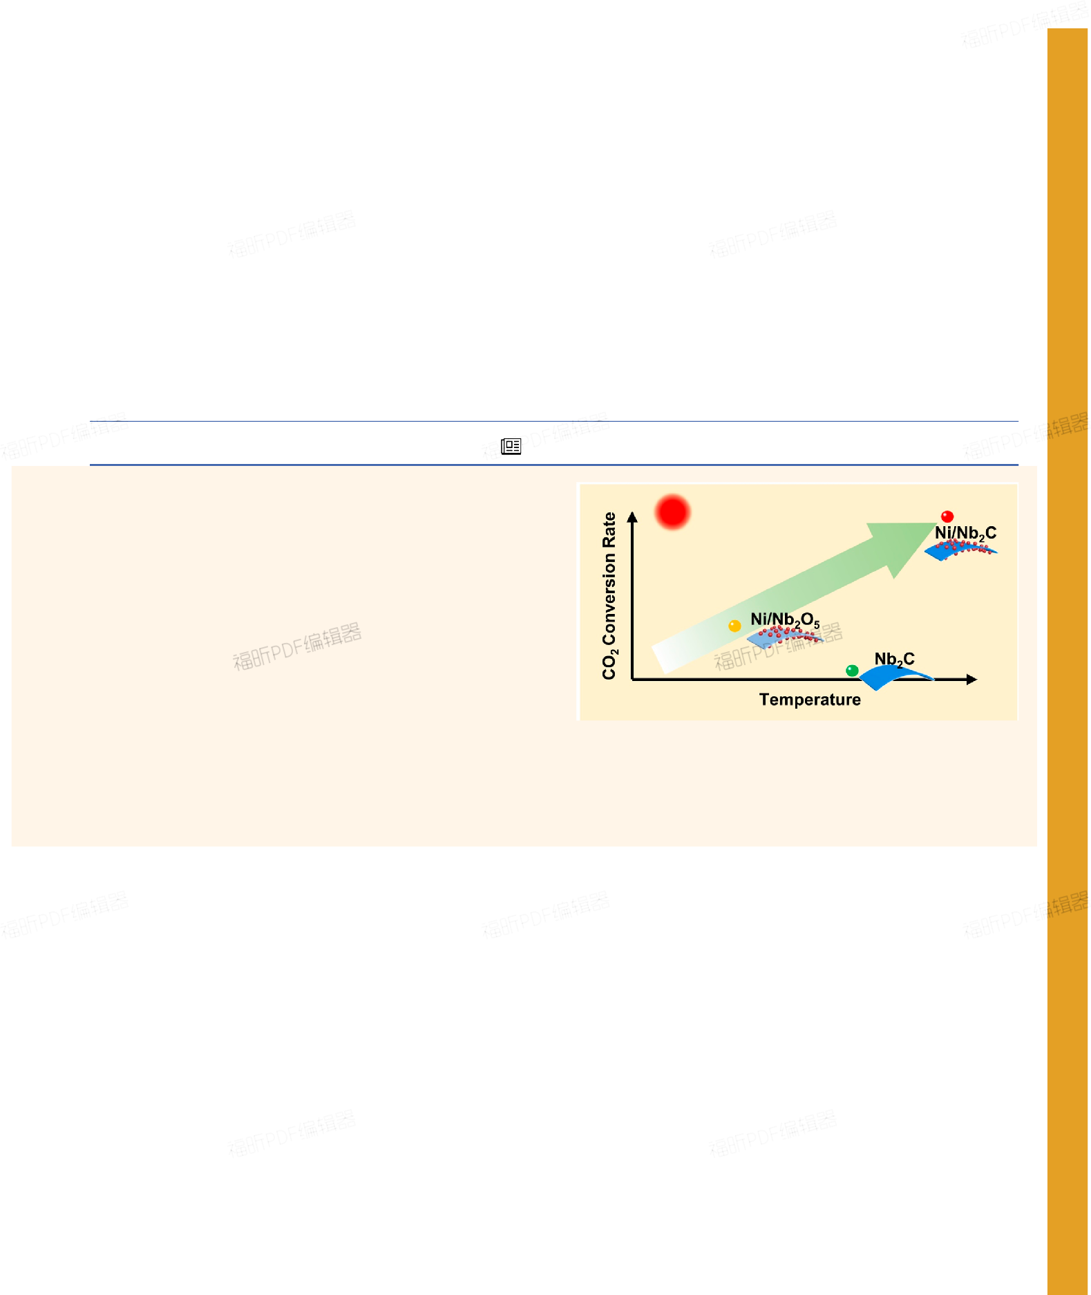© XXXX American Chemical Society
A
ARtIClE
Downloaded via SOOCHOW UNIV on February 26, 2021 at 01:25:39 (UTC).
See https://pubs.acs.org/sharingguidelines for options on how to legitimately share published articles.
https://dx.doi.org/10.1021/acsnano.1c00990
ACS Nano XXXX, XXX, XXX−XXX

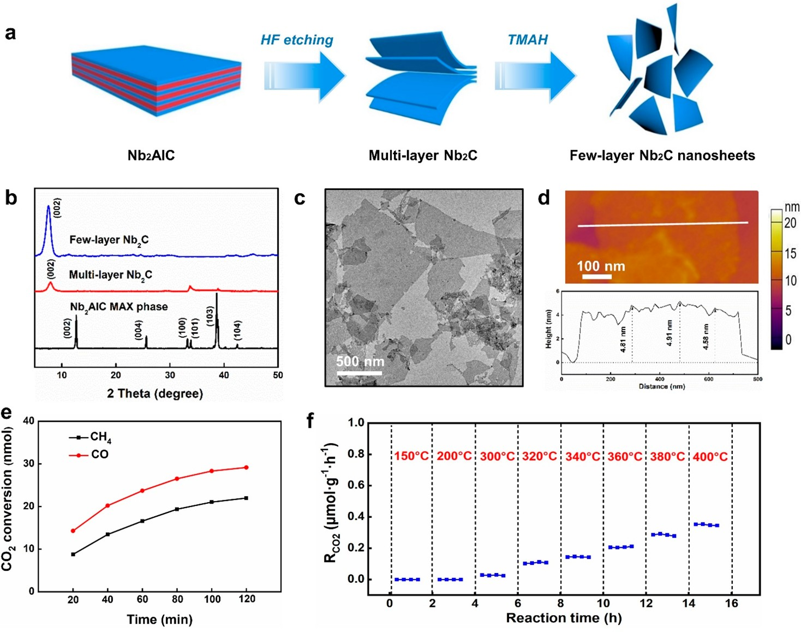

Figure 1. (a) Schematic illustration of the preparing process of Nb₂C MXene nanosheets. (b) XRD patterns of the Nb₂AlC precursor, multilayer Nb₂C after etching the Al layers, and few-layer Nb₂C nanosheets. (c) TEM and (d) AFM images of the as-obtained few-layer Nb₂C nanosheets. (e) Time-course photothermal conversion of carbon dioxide by few-layer Nb₂C nanosheets in the batch reactor. Reaction conditions: 10 mg of catalysts, H₂/CO₂ = 1:1, total pressure of 1 atm, and simulated sunlight with the intensity of 15 suns. (f) Temperature- dependent performance of Nb₂C in thermocatalytic CO₂ hydrogenation tested in the ﬂow reactor.

conversion property.⁴⁵ To date, MXene materials have been studied for many photothermal applications including cancer therapy, solar water desalination, solar photothermal electro- des, and light-driven actuators.⁴⁶⁻⁵³ In this context, MXene- based catalysts could enable eﬃcient sunlight utilitizations and exhibit strong photothermal eﬀects. After metal nanoparticles are loaded on MXenes, the photocatalytic processes may also be accelerated by the possible transfer of LSPR-excited hot charge carriers from MXenes to metal nanoparticles and adsorbed reactants.⁵⁴⁻⁵⁶ Although the use of 2D MXenes for photothermal catalytic conversion of CO₂ has not been reported, metal carbide nanoparticles were used for CO_{x} hydrogenation and water gas shift reactions.⁵⁷⁻⁵⁹ In a recent study, it was found that Fe₃C exhibited a stronger light absorption then Fe₃O₄ and a higher selectivity toward CH₄ than CO in photothermal CO₂ hydrogenation.⁵⁷ Another advantage of MXene materials lies in the ﬂexibility of tuning their optical, electronic, thermal, and surface properties by adjusting their compositions, structures, and terminations, which greatly broadens the choice of materials.³⁰ As a proof-of- concept study, we demonstrate that Nb₂C and Ti₃C₂, two typical MXene materials, can enhance the photothermal eﬀect and thus boost the photothermal catalytic activity of Ni nanoparticles. For example, the activity of Nb₂C-supported Ni nanoparticles in photothermal catalytic CO₂ hydrogenation is
6.3 times as high as that of the Ni/Nb₂O₅ sample with a similar structure and Ni particle size under the same testing conditions. Notably, a record CO₂ conversion rate of 8.50 mol·g_{Ni}⁻¹·h⁻¹ was reached for Nb₂C-supported Ni nano- particles under 36-sun illumination without external heating, which outperformed reported Ni-based photothermal catalysts.

Our study clearly reveals the great potential of MXene materials in the development of catalysts with excellent photothermal properties toward eﬃcient solar-to-chemical energy conversions.

RESULTS AND DISCUSSION

Two-dimensional (2D) Nb₂C nanosheets were synthesized via a modiﬁed chemical exfoliation method (Figure 1a).⁴⁷ This process involves the removal of Al layers in the precursor of the Nb₂AlC MAX phase through the treatment with HF and the subsequent intercalation in tetramethylammonium hydroxide (TMAH) to obtain few-layer Nb₂C nanosheets (Figures S1− S3). Figure 1b depicts the X-ray diﬀraction (XRD) patterns of the Nb₂AlC precursor, multilayer Nb₂C after HF treatment, and the ﬁnal product after the TMAH delamination. The
characteristic peaks corresponding to Nb₂AlC disappeared after HF etching, suggesting its complete conversion into Nb₂C.⁶⁰ A strong peak appeared at 7.9° in the XRD pattern of the HF-treated sample, which corresponds to the (002) peak of crystalline Nb₂C. After the subsequent intercalation by TMAH, this (002) peak of Nb₂C further downshifted to a lower angle, an indicator for the successful exfoliation to form few-layer Nb₂C nanosheets with a larger interlayer distance. The thickness of a typical Nb₂C nanosheet was found to be 4.8 nm, corresponding to three or four layers, from the atomic force microscopy (AFM) image (Figure 1c).⁶¹ Transmission electron microscopy (TEM) further conﬁrmed the formation of very thin Nb₂C nanosheets with lateral sizes of around 400 nm to 1.5 μm (Figure 1d). Energy-dispersive X-ray spectros- copy (EDS) element mapping results revealed the uniform

B https://dx.doi.org/10.1021/acsnano.1c00990

distribution of Nb and C throughout the Nb₂C nanosheet (Figure S3).
Since the use of MXene materials as catalysts for CO₂ hydrogenation reactions has not been reported, we ﬁrst investigated the photothermal catalytic performance of the as-obtained Nb₂C nanosheets. The reaction was carried out in a batch reactor working at atmospheric pressure under 15-sun simulated sunlight without external heating (Figure S4). The feeding gas contained CO₂ (0.5 bar) and H₂ (0.5 bar). Figure 1e shows the time-dependent production of CO and CH₄ (no other products were detected) catalyzed by the as-obtained Nb₂C nanosheets. The CO₂ conversion rate (R_{CO2}) normalized by the mass of Nb₂C was found to be 11 μmol· g_{cat}⁻¹·h⁻¹ during the ﬁrst 20 min, which is far below that of indium oxide and typical metal catalysts.^{62,63} Moreover, R_{CO2}

gradually decreased after the ﬁrst 20 min. The thermocatalytic activity of the as-obtained Nb₂C nanosheets was also tested in a ﬂow reactor at diﬀerent temperatures from 150 to 400 °C under dark conditions (Figure S5). Below 200 °C, no products were detected within the limit of the gas chromatography. Even at 400 °C, Nb₂C nanosheets exhibited a very low R_{CO2} of
0.35 μmol·g_{cat}⁻¹·h⁻¹ (Figure 1f). These results suggest that

Nb₂C is not an eﬀective single-component catalyst for CO₂ hydrogenation reactions.
While Nb₂C itself could not eﬀectively catalyze photo- thermal CO₂ hydrogenation, it might serve as an excellent support for metal nanoparticles to enhance the photothermal conversion eﬃciency. To test this hypothesis, we used Nb₂C nanosheets as the support for loading Ni nanoparticles through a two-step strategy (Figures 2a and S6). The loading amount of Ni in the as-obtained sample, denoted as Ni/Nb₂C, was found to be 6.0 wt % from the inductively coupled plasma mass spectrometry (ICP-MS) measurement. Transmission electron microscopy (TEM) revealed the successful loading of Ni

particles, obtained by counting 100 particles, was found to be
9.0 ± 1.6 nm (Figure S7). Figure 2c depicts the high-resolution transmission electron microscopy (HRTEM) of a typical Ni nanoparticle on the Nb₂C support. The distance between two adjacent planes along a speciﬁc direction was found to 0.204 nm for the Ni nanoparticle, in agreement with the lattice spacing of the (111) plane of Ni. EDS element mapping results further revealed similar distributions of Ni and O on the Nb₂C support (Figure 2d−h). The existence of the O element could be traced to the inevitable surface oxidation of Ni nanoparticles during the sample preparation for TEM observations. The successful loading of Ni nanoparticles was further conﬁrmed by the X-ray diﬀraction (XRD) pattern of the as-obtained

composite catalyst (Figure S8). The grain size of Ni nanoparticles, calculated from the width of the strongest XRD peak at 45°, was found to be 10.6 nm, which is close with the TEM observation.
To investigate the important role of Ni nanoparticles in H₂ and CO₂ activations over Ni/Nb₂C, temperature-programmed desorption (TPD) studies were performed on Nb₂C nano- sheets and the Ni/Nb₂C catalyst. As shown in Figure 3a, very

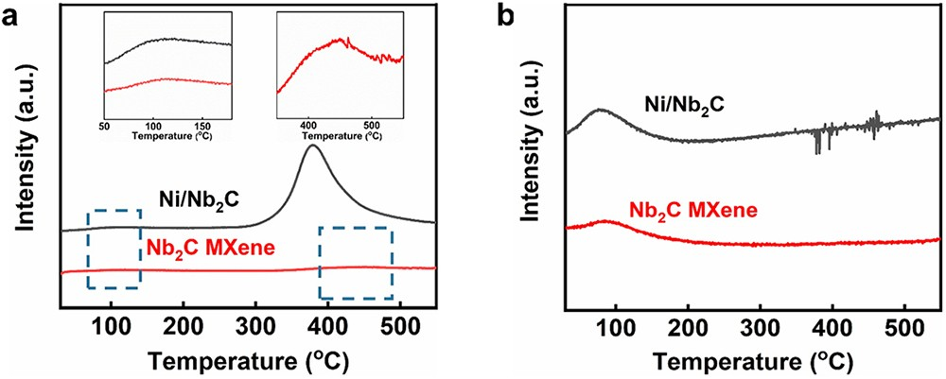
Figure 3. (a) H₂-TPD and (b) CO₂-TPD proﬁles of Nb₂C MXene and Ni/Nb₂C catalysts. Insets are enlarged regions showing the weak peaks.

nanoparticles on Nb₂C nanosheets without damaging the few-
layer structure (Figure 2b). The average size of Ni nano-

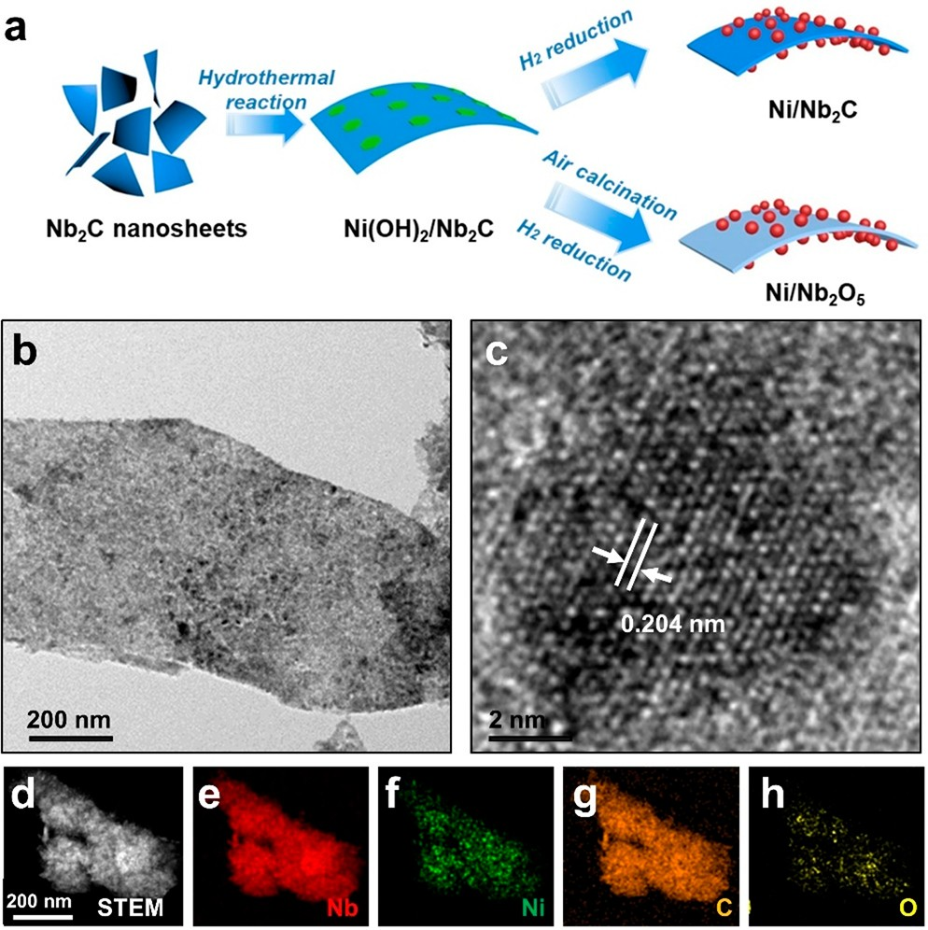

Figure 2. (a) Schematic illustration of the preparation processes of Ni/Nb₂C and Ni/Nb₂O₅ catalysts. (b) TEM, (c) HRTEM, and (d− h) elemental mapping images of Ni/Nb₂C.

weak peaks at ∼120 °C, corresponding to physically absorbed H₂, were observed in the H₂-TPD curves of both samples. In contrast, Ni/Nb₂C exhibited a signiﬁcantly stronger peak of H₂ chemisorption at ∼400 °C than that of Nb₂C. The CO₂-TPD curves of both samples only exhibited a peak at ∼100 °C corresponding to physically absorbed CO₂, and no obvious
peaks of CO₂ chemisorption were observed (Figure 3b).⁶⁴ These results suggest the introduction of Ni nanoparticles can greatly enhance the H₂ activation ability and thus accelerate CO₂ hydrogenation reactions, because the formation of Ni−H is crucial for the subsequent CO₂ reduction.⁶⁵

To demonstrate the advantages of the strongly light absorptive Nb₂C support, a control sample of Nb₂O₅- nanosheet-supported Ni nanoparticles, denoted as Ni/Nb₂O₅, was also prepared by slightly modifying the preparation conditions (Figure 2a). TEM and EDS elemental mapping studies revealed the good dispersity of Ni nanoparticles with the average size of 9.1 ± 2.4 nm on the Nb₂O₅ nanosheets (Figures S9 and S10). The ICP-MS measurement revealed the loading of Ni was 6.9 wt % in Ni/Nb₂O₅. These results reveal that the as-obtained Ni/Nb₂O₅ sample exhibited a similar structure and Ni particle size as Ni/Nb₂C (Table 1).
We then compared the photothermal catalytic performance of Ni/Nb₂C and Ni/Nb₂O₅ in the batch reactor under the same conditions as described above. CO and CH₄ were detected as the major products for both samples. Ni/Nb₂C exhibited an R_{CO2} of 87 mmol·g ⁻¹·h⁻¹ normalized by the
cat

Table 1. Properties and Photothermal Catalytic Performance of Ni/Nb₂C and Ni/Nb₂O₅

sample | loading amount of Niª (wt %) | size of Ni^{b} (nm) | RCO2c (mmol·gcat−1·h−1) | CH₄ rate (mmol·g_{cat}⁻¹·h⁻¹) | CH₄ selectivity (%)
Ni/Nb₂C | 6.0 | 9.0 | 87.0 | 72.5 | 83.4
Ni/Nb₂O₅ | 6.9 | 9.1 | 15.9 | 12.9 | 80.9
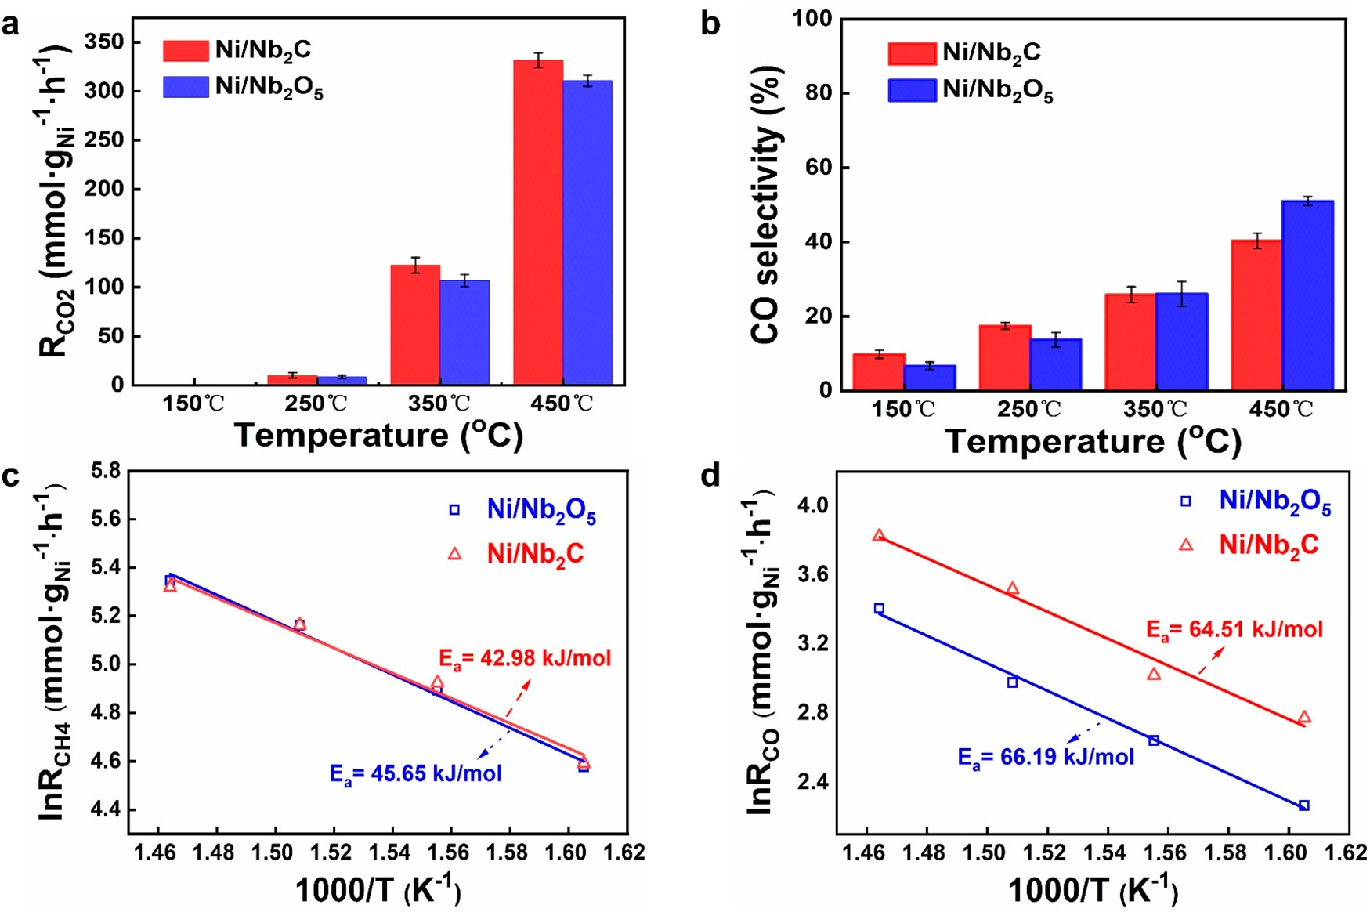
ªDetermined by ICP-MS. ^{b}Obtained by measuring 100 Ni nanoparticles from TEM images. ^{c}CO₂ conversion rate in the batch reactor under 15- sun illumination for 20 min.

Figure 4. (a,b) Thermal catalytic performance of Ni/Nb₂C (in blue) and Ni/Nb₂O₅ (in red) at diﬀerent temperatures. (c,d) Pseudo- Arrhenius plots drawn from temperature-dependent measurements of CH₄ and CO rates between 350 and 410 °C. The apparent activation energies for RWGS and methanation reactions were shown in the plots.

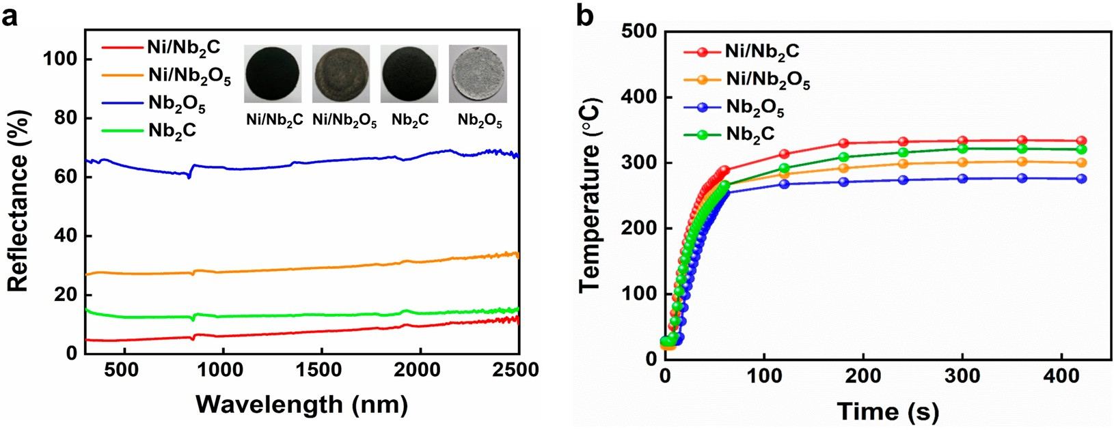
Figure 5. (a) Diﬀuse reﬂectance spectra of Ni/Nb₂C and Ni/Nb₂O₅. The inset shows digital photographs of two catalyst ﬁlms on boron silicate glass ﬁlters. (b) Surface temperature proﬁles of Nb₂C, Nb₂O₅, Ni/Nb₂C, and Ni/Nb₂O₅ under 15-sun illumination.

mass of the composite, an increase by 3 orders of magnitude from pure Nb₂C. Since catalytic activity was mainly contributed by Ni nanoparticles, R_{CO2} was also normalized by the mass of Ni for better comparisons with the control sample and results from the literature. R_{CO2} was found to be
1.45 and 0.23 mol·g_{Ni}⁻¹·h⁻¹ with a similar selectivity of

products for Ni/Nb₂C and Ni/Nb₂O₅, respectively (Table 1).
D

The use of carbon-13-labeled carbon dioxide (¹³CO₂) as an isotope tracer molecule conﬁrmed that both CH₄ and CO products originated from CO₂ (Figure S11).
As shown above, the activity of Ni/Nb₂C in photothermal

catalytic CO₂ hydrogenation is 6.3 times as high as that of the Ni/Nb₂O₅ sample with a similar structure and Ni particle size under the same testing conditions. We then looked into the
https://dx.doi.org/10.1021/acsnano.1c00990

origin of the enhanced photothermal catalytic activity for Ni/ Nb₂C. First, the intrinsic thermocatalytic activity of two catalysts was investigated in a ﬂow reactor at atmospheric pressure under dark conditions. The ﬂow rates were 2 mL/min for CO₂, 2 mL/min for H₂, and 6 mL/min for N₂. As shown in Figure 4a,b, both catalysts produced CH₄ and CO with very similar activity (R_{CO2}) and selectivity at the temperature range of 150 to 450 °C. The CO selectivity increased with the temperature for both samples, which can be attributed to the endothermic nature of the reverse water−gas shift reaction
(RWGS, CO₂ + H₂ ⇋ CO + H₂O, ΔH₍₂₉₈ _{K)} = 41.8 kJ·mol⁻¹)

as well as the rapid desorption of CO at high temperatures to inhibit further hydrogenation to produce CH₄ (Figure S12).⁶⁶⁻⁶⁸ Under the same conditions, no products were detected within the limit of the gas chromatography without the use of catalysts, conﬁrming the activation of H₂ and CO₂ by Ni catalysts. Futhermore, Ni/Nb₂C and Ni/Nb₂O₅ exhibited almost identical apparent activation energies for both RWGS and methanation reactions (Figure 4c,d). These results suggested that the intrinsic CO₂ and H₂ activation ability is not the major factor in determining the performance diﬀerence between Ni/Nb₂C and Ni/Nb₂O₅ in photothermal
catalysis.

Besides intrinsic CO₂ and H₂ activation ability, the photothermal eﬀect or the local temperature of catalysts under illuminations plays an important role in aﬀecting their photothermal catalytic performance.^{21,69} As discussed above, Nb₂C is an excellent photothermal conversion material and could enable the conversion of more photons into phonons. Compared with the Nb₂O₅ counterpart with the light gray color, the black color Nb₂C nanosheets can absorb sunlight more strongly (Figure 5a). As a result, Ni/Nb₂C exhibits stronger light absorption ability than Ni/Nb₂O₅ throughout the entire solar spectrum (Figure 5a). Figure 5b depicts the surface temperature proﬁles of Nb₂C, Nb₂O₅, Ni/Nb₂C, and Ni/Nb₂O₅ under 15-sun illumination recorded by a directly contacting thermocouple. Upon illumination, the surface temperatures of two catalysts increased rapidly and reached plateaus within 2 min. The stabilized surface temperature (T_{sur}) of Nb₂C nanosheets was found to be 321 °C, 47 °C higher than that of Nb₂O₅. This is consistent with the better photothermal eﬀect of Nb₂C. After Ni particles were loaded, T_{sur} increased for both supports but more obviously for Nb₂O₅. The surface temperature of Ni/Nb₂C was found to be 330 °C,
353 °C for Ni/Nb₂O₅, which is more than 49 °C lower than that of Ni/Nb₂C (Figure S14). These results further conﬁrm the advantage of Nb₂C nanosheets as the support to enhance the light absorption of Ni nanoparticles and thus increase the local temperature under photothermal catalytic conditions.

To further demonstrate the great potential of Nb₂C- supported Ni nanoparticles, the photothermal catalytic performance was investigated under diﬀerent light intensities (Figure 6). The activity of Ni/Nb₂C was improved with the

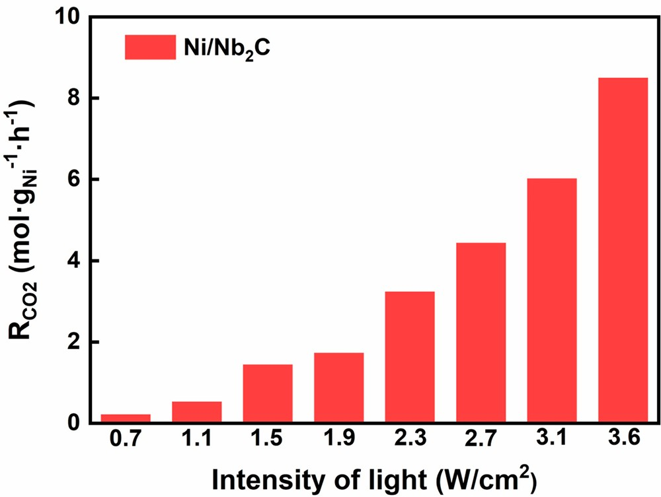
Figure 6. Photothermal catalytic activity of Ni/Nb₂C under diﬀerent illumination conditions. Testing conditions: CO₂/H₂ = 1:1, initial reactor pressure = 100 kPa, illumination time = 30 min.

increase of the light intensity. Notably, a record CO₂ conversion rate of 8.50 mol·g_{Ni}⁻¹·h⁻¹ was reached under 36- sun simulated sunlight without external heating, which outperformed reported Ni-based photothermal catalysts (Table S1).
While the use of Nb₂C can enhance the performance of metal catalysts in photothermal CO₂ hydrogenation, it is also necessary to investigate the stability of Ni nanoparticles on the Nb₂C support under catalytic conditions. The stability of Ni/ Nb₂C was ﬁrst studied in 10 consecutive cycles of photo- thermal catalytic testing (20 min for each cycle) under the illumination of light with the intensity of 15 suns in the batch reactor (Figure 7a). The CO₂ conversion rate remained above
Ni

which was 34 °C higher than that of Ni/Nb₂O₅. Notably,
1.4 mol·g ⁻¹·h⁻¹ with constant selectivity during the entire 10

Nb₂C nanosheets even exhibited a higher T_{sur} than Ni/Nb₂O₅, strongly revealing the superior photothermal eﬀect of MXene materials. Although these surface temperatures measured by the thermocouple were lower than the local temperatures of Ni nanoparticles, these results provide direct evidence for the important role of Nb₂C supports in improving the photo- thermal eﬀect of Ni nanoparticles.
To further demonstrate the advantage of the Nb₂C support, the photothermal catalytic activity of Ni/Nb₂C and Ni/Nb₂O₅ was also measured in the ﬂow reactor under 15-sun illumination without applying external heating. R_{CO2} was

cycles. The TEM image of the tested sample suggested that the few-layer structure was well-preserved with a very slight increase of the Ni particle size to 11.5 nm (Figure S15). The long-term stability of the sample was further tested in the ﬂow reactor. Speciﬁcally, the Ni/Nb₂C catalyst was tested at 400 °C continuously for 10 h under dark conditions. After a drop of activity by 15% during the ﬁrst 6 h, the CO₂ conversion rate stabilized at 143 mmol·g_{Ni}⁻¹·h⁻¹ with a nearly constant CO selectivity of 95% during the following 4 h (Figure 7b). These tests in both photothermal and thermal catalysis cleary reveal that the Nb₂C MXene support could eﬀectively stabilize Ni

found to be 0.15 mol·g ⁻¹·h⁻¹ for Ni/Nb C and 0.091 mol·

nanoparticles, which might be traced to the reactive metal−

gNi
−1·h−1
Ni

for Ni/Nb₂O₅ in the
2

ﬂow system. To reach the same
support interaction (RMSI).⁷⁰

CO₂ conversion degree of Ni/Nb₂C under photothermal conditions, it requires the heating of the reactor to nearly 400
°C under dark conditions (Figure S13). In our study, this temperature is deﬁned as the equivalent working temperature, T_{e}, of photothermal catalysts.¹¹ In contrast, T_{e} was found to be

To investigate the potential application of other MXene materials, Ti₃C₂ related catalysts were synthesized through a similar preparation method, and their catalytic performance in CO₂ hydrogenation was also investigated (Figures S16−S18). It was found that Ti₃C₂ itself is not an eﬀective single-
E https://dx.doi.org/10.1021/acsnano.1c00990

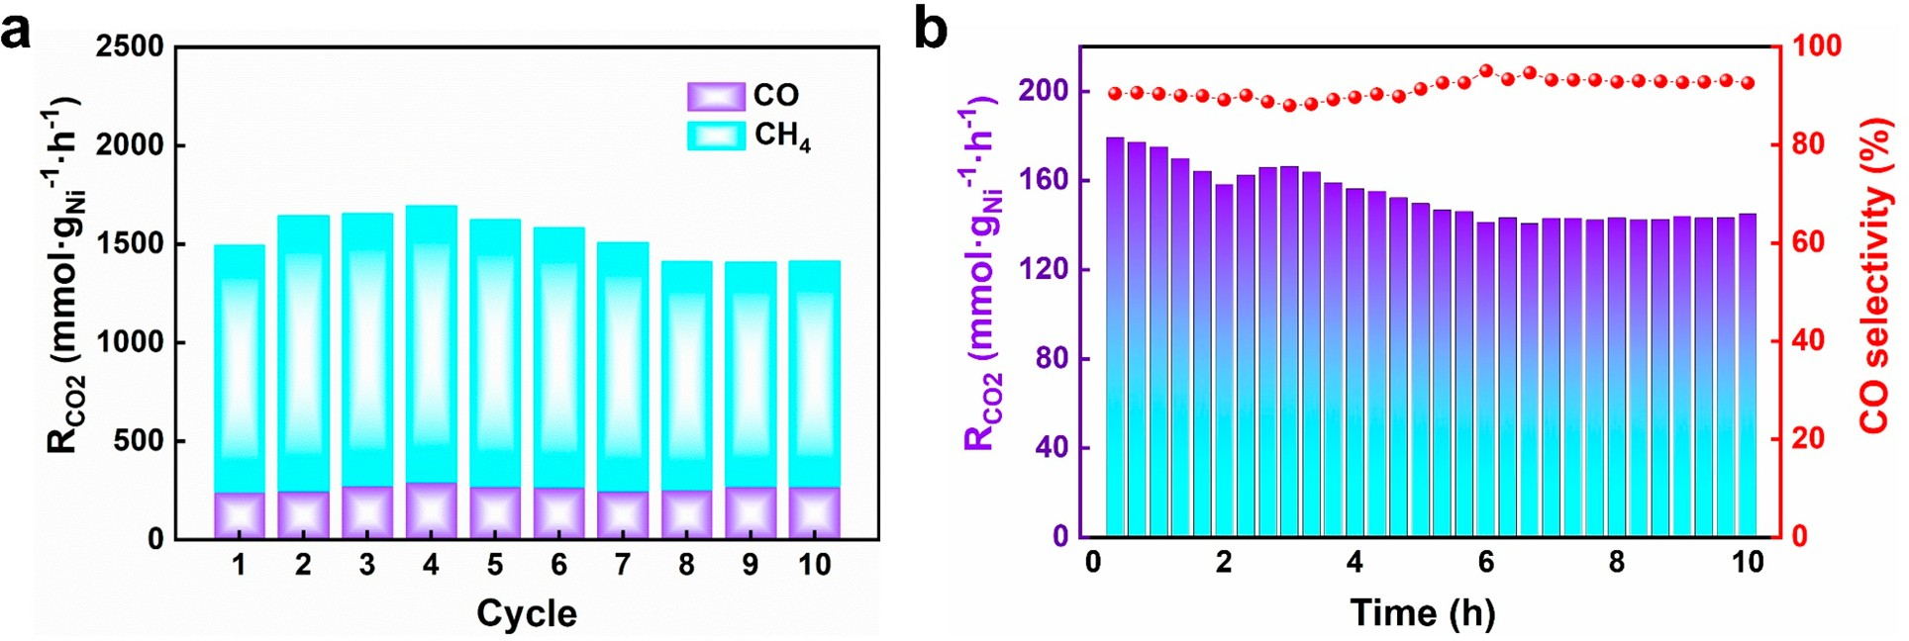

Figure 7. (a) CO and CH₄ production rates of Ni/Nb₂C in catalyzing hydrogenation of CO₂ under 15-sun illumination during 10 cycles of 20 min testing in the batch reactor. (b) Thermocatalytic performance of Ni/Nb₂C in catalyzing hydrogenation of CO₂ at 400 °C under dark conditions for a continuous 10-h test in the ﬂow reactor.

component CO₂ hydrogenation catalyst but could serve as an excellent support for metal-nanoparticle-based photothermal catalysts (Figure S19). After Ni nanoparticles were loaded, the Ni/Ti₃C₂ composite could enable the photothermal con-
purchased from Sigma-Aldrich. Ethanol was purchased from Sinopharm Chemical Reagent Co., Ltd. Milli-Q water (Millipore,
18.2 MΩ cm⁻¹ at 25 °C) was used in all the experiments.
Preparation of Nb₂C and Ti₃C₂ MXene Nanosheets. Few-layer

version of CO₂ with a high rate of 702.4 mmol·g_{Ni}⁻¹·h⁻¹, a
Nb₂C nanosheets were synthesized through a modiﬁed two-step
exfoliation method. In a typical synthesis, 1 g of Nb₂AlC powders was

nearly 2-fold increase from that of TiO₂-supported Ni nanoparticles with a similar structure, Ni size, loading amount, and intrinsic thermocatalytic activity (Table S2). Speciﬁcally, owing to the advantage of Ti₃C₂ nanosheets as the support materials, the Ni/Ti₃C₂ exhibited a better light absorption capacity and thus increased the surface temperature under photothermal catalytic conditions (Figures S20 and S21). These results further demonstrate the great potential of MXene materials as excellent photothermal supports in photothermal CO₂ catalysis.

CONCLUSION

In summary, we have demonstrated the use of two MXene materials as superior photothermal supports for Ni nano- particles to enhance the photothermal eﬀect and thus the performance in photothermal CO₂ catalysis. Notably, a record CO₂ conversion rate of 8.50 mol·g_{Ni}⁻¹·h⁻¹ was reached for Nb₂C-supported Ni nanoparticles under 36-sun illumination without external heating. Future work will be focused on the exploration of more MXene materials as photothermal supports and the investigation of the photothermal catalytic mechanism of MXene-supported metal nanoparticles. Our
study bridges the gap between MXene materials with excellent photothermal properties and photothermal CO₂ catalysis to develop a subﬁeld of MXene-based photothermal CO₂ conversions. This work will also stimulate the interest in MXene-supported metal nanoparticles for more heterogeneous catalytic reactions, particularly driven by sunlight.

METHODS
Materials. All chemicals were used as received without further puriﬁcation. Niobium aluminum carbide powder (Nb₂AlC, purity:
>90%, particle size: 200 mesh) and titanium aluminum carbide (Ti₃AlC₂, purity: 98%, particle size: 200 mesh) were purchased from
Forsman Scientiﬁc Co., Ltd. Hydroﬂuoric acid (HF, 49 wt % in H₂O), ammonium hydroxide solution (NH₃·H₂O, 28 wt %), and
dissolved in 15 mL of hydroﬂuoric acid aqueous solution (49 wt %) under magnetic stirring for 90 h at room temperature. After the HF treatment, the residual solids were collected by centrifugation and washed several times with water until the pH of the supernatant reached ∼7 to remove residual HF. The cleaned sample was then dispersed in 10 mL of TMAH a.q. (50 wt %) under vigorous stirring for 50 h at room temperature. The products were collected by centrifugation, washed with water and ethanol for several times, and ﬁnally dried in an vacuum oven. The synthesis process was used to prepare few-layer Ti₃C₂ nanosheets with Ti₃AlC₂ as the precursor
with a slight modiﬁcation. Speciﬁcally, 1 g of Ti₃AlC₂ powders was dissolved in 15 mL of hydroﬂuoric acid aqueous solution (49 wt %) under magnetic stirring for 2 h at room temperature. After the etching process, the solids were collected by centrifugation and washed with DI water until the pH of the supernatant reached ∼7 to remove residual HF. Then, the multilayer Ti₃C₂ MXene was then dispersed in 10 mL of TMAH a.q. (50 wt %) under vigorous stirring for another
10 h at room temperature. The products were collected by centrifugation, washed with water and ethanol for several times, and ﬁnally dried in an vacuum oven.
Preparation of Ni/Nb₂C, Ni/Nb₂O₅, Ni/Ti₃C₂, and Ni/TiO₂ Catalysts. In a typical synthesis of Ni/Nb₂C, 0.2326 g of Ni(NO₃)₂·6H₂O, 0.4 g of PVP, and 251 mg of Nb₂C nanosheets were mixed in 40 mL of water under magnetic stirring for 10 min. A 240 μL aliquot of NH₃·H₂O (28 wt %) was then injected into the reaction under magnetic stirring for 30 min. The mixed solution was sealed into a Teﬂon-lined autoclave and heated at 150 °C for 24 h. After cooling down to room temperature, the black precipitates of Ni(OH)₂/Nb₂C were collected by centrifugation, washed with water and ethanol for several times, and dried in an vacuum oven. Finally, the dried powders were reduced at 300 °C for 3 h under H₂ atmosphere to obtain the Ni/Nb₂C product. The preparation of Ni/Nb₂O₅ followed the same process as Ni/Nb₂C except for an additional calcination of Ni(OH)₂/Nb₂C at 500 °C for 2 h before H₂ reduction. The praparation processes of Ni/Ti₃C₂ and Ni/TiO₂ catalysts were similar to those of Ni/Nb₂C and Ni/Nb₂O₅, respectively, with few-layer Ti₃C₂ nanosheets as supports.
Characterizations. Transmission electron microscopy (TEM) images were obtained with an FEI-Tecnai F20 (200 kV) transmission

tetramethylammonium hydroxide pentahydrate (C₄H₁₃NO·5H₂O, TMAH, 97%) were purchased from Aladdin, Shanghai yuanye Bio- Technology Co., Ltd. and Macklin, respectively. Ni(NO₃)₂·6H₂O (>97%) and polyvinylpyrrolidone (PVP, M_{n} = 360 000) were
F
electron microscope. X-ray diﬀraction (XRD) was measured on an Empyrean diﬀractometer with Cu Kα radiation. Scanning electron microscopy (SEM) images were acquired on a Zeiss Supra 55 instrument (from Carl Zeiss, Germany). The Ni contents of diﬀerent

https://dx.doi.org/10.1021/acsnano.1c00990

samples were measured by an inductively coupled plasma source mass spectrometer (ICP-MS) (Aurora M90, Jenoptik). Diﬀuse reﬂectance spectra of diﬀerent samples were recorded with a Lambda 950 UV/ visible/near-infrared spectrometer from PerkinElmer and an integrat- ing sphere with a diameter of 150 mm. The zeta potential was measured on a MALVERN ZEN3690 system. AFM analysis of samples was performed with an Asylum Research Cypher scanning probe microscope under ambient conditions.
Photocatalytic Measurements. The gas-phase photothermal hydrogenation of CO₂ experiments was carried out in a batch reactor (Labsolar 6A, Perfectlight) with internal gas circulation. A 300 W Xe arc lamp was used as the irradiation source to illuminate the catalyst without any ﬁlter. The catalyst powders (∼15 mg) were dispersed in ethanol under sonication. The suspension was transferred into a glass ﬁber ﬁlter with the area of 5.52 cm² through the drop-casting method, followed by drying the catalyst ﬁlm in a vacuum oven. After the catalyst ﬁlm was loaded, the reactor was degassed and purged with a mixture of CO₂ and H₂ (1:1) two times. The reactor was sealed when the pressure reached 1 bar, and light was turned on to initiate the photocatalytic reaction. After a certain amount of time, the
concentration of diﬀerent gases was analyzed with a thermal conductivity detector (TCD) and a ﬂame ionization detector (FID) with a convertor installed in a gas chromatograph (GC7900, Techcomp).
The response factor of gas reactants and products was calibrated using standard curve methods. The CO₂ conversion rate (R_{CO2}), seen as characteristic of the photothermal catalytic activity, was deﬁned as the sum of the CO formation rate (F_{CO}) and CH₄ formation rate (F_{CH4}) owing to the mere detection of CO and CH₄ in the products. F_{CO} and F_{CH4} are deﬁned as
Temperature-Programmed Desorption (TPD) Experiment. The TPD experiment was performed on an automatic chemical adsorption instrument (FINETEC/FINE-SORB-3010). For H₂- and CO₂-TPD, ∼20 mg of sample was ﬁxed in a U-shape quartz tube and ﬂushed with Ar (40 mL/min) for 10 min, followed by heating to 300
°C (10 °C/min) for 60 min and then cooling to room temperature in the same Ar ﬂow. Afterward, the sample was exposed to the adsorbate (e.g., H₂ and CO₂) with a ﬂow rate of 80 mL/min for 20 min at 25 °C and then ﬂushed with Ar ﬂow (40 mL/min) for 10 min. Finally, the sample was heated to 600 °C (10 °C/min) in the Ar ﬂow (40 mL/ min). The temperature and current for TCD were 60 °C and 90 mA, respectively. For CO-TPD, ∼10 mg of sample was put in a U-shaped quartz tube and ﬂushed for 20 min with He (40 mL/min). Afterward, CO was introduced into the U-shaped quartz tube for 10 min for adsorption, followed by ﬂushing with He (40 mL/min) for 10 min to remove the physical adsorption. Finally, the sample was heated to 700
°C at a rate of 10 °C/min in He ﬂow (40 mL/min). The desorbed CO was measured by a TCD. The temperature and current of the TCD were 60 °C and 90 mA, respectively.

ASSOCIATED CONTENT
*sı Supporting Information
The Supporting Information is available free of charge at https://pubs.acs.org/doi/10.1021/acsnano.1c00990.
Experimental sections of catalysts; materials and syn- thesis methods; structural characterization of MXene materials and MXene-based catalysts; conﬁguration of tested catalyst reactors; CO₂ and H₂ TPD proﬁles of

FCO
= n(CO)
m(cat)*ω(Ni)*t

MXene and MXene-based catalysts; photothermal and thermal catalytic testing of MXene and MXene-based catalysts (PDF)

FCH4 = n(CH₄)
*ω *
m(cat) (Ni) t
RCO2 = FCO + FCH4
The selectivity of CO is deﬁned as
S(CO) = F(CO)
F(CO) + F(CH4)
where n is the yield of products (mol), ω(Ni) is the loading percent of Ni, m(cat) is the mass of the catalyst (g), and t is the irradiation time illuminated by the 300 W Xe arc lamp (h).
Isotope tracing experiments were performed using ¹³CO₂ (99.9 atomic % Sigma-Aldrich) in a custom fabricated 1.5 mL stainless steel batch reactor with a fused silica view port sealed with Viton O-rings. The reactors were evacuated prior to being injected with ¹³CO₂ followed by H₂. The partial pressure was ∼14 psi for both CO₂ and H₂. Isotope product gases were measured using an Agilent 7890A gas chromatographic mass spectrometer (GC-MS) with a 60-mGS- Carbon plot column fed to the mass spectrometer.
Thermocatalytic Measurements. Thermocatalytic CO₂ hydro- genation experiments were performed in the ﬂow reactor as shown in Figure S5. The ﬂow reactor system comprised the ﬂow controllers, reactor, and online testing system. The reactor was equipped with a circular quartz window (r = 2.75 cm) to allow illumination from the top. The tempreature of the reactor was controlled by a homemade heating setup, and the thermocouple was placed under the catalyst ﬁlm. The ﬂow rates of feeding gases were ﬁxed at 2 mL/min for CO₂, 2 mL/min for H₂, and 6 mL/min for N₂. The pressure of the reactor was monitored by a digital pressure gauge from ANCN Smart Instrument Inc. The amounts of gas reactants and products were analyzed online by a gas chromatograph (Agilent 7890B) equipped with a TCD and FID with a convertor. N₂ in the ﬂow was used as the inner standard. The response factor of gas reactants and products was calibrated using the same standard curve method for photothermal catalysis.

AUTHOR INFORMATION
Corresponding Authors
Chaoran Li − Institute of Functional Nano & Soft Materials (FUNSOM), Jiangsu Key Laboratory for Carbon-Based Functional Materials & Devices, Soochow University, Suzhou 215123, PR China; orcid.org/0000-0001-9517-8431;
Email: crli@suda.edu.cn
Geoﬀrey A. Ozin − Materials Chemistry and Nanochemistry Research Group, Solar Fuels Cluster, Departments of Chemistry, University of Toronto, Toronto, Ontario M5S 3H6, Canada; orcid.org/0000-0002-6315-0925;

Email: gozin@chem.utoronto.ca
Xiaohong Zhang − Institute of Functional Nano & Soft Materials (FUNSOM), Jiangsu Key Laboratory for Carbon- Based Functional Materials & Devices, Soochow University, Suzhou 215123, PR China; orcid.org/0000-0002-6732- 2499; Email: xiaohong_zhang@suda.edu.cn
Le He − Institute of Functional Nano & Soft Materials (FUNSOM), Jiangsu Key Laboratory for Carbon-Based
Functional Materials & Devices, Soochow University, Suzhou 215123, PR China; orcid.org/0000-0002-4520-0482;

Email: lehe@suda.edu.cn
Authors
Zhiyi Wu − Institute of Functional Nano & Soft Materials (FUNSOM), Jiangsu Key Laboratory for Carbon-Based Functional Materials & Devices, Soochow University, Suzhou 215123, PR China
Zhao Li − Materials Chemistry and Nanochemistry Research Group, Solar Fuels Cluster, Departments of Chemistry, University of Toronto, Toronto, Ontario M5S 3H6, Canada

- https://dx.doi.org/10.1021/acsnano.1c00990

Kai Feng − Institute of Functional Nano & Soft Materials (FUNSOM), Jiangsu Key Laboratory for Carbon-Based Functional Materials & Devices, Soochow University, Suzhou 215123, PR China
Mujin Cai − Institute of Functional Nano & Soft Materials (FUNSOM), Jiangsu Key Laboratory for Carbon-Based Functional Materials & Devices, Soochow University, Suzhou
215123, PR China
Dake Zhang − Institute of Functional Nano & Soft Materials (FUNSOM), Jiangsu Key Laboratory for Carbon-Based Functional Materials & Devices, Soochow University, Suzhou 215123, PR China
Shenghua Wang − Institute of Functional Nano & Soft Materials (FUNSOM), Jiangsu Key Laboratory for Carbon- Based Functional Materials & Devices, Soochow University,
Suzhou 215123, PR China
Mingyu Chu − Institute of Functional Nano & Soft Materials (FUNSOM), Jiangsu Key Laboratory for Carbon-Based Functional Materials & Devices, Soochow University, Suzhou 215123, PR China
Chengcheng Zhang − Institute of Functional Nano & Soft Materials (FUNSOM), Jiangsu Key Laboratory for Carbon-
Based Functional Materials & Devices, Soochow University, Suzhou 215123, PR China
Jiahui Shen − Institute of Functional Nano & Soft Materials (FUNSOM), Jiangsu Key Laboratory for Carbon-Based Functional Materials & Devices, Soochow University, Suzhou
215123, PR China
Zheng Huang − Institute of Functional Nano & Soft Materials (FUNSOM), Jiangsu Key Laboratory for Carbon-Based Functional Materials & Devices, Soochow University, Suzhou 215123, PR China
Yanling Xiao − Institute of Functional Nano & Soft Materials (FUNSOM), Jiangsu Key Laboratory for Carbon-Based Functional Materials & Devices, Soochow University, Suzhou
215123, PR China
Complete contact information is available at: https://pubs.acs.org/10.1021/acsnano.1c00990

Author Contributions

The manuscript was written through contributions of all authors. All authors have given approval to the ﬁnal version of the manuscript.
Notes
The authors declare no competing ﬁnancial interest.

ACKNOWLEDGMENTS

We acknowledge the support from the National Natural Science Foundation of China (51920105005, 51802208,
21902113, 51821002, 91833303), the Natural Science Foundation of Jiangsu Province (BK2020101), the 111 project, the Collaborative Innovation Centre of Suzhou Nano Science & Technology, and the Priority Academic Program Develop- ment of Jiangsu Higher Education Institutions (PAPD).
G.A.O. is grateful to the Natural Sciences and Engineering Council of Canada for support of this work.

REFERENCES
- Ghoussoub, M.; Xia, M.; Duchesne, P. N.; Segal, D.; Ozin, G. Principles of Photothermal Gas-Phase Heterogeneous CO₂ Catalysis. Energy Environ. Sci. 2019, 12, 1122−1142.
- Meng, X.; Liu, L.; Ouyang, S.; Xu, H.; Wang, D.; Zhao, N.; Ye, J. Nanometals for Solar-to-Chemical Energy Conversion: From Semi- conductor-Based Photocatalysis to Plasmon-Mediated Photocatalysis and Photo-Thermocatalysis. Adv. Mater. 2016, 28, 6781−6803.
- Qian, C.; Sun, W.; Hung, D. L. H.; Qiu, C.; Makaremi, M.; Hari
Kumar, S. G.; Wan, L.; Ghoussoub, M.; Wood, T. E.; Xia, M.;
Tountas, A. A.; Li, Y. F.; Wang, L.; Dong, Y.; Gourevich, I.; Singh, C. V.; Ozin, G. A. Catalytic CO₂ Reduction by Palladium-Decorated Silicon-Hydride Nanosheets. Nat. Catal. 2019, 2, 46−54.
- Wan, L.; Zhou, Q.; Wang, X.; Wood, T. E.; Wang, L.; Duchesne,
P. N.; Guo, J.; Yan, X.; Xia, M.; Li, Y. F.; Jelle, A. A.; Ulmer, U.; Jia, J.; Li, T.; Sun, W.; Ozin, G. A. Cu₂O Nanocubes with Mixed Oxidation- State Facets for (Photo)catalytic Hydrogenation of Carbon Dioxide. Nat. Catal. 2019, 2, 889−898.
- Zhao, L.; Qi, Y.; Song, L.; Ning, S.; Ouyang, S.; Xu, H.; Ye, J.
Solar-Driven Water-Gas Shift Reaction over CuO_{x}/Al₂O₃ with 1.1% of Light-to-Energy Storage. Angew. Chem., Int. Ed. 2019, 58, 7708− 7712.
- Qi, Y.; Song, L.; Ouyang, S.; Liang, X.; Ning, S.; Zhang, Q.; Ye, J. Photoinduced Defect Engineering: Enhanced Photothermal Catalytic Performance of 2D Black In₂O_{3‑x} Nanosheets with Bifunctional Oxygen Vacancies. Adv. Mater. 2020, 32, 1903915.
- Wang, J.; Li, Y.; Deng, L.; Wei, N.; Weng, Y.; Dong, S.; Qi, D.; Qiu, J.; Chen, X.; Wu, T. High-Performance Photothermal Conversion of Narrow-Bandgap Ti₂O₃ Nanoparticles. Adv. Mater. 2017, 29, 1603730.
- Zhou, L.; Tan, Y.; Wang, J.; Xu, W.; Yuan, Y.; Cai, W.; Zhu, S.; Zhu, J. 3D Self-Assembly of Aluminium Nanoparticles for Plasmon- Enhanced Solar Desalination. Nat. Photonics 2016, 10, 393−398.
- Meng, X.; Wang, T.; Liu, L.; Ouyang, S.; Li, P.; Hu, H.; Kako,
T.; Iwai, H.; Tanaka, A.; Ye, J. Photothermal Conversion of CO₂ into CH₄ with H₂ over Group VIII Nanocatalysts: An Alternative Approach for Solar Fuel Production. Angew. Chem., Int. Ed. 2014, 53, 11478−11482.
- Chen, G.; Gao, R.; Zhao, Y.; Li, Z.; Waterhouse, G. I. N.; Shi,
R.; Zhao, J.; Zhang, M.; Shang, L.; Sheng, G.; Zhang, X.; Wen, X.; Wu, L. Z.; Tung, C. H.; Zhang, T. Alumina-Supported CoFe Alloy Catalysts Derived from Layered-Double-Hydroxide Nanosheets for Efficient Photothermal CO₂ Hydrogenation to Hydrocarbons. Adv. Mater. 2018, 30, 1704663.
- Li, Z.; Liu, J.; Zhao, Y.; Waterhouse, G. I. N.; Chen, G.; Shi, R.; Zhang, X.; Liu, X.; Wei, Y.; Wen, X. D.; Wu, L. Z.; Tung, C. H.; Zhang, T. Co-Based Catalysts Derived from Layered-Double- Hydroxide Nanosheets for the Photothermal Production of Light Olefins. Adv. Mater. 2018, 30, 1800527.
- Wang, L.; Dong, Y.; Yan, T.; Hu, Z.; Jelle, A. A.; Meira, D. M.; Duchesne, P. N.; Loh, J. Y. Y.; Qiu, C.; Storey, E. E.; Xu, Y.; Sun, W.; Ghoussoub, M.; Kherani, N. P.; Helmy, A. S.; Ozin, G. A. Black Indium Oxide a Photothermal CO₂ Hydrogenation Catalyst. Nat. Commun. 2020, 11, 2432.
- Li, Y.; Hao, J.; Song, H.; Zhang, F.; Bai, X.; Meng, X.; Zhang, H.; Wang, S.; Hu, Y.; Ye, J. Selective Light Absorber-Assisted Single Nickel Atom Catalysts for Ambient Sunlight-Driven CO₂ Methana- tion. Nat. Commun. 2019, 10, 2359.
- Kong, T.; Low, J.; Xiong, Y. Catalyst: How Material Chemistry Enables Solar-Driven CO₂ Conversion. Chem. 2020, 6, 1035−1038.
- Wu, S.; Li, Y.; Zhang, Q.; Jiang, Z.; Yang, Y.; Wu, J.; Zhao, X.
High Light-to-Fuel Efficiency and CO₂ Reduction Rates Achieved on a Unique Nanocomposite of Co/Co Doped Al₂O₃ Nanosheets with UV-vis-IR Irradiation. Energy Environ. Sci. 2019, 12, 2581−2590.
- Yu, F.; Wang, C.; Li, Y.; Ma, H.; Wang, R.; Liu, Y.; Suzuki, N.;
Terashima, C.; Ohtani, B.; Ochiai, T.; Fujishima, A.; Zhang, X. Enhanced Solar Photothermal Catalysis over Solution Plasma Activated TiO₂. Adv. Sci. 2020, 7, 2000204.
- Kong, N.; Han, B.; Li, Z.; Fang, Y.; Feng, K.; Wu, Z.; Wang, S.; Xu, A.-B.; Yu, Y.; Li, C.; Lin, Z.; He, L. Ruthenium Nanoparticles Supported on Mg(OH)₂ Microflowers as Catalysts for Photothermal Carbon Dioxide Hydrogenation. ACS Appl. Nano Mater. 2020, 3, 3028−3033.

- https://dx.doi.org/10.1021/acsnano.1c00990

- Chen, G.; Waterhouse, G. I. N.; Shi, R.; Zhao, J.; Li, Z.; Wu, L.; Tung, C.-H.; Zhang, T. From Solar Energy to Fuels: Recent Advances in Light-Driven C1 Chemistry. Angew. Chem., Int. Ed. 2019, 58, 17528−17551.
- Wang, Z. J.; Song, H.; Liu, H.; Ye, J. Coupling of Solar Energy
and Thermal Energy for Carbon Dioxide Reduction: Status and Prospects. Angew. Chem., Int. Ed. 2020, 59, 8016−8035.
- Jia, J.; Qian, C.; Dong, Y.; Li, Y. F.; Wang, H.; Ghoussoub, M.;
Butler, K. T.; Walsh, A.; Ozin, G. A. Heterogeneous Catalytic Hydrogenation of CO₂ by Metal Oxides: Defect Engineering- Perfecting Imperfection. Chem. Soc. Rev. 2017, 46, 4631−4644.
- Feng, K.; Wang, S.; Zhang, D.; Wang, L.; Yu, Y.; Feng, K.; Li,
Z.; Zhu, Z.; Li, C.; Cai, M.; Wu, Z.; Kong, N.; Yan, B.; Zhong, J.;
Zhang, X.; Ozin, G. A.; He, L. Cobalt Plasmonic Superstructures Enable Almost 100% Broadband Photon Efficient CO₂ Photocatalysis. Adv. Mater. 2020, 32, 2000014.
- Zhang, D.; Lv, K.; Li, C.; Fang, Y.; Wang, S.; Chen, Z.; Wu, Z.; Guan, W.; Lou, D.; Sun, W.; Yang, D.; He, L.; Zhang, X. All-Earth- Abundant Photothermal Silicon Platform for CO₂ Catalysis with Nearly 100% Sunlight Harvesting Ability. Solar RRL 2021, 5, 2000387.
- Fang, Y.; Lv, K.; Li, Z.; Kong, N.; Wang, S.; Xu, A. B.; Wu, Z.; Jiang, F.; Li, C.; Ozin, G. A.; He, L. Solution−Liquid−Solid Growth and Catalytic Applications of Silica Nanorod Arrays. Adv. Sci. 2020, 7, 2000310.
- O’Brien, P. G.; Sandhel, A.; Wood, T. E.; Jelle, A. A.; Hoch, L. B.; Perovic, D. D.; Mims, C. A.; Ozin, G. A. Photomethanation of Gaseous CO₂ over Ru/Silicon Nanowire Catalysts with Visible and Near-Infrared Photons. Adv. Sci. 2014, 1, 1400001.
- Hoch, L. B.; O’Brien, P. G.; Jelle, A.; Sandhel, A.; Perovic, D. D.; Mims, C. A.; Ozin, G. A. Nanostructured Indium Oxide Coated Silicon Nanowire Arrays: A Hybrid Photothermal/Photochemical Approach to Solar Fuels. ACS Nano 2016, 10, 9017−9025.
- O’Brien, P. G.; Ghuman, K. K.; Jelle, A. A.; Sandhel, A.; Wood,
T. E.; Loh, J. Y. Y.; Jia, J.; Perovic, D.; Singh, C. V.; Kherani, N. P.; Mims, C. A.; Ozin, G. A. Enhanced Photothermal Reduction of Gaseous CO₂ over Silicon Photonic Crystal Supported Ruthenium at Ambient Temperature. Energy Environ. Sci. 2018, 11, 3443−3451.
- Jelle, A. A.; Ghuman, K. K.; O’Brien, P. G.; Hmadeh, M.;
Sandhel, A.; Perovic, D. D.; Singh, C. V.; Mims, C. A.; Ozin, G. A. Highly Efficient Ambient Temperature CO₂ Photomethanation Catalyzed by Nanostructured RuO₂ on Silicon Photonic Crystal Support. Adv. Energy Mater. 2018, 8, 1702277.
- Ghidiu, M.; Lukatskaya, M. R.; Zhao, M. Q.; Gogotsi, Y.; Barsoum, M. W. Conductive Two-Dimensional Titanium Carbide ’Clay’ with High Volumetric Capacitance. Nature 2014, 516, 78−81.
- Xia, Y.; Mathis, T. S.; Zhao, M. Q.; Anasori, B.; Dang, A.; Zhou,
Z.; Cho, H.; Gogotsi, Y.; Yang, S. Thickness-Independent Capacitance of Vertically Aligned Liquid-Crystalline MXenes. Nature 2018, 557, 409−412.
- Anasori, B.; Lukatskaya, M. R.; Gogotsi, Y. 2D Metal Carbides
and Nitrides (MXenes) for Energy Storage. Nat. Rev. Mater. 2017, 2, 16098.
- Lukatskaya, M. R.; Mashtalir, O.; Ren, C. E.; Dall’Agnese, Y.; Rozier, P.; Taberna, P. L.; Naguib, M.; Simon, P.; Barsoum, M. W.; Gogotsi, Y. Cation Intercalation and High Volumetric Capacitance of Two-Dimensional Titanium Carbide. Science 2013, 341, 1502−1505.
- Shahzad, F.; Alhabeb, M.; Hatter, C. B.; Anasori, B.; Man
Hong, S.; Koo, C. M.; Gogotsi, Y. Electromagnetic Interference Shielding with 2D Transition Metal Carbides (MXenes). Science 2016, 353, 1137−1140.
- Agresti, A.; Pazniak, A.; Pescetelli, S.; Di Vito, A.; Rossi, D.;
Pecchia, A.; Auf der Maur, M.; Liedl, A.; Larciprete, R.; Kuznetsov, D. V.; Saranin, D.; Di Carlo, A. Titanium-Carbide MXenes for Work Function and Interface Engineering in Perovskite Solar Cells. Nat. Mater. 2019, 18, 1228−1234.
- Pomerantseva, E.; Bonaccorso, F.; Feng, X.; Cui, Y.; Gogotsi, Y.
Energy Storage: The Future Enabled by Nanomaterials. Science 2019,
366, No. eaan8285.
- Li, Y.; Shao, H.; Lin, Z.; Lu, J.; Liu, L.; Duployer, B.; Persson, P.
O. A.; Eklund, P.; Hultman, L.; Li, M.; Chen, K.; Zha, X. H.; Du, S.; Rozier, P.; Chai, Z.; Raymundo-Pinero, E.; Taberna, P. L.; Simon, P.; Huang, Q. A General Lewis Acidic Etching Route for Preparing MXenes with Enhanced Electrochemical Performance in Non- Aqueous Electrolyte. Nat. Mater. 2020, 19, 894−899.
- Guo, Z.; Zhou, J.; Zhu, L.; Sun, Z. MXene: A Promising Photocatalyst for Water Splitting. J. Mater. Chem. A 2016, 4, 11446− 11452.
- Ran, J.; Gao, G.; Li, F. T.; Ma, T. Y.; Du, A.; Qiao, S. Z. Ti₃C₂ MXene Co-Catalyst on Metal Sulfide Photo-Absorbers for Enhanced Visible-Light Photocatalytic Hydrogen Production. Nat. Commun. 2017, 8, 13907.
- Shao, M.; Shao, Y.; Chai, J.; Qu, Y.; Yang, M.; Wang, Z.; Yang, M.; Ip, W. F.; Kwok, C. T.; Shi, X.; Lu, Z.; Wang, S.; Wang, X.; Pan,
H. Synergistic Effect of 2D Ti₂C and g-C₃N₄ for Efficient Photocatalytic Hydrogen Production. J. Mater. Chem. A 2017, 5, 16748−16756.
- Gao, G.; O’Mullane, A. P.; Du, A. 2D MXenes: A New Family
of Promising Catalysts for the Hydrogen Evolution Reaction. ACS Catal. 2017, 7, 494−500.
- Li, N.; Chen, X.; Ong, W. J.; MacFarlane, D. R.; Zhao, X.;
Cheetham, A. K.; Sun, C. Understanding of Electrochemical Mechanisms for CO₂ Capture and Conversion into Hydrocarbon Fuels in Transition-Metal Carbides (MXenes). ACS Nano 2017, 11, 10825−10833.
- Xiu, L.; Wang, Z.; Yu, M.; Wu, X.; Qiu, J. Aggregation-Resistant
3D MXene-Based Architecture as Efficient Bifunctional Electro- catalyst for Overall Water Splitting. ACS Nano 2018, 12, 8017−8028.
- Zhang, J.; Zhao, Y.; Guo, X.; Chen, C.; Dong, C.; Liu, R.; Han,
C.-P.; Li, Y.; Gogotsi, Y.; Wang, G. Single Platinum Atoms Immobilized on an MXene as an Efficient Catalyst for the Hydrogen Evolution Reaction. Nat. Catal. 2018, 1, 985−992.
- Luo, Y.; Chen, G.-F.; Ding, L.; Chen, X.; Ding, L.-X.; Wang, H.
Efficient Electrocatalytic N₂ Fixation with MXene under Ambient Conditions. Joule 2019, 3, 279−289.
- Kuznetsov, D. A.; Chen, Z.; Kumar, P. V.; Tsoukalou, A.;
Kierzkowska, A.; Abdala, P. M.; Safonova, O. V.; Fedorov, A.; Muller,
C. R. Single Site Cobalt Substitution in 2D Molybdenum Carbide (MXene) Enhances Catalytic Activity in the Hydrogen Evolution Reaction. J. Am. Chem. Soc. 2019, 141, 17809−17816.
- Xu, D.; Li, Z.; Li, L.; Wang, J. Insights into the Photothermal
Conversion of 2D MXene Nanomaterials: Synthesis, Mechanism, and Applications. Adv. Funct. Mater. 2020, 30, 2000712.
- Lin, H.; Wang, X.; Yu, L.; Chen, Y.; Shi, J. Two-Dimensional Ultrathin MXene Ceramic Nanosheets for Photothermal Conversion. Nano Lett. 2017, 17, 384−391.
- Xuan, J.; Wang, Z.; Chen, Y.; Liang, D.; Cheng, L.; Yang, X.;
Liu, Z.; Ma, R.; Sasaki, T.; Geng, F. Organic-Base-Driven Intercalation and Delamination for the Production of Functionalized Titanium Carbide Nanosheets with Superior Photothermal Therapeutic Performance. Angew. Chem., Int. Ed. 2016, 55, 14569−14574.
- Fan, X.; Ding, Y.; Liu, Y.; Liang, J.; Chen, Y. Plasmonic Ti₃C₂T_{x}
MXene Enables Highly Efficient Photothermal Conversion for Healable and Transparent Wearable Device. ACS Nano 2019, 13, 8124−8134.
- Cao, W.; Feng, W.; Jiang, Y.; Ma, C.; Zhou, Z.; Ma, M.; Chen,
Y.; Chen, F. Two-Dimensional MXene-Reinforced Robust Surface Superhydrophobicity with Self-Cleaning and Photothermal-Actuating Binary Effects. Mater. Horiz. 2019, 6, 1057−1065.
- Li, R.; Zhang, L.; Shi, L.; Wang, P. MXene Ti₃C₂: An Effective 2D Light-to-Heat Conversion Material. ACS Nano 2017, 11, 3752− 3759.
- Wang, Y.; Zhou, L.; Luo, X.; Zhang, Y.; Sun, J.; Ning, X. A.; Yuan, Y. Solar Photothermal Electrodes for Highly Efficient Microbial Energy Harvesting at Low Ambient Temperatures. ChemSusChem 2018, 11, 4071−4076.
- Dai, C.; Lin, H.; Xu, G.; Liu, Z.; Wu, R.; Chen, Y.
Biocompatible 2D Titanium Carbide (MXenes) Composite Nano-

  - https://dx.doi.org/10.1021/acsnano.1c00990

sheets for pH-Responsive MRI-Guided Tumor Hyperthermia. Chem. Mater. 2017, 29, 8637−8652.
- Pang, J.; Mendes, R. G.; Bachmatiuk, A.; Zhao, L.; Ta, H. Q.;
Gemming, T.; Liu, H.; Liu, Z.; Rummeli, M. H. Applications of 2D MXenes in Energy Conversion and Storage Systems. Chem. Soc. Rev. 2019, 48, 72−133.
- Cortes, E.; Besteiro, L. V.; Alabastri, A.; Baldi, A.; Tagliabue,
G.; Demetriadou, A.; Narang, P. Challenges in Plasmonic Catalysis.
ACS Nano 2020, 14, 16202−16209.
- Mateo, D.; Cerrillo, J. L.; Durini, S.; Gascon, J. Fundamentals
and Applications of Photo-Thermal Catalysis. Chem. Soc. Rev. 2021,
50, 2173−2210.
- Zhan, C.; Chen, X.-J.; Yi, J.; Li, J.-F.; Wu, D.-Y.; Tian, Z.-Q.
From Plasmon-Enhanced Molecular Spectroscopy to Plasmon- Mediated Chemical Reactions. Nat. Rev. Chem. 2018, 2, 216−230.
- Song, C.; Liu, X.; Xu, M.; Masi, D.; Wang, Y.; Deng, Y.; Zhang,
M.; Qin, X.; Feng, K.; Yan, J.; Leng, J.; Wang, Z.; Xu, Y.; Yan, B.; Jin, S.; Xu, D.; Yin, Z.; Xiao, D.; Ma, D. Photothermal Conversion of CO₂ with Tunable Selectivity Using Fe-Based Catalysts: From Oxide to Carbide. ACS Catal. 2020, 10, 10364−10374.
- Gao, W.; Gao, R.; Zhao, Y.; Peng, M.; Song, C.; Li, M.; Li, S.;
Liu, J.; Li, W.; Deng, Y.; Zhang, M.; Xie, J.; Hu, G.; Zhang, Z.; Long, R.; Wen, X.-D.; Ma, D. Photo-Driven Syngas Conversion to Lower
- Cai, M.; Li, C.; He, L. Enhancing Photothermal CO₂ Catalysis by Thermal Insulating Substrates. Rare Met. 2020, 39, 881−886.
- Li, Z.; Cui, Y.; Wu, Z.; Milligan, C.; Zhou, L.; Mitchell, G.; Xu, B.; Shi, E.; Miller, J. T.; Ribeiro, F. H.; Wu, Y. Reactive Metal− Support Interactions at Moderate Temperature in Two-Dimensional Niobium-Carbide-Supported Platinum Catalysts. Nat. Catal. 2018, 1, 349−355.

Olefins over 2917−2928.
Oxygen-Decorated
Fe₅C₂ Catalyst. Chem. 2018, 4,

- Zhang, X.; Zhang, M.; Deng, Y.; Xu, M.; Artiglia, L.; Wen, W.;
Gao, R.; Chen, B.; Yao, S.; Zhang, X.; Peng, M.; Yan, J.; Li, A.; Jiang,
Z.; Gao, X.; Cao, S.; Yang, C.; Kropf, A. J.; Shi, J.; Xie, J.; et al. A Stable Low-Temperature H₂-Production Catalyst by Crowding Pt on Alpha-MoC. Nature 2021, 589, 396−401.
- Lin, H.; Gao, S.; Dai, C.; Chen, Y.; Shi, J. A Two-Dimensional
Biodegradable Niobium Carbide (MXene) for Photothermal Tumor Eradication in NIR-I and NIR-II Biowindows. J. Am. Chem. Soc. 2017, 139, 16235−16247.
- Cao, S. W.; Shen, B. J.; Tong, T.; Fu, J. W.; Yu, J. G. 2D/2D
Heterojunction of Ultrathin MXene/Bi₂WO₆ Nanosheets for Improved Photocatalytic CO₂ Reduction. Adv. Funct. Mater. 2018, 28, 1800136.
- He, L.; Wood, T. E.; Wu, B.; Dong, Y.; Hoch, L. B.; Reyes, L. M.; Wang, D.; Kübel, C.; Qian, C.; Jia, J.; Liao, K.; O’Brien, P. G.; Sandhel, A.; Loh, J. Y. Y.; Szymanski, P.; Kherani, N. P.; Sum, T. C.; Mims, C. A.; Ozin, G. A. Spatial Separation of Charge Carriers in In₂O_{3−x}(OH)_{y} Nanocrystal Superstructures for Enhanced Gas-Phase Photocatalytic Activity. ACS Nano 2016, 10, 5578−5586.
- Wang, L.; Ghoussoub, M.; Wang, H.; Shao, Y.; Sun, W.;
Tountas, A. A.; Wood, T. E.; Li, H.; Loh, J. Y. Y.; Dong, Y.; Xia, M.;
Li, Y.; Wang, S.; Jia, J.; Qiu, C.; Qian, C.; Kherani, N. P.; He, L.; Zhang, X.; Ozin, G. A. Photocatalytic Hydrogenation of Carbon Dioxide with High Selectivity to Methanol at Atmospheric Pressure. Joule 2018, 2, 1369−1381.
- Yu, X. F.; Li, Y. C.; Cheng, J. B.; Liu, Z. B.; Li, Q. Z.; Li, W. Z.;
Yang, X.; Xiao, B. Monolayer Ti₂CO₂: A Promising Candidate for NH₃ Sensor or Capturer with High Sensitivity and Selectivity. ACS Appl. Mater. Interfaces 2015, 7, 13707−13713.
- Sastre, F.; Puga, A. V.; Liu, L.; Corma, A.; Garcia, H. Complete
Photocatalytic Reduction of CO₂ to Methane by H₂ under Solar Light Irradiation. J. Am. Chem. Soc. 2014, 136, 6798−6801.
- Kang, Q.; Wang, T.; Li, P.; Liu, L.; Chang, K.; Li, M.; Ye, J.
Photocatalytic Reduction of Carbon Dioxide by Hydrous Hydrazine over Au-Cu Alloy Nanoparticles Supported on SrTiO₃/TiO₂ Coaxial Nanotube Arrays. Angew. Chem., Int. Ed. 2015, 54, 841−845.
- Lee, S.; Jeong, S.; Kim, W. D.; Lee, S.; Lee, K.; Bae, W. K.;
Moon, J. H.; Lee, S.; Lee, D. C. Low-Coordinated Surface Atoms of CuPt Alloy Cocatalysts on TiO₂ for Enhanced Photocatalytic Conversion of CO₂. Nanoscale 2016, 8, 10043−10048.
- Dong, C.; Lian, C.; Hu, S.; Deng, Z.; Gong, J.; Li, M.; Liu, H.;
Xing, M.; Zhang, J. Size-Dependent Activity and Selectivity of Carbon Dioxide Photocatalytic Reduction over Platinum Nanoparticles. Nat. Commun. 2018, 9, 1252.

  - https://dx.doi.org/10.1021/acsnano.1c00990

