

Hydrogen storage in incompletely etched multilayer Ti₂CT_{x} at room temperature
Shiyuan Liu 1, Jieyuan Liu 1, Xiaofang Liu1, Jiaxiang Shang1, Li Xu2, Ronghai Yu1 and Jianglan Shui 1 ✉

Hydrogen storage materials are the key to hydrogen energy utilization. However, current materials can hardly meet the storage capacity and/or operability requirements of practical applications. Here we report an advancement in hydrogen storage per- formance and related mechanism based on a hydrofluoric acid incompletely etched MXene, namely, a multilayered Ti₂CT_{x} (T is a functional group) stack that shows an unprecedented hydrogen uptake of 8.8 wt% at room temperature and 60 bar H₂. Even under completely ambient conditions (25 °C, 1 bar air), Ti₂CT_{x} is still able to retain ~4 wt% hydrogen. The hydrogen storage is stable and reversible in the material, and the hydrogen release is controllable by pressure and temperature below 95 °C. The storage mechanism is deduced to be a nanopump-effect-assisted weak chemisorption in the sub-nanoscale interlayer space of the material. Such a storage approach provides a promising strategy for designing practical hydrogen storage materials.

ydrogen storage is a key link in the hydrogen economy and of great importance to fuel cell vehicles (FCVs)1–3. Current FCVs use compressed hydrogen in vessels, which have limi-
H


tations on the volumetric and gravimetric storage densities as well as safety4. Solid-state hydrogen storage material is a promising solu- tion to resolve these problems. For onboard applications, the hydro- gen storage material should satisfy comprehensive requirements: high gravimetric and volumetric capacities, high storage stability and cycling stability, fast kinetics, near-ambient operating condi- tions, high safety and low cost5–8. Until now, a variety of solid-state hydrogen storage materials have been developed, which can be clas- sified into two types based on the different storage mechanisms, depending on the interaction between the host and H₂. Some porous materials with a high specific surface area can capture hydrogen mol- ecules through physical adsorption; further, they can have consider- able capacities, excellent kinetics and better cycling performance. However, due to the weak adsorption, it is necessary to operate them at an extremely low temperature (for example, −200 °C) and high pressure9. Metal hydrides are more practical materials that cap- ture hydrogen through chemical bonds. A well-known material is LaNi₅, which can store/release hydrogen under ambient conditions due to its appropriate chemical adsorption strength to hydrogen, but it has a fairly low storage capacity (less than 2 wt%). Although it is sufficient for nickel–metal hydride batteries, LaNi₅ cannot meet the requirements of FCVs10,11. Lightweight metal hydrides, such as Mg-based materials, have the advantage of high hydrogen storage capacity12,13. However, excessively strong chemical bonds result in the difficulty of releasing hydrogen, typically requiring high tem- peratures of 300–400 °C to overcome the thermodynamic energy barriers. High-temperature operation necessitates thermal manage- ment costs and complicates the hydrogen storage system14–16.

The development of high-capacity hydrogen storage materials under ambient conditions is a long-term goal in the field of hydro- gen storage. Obviously, a moderate interaction with hydrogen is a prerequisite for practical hydrogen storage materials. In 1987,
G. J. Kubas17 reported that H₂ could be reversibly added to tran- sition metal complexes at room temperature by weak chemisorp- tion. Recently, Antonelli et al. demonstrated a Kubas-type material,
namely, manganese hydride molecular sieve, which could uptake

10.5 wt% H₂ under 120 bar H₂ at room temperature17,18; it could potentially reach the US Department of Energy (DOE) targets even after taking the system into account19. However, unlike conventional metal hydrides, the hydrogen adsorption–desorption of Kubas-type materials is similar to physical adsorption, showing a linear depen- dence on H₂ pressure. In other words, the system must maintain a high H₂ pressure to store hydrogen in the material. To make more practical hydrogen storage materials, breakthroughs are still needed in the storage mechanism and material system.
MXene is a type of two-dimensional transition metal carbide/ nitride derived from the etched MAX phase20. Here we demon- strate highly reversible hydrogen storage in multilayered Ti₂CT_{x} (T is a functional group) stacks, which were prepared by incomplete hydrofluoric acid (HF) etching. Such Ti₂C sheets are decorated with abundant fluorine (−F) groups and have a narrow interlayer dis- tance of ~7 Å, thereby creating nanopump-effect-assisted weak che- misorption towards hydrogen. The as-prepared Ti₂CT_{x} can uptake over 8.8 wt% hydrogen under a relatively safe pressure of 60 bar. Compared with the known room-temperature hydrogen storage materials, Ti₂CT_{x} shows the superiority of low-pressure hydrogen storage, which is almost double of the previously reported highest storage capacity under the same pressure. Even under completely ambient conditions (25 °C and 1 bar air), Ti₂CT_{x} can still retain 4 wt% hydrogen. In addition, the dehydrogenation is fast and con- trollable by the degree of vacuum and at a temperature below 95 °C.

Preparation and structure of Ti₂CT_{x} and its hydrogen storage An optimized Ti₂CT_{x} stack was prepared by etching Ti₂AlC in a 12% HF solution for 8 h. The experimental section details the material preparation process. The inset in Fig. 1a shows the multilayer struc- ture of Ti₂CT_{x} after removing most of the interlayer Al atoms from the Ti₂AlC precursor. The high-angular annular dark-field scan- ning transmission electron microscopy (HAADF-STEM) image shows the atomic images of two adjacent Ti₂C sheets (Fig. 1a,b and Supplementary Fig. 1). A further observation reveals that the Ti₂C sheets are not exactly parallel but exhibit a bell-mouth shape with gradually increasing interlayer distance from 6.8 Å to 9.0 Å. In the








ARTICLES
https://doi.org/10.1038/s41565-020-00818-8

1School of Materials Science and Engineering, Beihang University, Beijing, China. 2State Grid Smart Grid Research Institute, Future Science and Technology City, Beijing, China. ✉e-mail: shuijianglan@buaa.edu.cn

- c d e

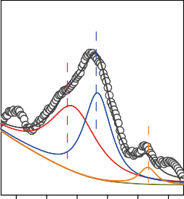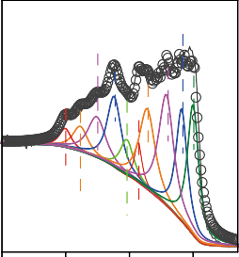
Intensity (a.u.)
Intensity (a.u.)
Intensity (a.u.)
*

29–95 Ti₂AlC
*
2 x
Ti CT
6.8 Å
MXene AlTi * AlF₃

8.7 Å
Al2p
Al–OH
Al–F
Al–Ti
Ti(II)
Ti2p
Ti(III)
Ti–C
Ti–F
Ti–O
C–Ti–F

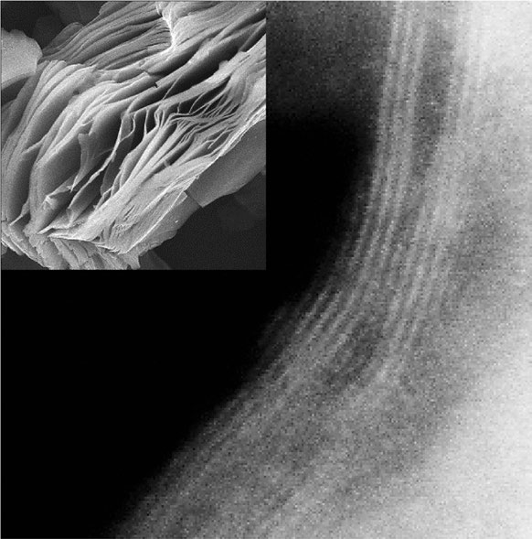10 20 30 40 50 60
ii
1 µm
i
Al atom
Ti atom
C atom
2 nm
2& (°)
80 78 76 74 72 70
Binding energy (eV)
470 465 460 455
Binding energy (eV)

f Incompletely etched Ti2CTX

Hydrogen absorption

- 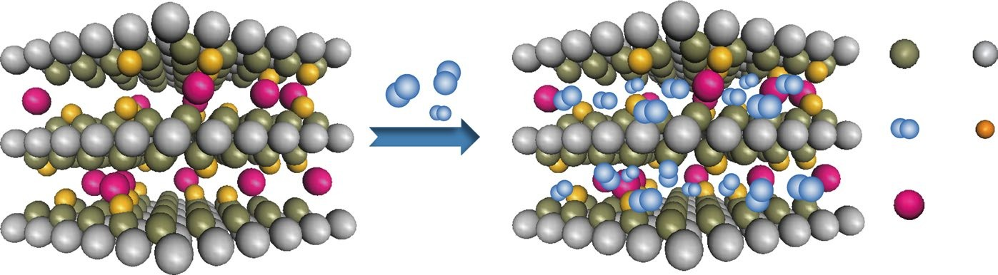C
Ti

H2
H2 gas
Al

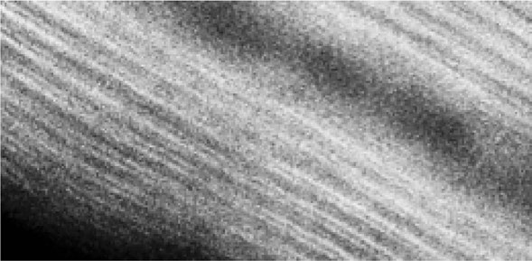F
8.98 Å
6.79 Å

7.70 Å
2 nm
6.8 Å
6.8 Å

Fig. 1 | Structural characterization of Ti₂CT_{x}. a, HAADF-STEM image of two adjacent Ti₂CT_{x} nanosheets, showing the residual Al atoms due to incomplete etching (region i) and a bell-mouth morphology (region ii). Inset: scanning electron microscopy image of the Ti₂CT_{x} stack. b, HAADF-STEM image of multilayered Ti₂CT_{x}. c, XRD patterns of Ti₂CT_{x} with the reference of Ti₂AlC. 29–95 is the powder diffraction file number of Ti₂AlC. d,e, XPS spectra of elemental Al (d) and Ti (e) in Ti₂CT_{x}. f, Schematic of the hydrogen storage process in the narrow interlayer space of Ti₂CT_{x}.

vicinity of the region with residual Al atoms (marked as ‘i’ in Fig. 1a), the interlayer distance is narrow and close to the original value of
6.8 Å; however, interlayer expansion occurs in the remote region marked as ‘ii’ due to the removal of Al and the insertion of functional groups. This structural characteristic is confirmed by X-ray diffrac- tion (XRD), as shown in Fig. 1c, which reveals a split (002) peak at around 2θ = 10–13°, where θ is the grazing angle, correspond- ing to an interlayer distance of 8.7–6.8 Å. The bell-mouth structure provides a fast channel for H₂ to travel in and out of the stack. For HF-etched Ti₂CT_{x}, −F is the major termination on the surface of the Ti₂C nanosheets with a small number of hydroxyl (–OH) and oxygen (–O) groups21. The X-ray photoelectron spectroscopy (XPS) data of the bulk Ti₂CT_{x} shows that the residual Al—essential for maintain- ing an optimal interlayer distance—is approximately 2.64 at% and bonded with Ti, F and OH (Fig. 1d and Supplementary Table 1). The Ti2p (Fig. 1e) and F1s (Supplementary Fig. 3a) spectra prove that Ti atoms are mainly connected with F terminations22,23. Figure 1f shows a schematic of hydrogen storage in Ti₂CT_{x}, where the key factors are the narrow interlayer distance (6.8 Å) and the F func- tional groups, as proven later. Previous first-principles calculations based on a multilayer graphene structure reveal that a narrow space of 6–7 Å between the two nanosheets may create a nanopump effect to increase the H₂ pressure inside the interlayer space24,25. Similarly, the nanopump effect generated by two adjacent Ti₂C nanosheets can draw H₂ into the Ti₂CT_{x} stack. It should be mentioned that Ti₂CT_{x} has a large surface area (theoretically about 230 m2 g−1) to adsorb hydrogen, although the measured Brunauer–Emmett–Teller surface areas are only 3.3 and 10.5 m2 g−1, respectively, based on N₂ and CO₂ isotherms. It is because N₂ or CO₂ could not enter the nar- row interlayer space for effective measurements (Supplementary Fig. 4 provides the explanation)26,27. This property guarantees that the adsorbed H₂ is not replaced by other gases (such as O₂, N₂, H₂O or CO₂) present in the Earth’s atmosphere.
From the perspectives of safety, cost and convenience, practical hydrogen storage materials are expected to uptake/release hydrogen

at near room temperature and under a relatively safe pressure. As shown by the hydrogen adsorption isotherm curve measured at room temperature (Fig. 2a), Ti₂CT_{x} uptakes 4.2, 5.7 and 8.8 wt% H₂ at 20, 40 and 60 bar, respectively. Compared with other room-temperature hydrogen storage materials, such as high-performance Kubas-type materials18,28 and typical metal hydrides29,30, Ti₂CT_{x} shows a notable advantage in storage capacity, almost double that of the previously reported highest performance. The pressure–composition–tem- perature curve of Ti₂CT_{x} (Supplementary Fig. 5) shows neither a platform nor an exact linear characteristic, indicating that Ti₂CT_{x} does not store hydrogen via typical chemisorption, physisorp- tion or Kubas-type interaction. A comparison with other types of hydrogen storage materials is provided in Supplementary Table
2. Figure 2b shows the initial several cycles collected at 25 °C and 50 bar. After one activation cycle, the hydrogen storage capacity of Ti₂CT_{x} was 8.14 and 7.24 wt% in the second and third cycles, respec- tively, which was then maintained at about 7.5 wt% for the follow- ing three cycles (Supplementary Fig. 6). With a Ti₂CT_{x} tap density of 1.285 g cm−3, the corresponding volumetric capacity is calculated to be 96.4 kg H₂ m−3. The gravimetric and volumetric H₂ storage capacities of Ti₂CT_{x} can, in principle, approach or even surpass the DOE system-level targets19, namely, 6.5 wt% and 40 kg H₂ m−3. During the dehydrogenation process, the hydrogenated Ti₂CT_{x} released 80–85% of the absorbed H₂ within several seconds and fully released the residual hydrogen within 10–20 min (Fig. 2b, inset) at 95 °C under 0.5–0.7 bar. A dehydrogenation temperature below 95 °C is feasible for FCVs, because the waste heat from the fuel cell engine can meet this heating requirement via a heat exchanger. The multilayer structure and the narrow interlayer distance of Ti₂CT_{x} are well maintained during the hydrogen absorption–desorp- tion cycle (Fig. 2c and Supplementary Fig. 7). A repeating cycling experiment on another batch of Ti₂CT_{x} is shown in Supplementary Fig. 8. A 20-cycle test shown in Supplementary Fig. 9 demonstrates that the hydrogen storage performance of Ti₂CT_{x} has good cyclabil- ity. The composition of Ti₂CT_{x} changes little after the 20-cycle test

- 10

8
Hydrogen content (wt%)

6

4

2
- 10

5
Hydrogen content (wt%)

0

–5

8.07 wt%
Abs.

0
–2
–4
–6
–8

Des.

8.14 wt%
Abs.

Des.

7.53 wt%
Abs.

Des.
16
Activation

8.07 wt%
Abs.

Des.

7.56 wt%
Abs.

Des.
26 28
Cooling

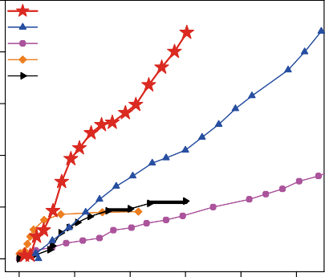0
This work Ref. 8
Ref. 20
Ref. 21
Ref. 22
Ti₂CT_{x}
Mn hydride
Cr(III) alkyl hydride Mn0.9Ca0.1Ni4.6Fe0.3Al0.1
TiFe0.86Mn0.1Y0.1−xCux
0 20 40 60 80 100
Pressure (bar)

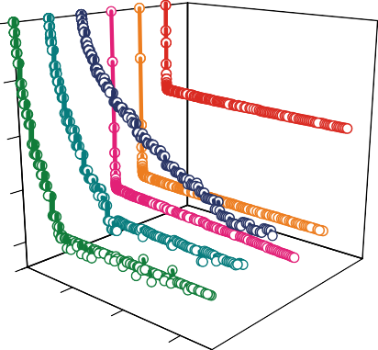
- d
(002)
desorption
First
First absorption
Ti₂CT_{x}
0

–2
Intensity (a.u.)
Hydrogen desorbed (wt%)

–4
–10
0
0 20 40 min
2 4

e

8 10 14
Time (h)

20 22

Heating

10 15 20
2& (°)
–6

–8
0
0.2

0.4

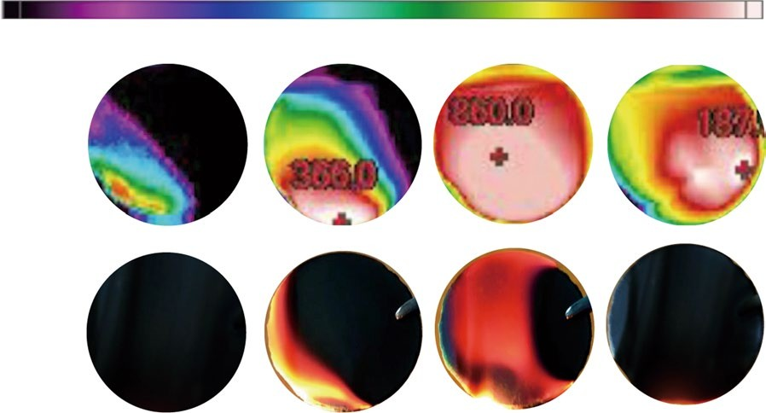0.6
Disc made from hydrogenated Ti₂CT_{x}
40 °C
Infrared image
860 °C
Visual image
2 cm
Fired
Burning
Burned out

Fig. 2 | Hydrogen storage performances of Ti₂CT_{x}. a, Comparison of hydrogen adsorption isotherm curves of Ti₂CT_{x} with some representative
room-temperature hydrogen storage materials, namely, Kubas-type materials and metal hydrides. b, Hydrogen absorption and desorption curves of Ti₂CT_{x} in the initial several cycles. Abs., absorption; Des., desorption. Inset: enlarged view of the desorption process. c, XRD patterns of pristine, hydrogenated and
dehydrogenated Ti₂CT_{x}. d, Hydrogen desorption curves under different temperatures (in a vacuum) and pressures (fixed at 95 °C). The plan view is shown in Supplementary Fig. 11. Ti₂CT_{x} is pre-stored with ~7.5 wt% reversible H₂. e, Infrared images and photographs of ignited hydrogenated Ti₂CT_{x} discs. The numbers in the images denote the detected temperatures of the hottest spots on the disc.

(determined by XPS; Supplementary Table 3), proving its good structural stability. In addition, the US DOE set a series of dor- mancy time targets for the hydrogen storage stability, that is, the minimum time until the first release from the initial usable capacity of 95% (ref. 19). Four hydrogenated Ti₂CT_{x} samples were subjected to stability tests for 1, 7, 10 and 14 days, and they lost 0.5%, 4.1%,
10.1% and 9.3% hydrogen, respectively (Supplementary Fig. 10), reaching the US DOE 2020 target.
Controllable hydrogen release is of great importance to the practical application of storage materials, especially for FCVs. The dehydrogenation rate of Ti₂CT_{x} can be switched between fast and slow modes by changing the H₂ pressure, for example, from 5 bar to 15 bar, as shown in Fig. 2d and Supplementary Fig. 11. Moreover, the amount of released H₂ can be controlled by adjusting the desorp- tion temperature, for example, 4.0 wt% H₂ at 75 °C and 7.5 wt% H₂ at 95 °C. Interestingly, after switching the environment from 50 bar H₂ to a completely ambient environment (1 bar air), the hydrogenated Ti₂CT_{x} was still able to retain about half the absorbed hydrogen (~4 wt%) as determined by a straightforward weighting measure- ment (Supplementary Fig. 12). A combustion experiment verified this ambient storage property (Fig. 2e). Supplementary Fig. 13 and Supplementary Videos 1–4 show the experimental setups and the combustion processes. The hydrogenated Ti₂CT_{x} disc was ignited by a candle flame. After removing the candle, the ‘burning’ lasted for a few seconds, and the combustion centre (denoted by a
temperature of 860 °C, that is, the limit of the thermometer) gradu- ally moved from the ignition point to a farther point. For compari- son, the dehydrogenated disc was difficult to ignite, and no flame was observed. (Supplementary Fig. 14). It is worth noting that the hydrogenated Ti₂CT_{x} disc with a high amount of hydrogen did not explode when it came into contact with fire. This is because the stored hydrogen cannot be completely released immediately when heated under ambient pressure. Meanwhile, the oxygen molecules with a large kinetic diameter (~3.5 Å) cannot easily enter the free interlayer of Ti₂CT_{x} (~3.5 Å; Supplementary Fig. 4) to react with the hydrogen31. The hydrogen storage capability of Ti₂CT_{x} has been confirmed by the above pressure–composition–temperature data and the weighting and combustion experiments, which reduce the possibility of the non-reproducibility of data that may occur in hydrogen storage studies32.

Key structural parameters for hydrogen storage in Ti₂CT_{x}
In the following comparative experiments, we further determine that the key structural parameters affecting the hydrogen storage in Ti₂CT_{x} are the narrow interlayer distance and the –F functional groups. Single-layer Ti₂CT_{x} nanosheets show almost no H₂ stor- age (Supplementary Fig. 16), which proves that the multilayered structure is essential for hydrogen storage. Moreover, by control- ling the etching degree, we synthesized two Ti₂CT_{x} and two Ti₃C₂T_{x}; they were termed as L-Ti₃C₂T_{x}, Ti₃C₂T_{x}, L-Ti₂CT_{x} and Ti₂CT_{x} with

a b 10
13.5 Å
L-Ti C T
3 2 x
9.9 Å
Ti C T
3 2 x
7.8 Å
L-Ti2CTx
6.8 Å
Ti2CTx

8
Absorbed hydrogen (wt%)
second cycle (Fig. 3c). The strong peak corresponding to the Ti–O/Ti–OH bonds in the Fourier transform infrared (FTIR) spectra (684/633 cm–1, marked by the dashed line) disappeared after the first hydrogenation/dehydrogenation cycle in Ti₂C(OH)_{x}

₆ (Fig. 3d). In contrast, the –F peak in Ti CT (around 608 cm–1)34
Ti2CT
Ti C T
L-Ti₂CT
3 2 x
L-Ti3C2Tx
8.43 wt%
3.04 wt%
1.25 wt%
0.44 wt%
Intensity (a.u.)
2 x
does not change. These results suggest that the –F functional
₄ groups are stable and responsible for the reversible H₂ storage in Ti₂CT_{x}, while the O-containing groups are mainly responsible for
₂ the irreversible capacity.

0 H₂ storage mechanism

c 10

5
Hydrogen content (wt%)
6 9 12 15 18
2& (°)
0 0.5 1.0 1.5
Time (h)

d
Ti2C(OH)x before Ti–OH Ti–O
Ti2C(OH)x after

Ti2CTx before

Ti2CTx after

Ti–F
The H₂ storage mechanism of Ti₂CT_{x} was deduced by the com- bination of density functional theory (DFT) calculation and experimental characterizations. The H₂ molecules are inserted into a calculated bilayer Ti₂C model with an interlayer distance of 6.8 Å (Fig. 4a(i) and Supplementary Fig. 22a). H₂ first spon- taneously dissociates into H atoms and occupies the hollow sites on Ti₂C (below the centre of three Ti atoms of the top sheet and above one Ti atom of the bottom sheet). The calculated H₂

0 adsorption energy (E
Abs.
Abs.
Des.
Heating

Cooling
Transmittance (%)
abs
) of the bonded H atom is −3.506 eV H–1,

–5

–10

0 1 2 3 7 8
Time (h)

2,000 1,500 1,000
Wavenumber (cm^{–1})

500
belonging to a typical chemisorption process35 (Supplementary Fig. 22b). Pinero et al. studied the interaction between hydrogen and the TiC(001) surface and revealed that H₂ molecules can be adsorbed over the Ti sites35. In our calculations, we found that after all the hollow sites are occupied, with the further insertion of H₂, the second type of hydrogen can be adsorbed on the rest of the Ti atoms and maintain the molecular structure. However,

Fig. 3 | Key structural factors determining hydrogen storage in Ti₂CT_{x}. a, XRD patterns of MXenes (Ti₂CT_{x} and Ti₃C₂T_{x}) with different interlayer distances. b, The corresponding hydrogen absorption curves. c, The two
initial hydrogen absorption kinetics curves of Ti C(OH) . Abs., absorption;
2 x
the orientations of the axes of the H₂ molecules change, and the H–H-bond length marginally increases from 0.750 Å to 0.796 Å (Fig. 4a(ii) and Supplementary Fig. 22c). The corresponding E_{abs} is near –0.133 eV H₂–1 (Fig. 4b and Supplementary Table 5), suggest-

Des., desorption. d
ing a weak chemical interaction between H₂ and the Ti₂C sheet36,37.

, FTIR spectra of Ti₂CT_{x} and Ti₂C(OH)_{x} before and after
This weak interaction alone is not strong enough for Ti CT to

the first hydrogenation/dehydrogenation cycle. The dashed lines indicate 2 x

the positions of the O-containing functional groups and the black line indicates the position of the –F functional group.

interlayer distances of 13.5, 9.9, 7.8 and 6.8 Å, respectively (Fig. 3a and Supplementary Fig. 17). The completely etched samples (L-Ti₂CT_{x} and L-Ti₃C₂T_{x}) have larger interlayer distances than their incompletely etched counterparts. Figure 3b shows that the H₂ stor- age capacity decreases with an increase in the interlayer distance. The incompletely etched Ti₂CT_{x} with the smallest interlayer dis- tance of about 6.8 Å possesses the highest hydrogen storage capacity of 8.43 wt%. Further, L-Ti₂CT_{x} with a larger interlayer distance of
7.8 Å shows a lower hydrogen uptake of 3.04 wt%. As the distance further increases, Ti₃C₂T_{x} (9.9 Å) and L-Ti₃C₂T_{x} (13.5 Å) adsorb only 1.25 and 0.44 wt% H₂, respectively. This demonstrates that the nanopump effect is sensitive to the interlayer distance of MXenes, and a narrow interlayer distance is essential for trapping hydrogen in the interlayer space.
For HF-etched Ti₂CT_{x}, –F is the main functional group with a small amount of O-containing groups23. To reveal the roles of the functional groups, we prepared Ti₂CT_{x} without –F- and/or O-containing groups for comparison. Ti₂C-800 was prepared by calcining Ti₂CT_{x} at 800 °C in an Ar atmosphere to reduce the func- tional groups while maintaining the narrow interlayer distance (Supplementary Figs. 18 and 19a)21,33. The low capacity of 0.82 wt% of Ti₂C-800 indicates that the functional groups are necessary for large hydrogen storage in Ti₂CT_{x} (Supplementary Fig. 19b). The
–F-free sample, Ti₂C(OH)_{x}, was prepared via an NaOH-assisted hydrothermal method (Supplementary Figs. 20 and 21; the ele- mental contents of Ti₂C(OH)_{x} are shown in Supplementary Table 4). Ti₂C(OH)_{x} adsorbed 7.97 wt% H₂ but released only 3.12 wt% in the first cycle and then adsorbed only 2.64 wt% H₂ in the
capture H₂ at room temperature. However, with the assistance of the nanopump effect, this weak chemisorption is sufficient for room-temperature hydrogen storage. This phenomenon is simi- lar to the hydrogen storage of Kubas materials, but the difference is that Kubas materials require high ambient H₂ pressure. As a comparison, H₂ molecules in another model with a larger inter- layer distance of 8.0 Å do not rotate and the E_{abs} is −0.068 eV H₂–1, belonging to physical adsorption (Fig. 4a(iii) and Supplementary Fig. 22d). The variation in the hydrogen adsorption strength with the interlayer distance explains the previous comparative experi- ments, as shown in Fig. 3a,b, and theoretically demonstrates the importance of an appropriate interlayer distance for achieving a moderate hydrogen–host interaction.
The multiple hydrogen-binding configurations in Ti₂CT_{x} were characterized by several methods. Here 1H NMR (Fig. 4c) detected a large amount of mobile H₂ molecules in the hydrogenated Ti₂CT_{x} by an increment in the peak intensity at 0 ppm (ref. 38). The substan- tial increment in the peaks at 4–12 ppm represents an increase in the chemisorbed hydrogen in hydrogenated Ti₂CT_{x} (refs. 39,40). The temperature-programmed desorption result (Fig. 4d) confirms the presence of these hydrogen species in the hydrogenated Ti₂CT_{x}. The desorption peak at 80 °C is associated with the weak-chemisorption H₂ trapped in the interlayer space of Ti₂CT_{x} sheets due to the nanopump effect. The peak at 117 °C may arise from the chemi- sorbed hydrogen that is bound to Ti and/or T_{x} (T = –F, –O and
–OH). In addition, the XPS results show that the valence states of Ti, O, F and C of Ti₂CT_{x} decrease slightly after hydrogenation (Supplementary Fig. 23), which should be ascribed to the reduction effect of the adsorbed hydrogen.
The specific hydrogen configurations are further characterized by FTIR spectroscopy, as shown in Fig. 4e. The peak at 3,583 cm−1 belongs to the O–H–F interaction, indicating that the absorp- tion of hydrogen is related to the synergistic effect of the F and

Physical adsorption
Weak chemical interaction
E_{abs} = −0.134 to −0.128 eV H ^{–1}
2
Chemical absorption

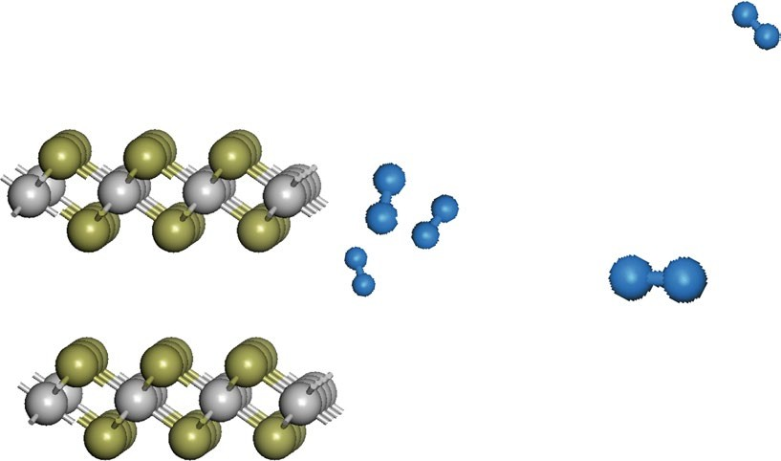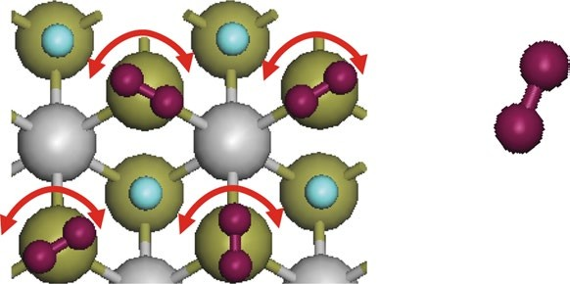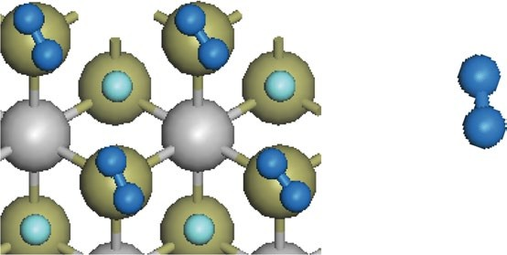c d e
a
Initial structure

Side view
Ti
C H
H₂
b
(i)
Pristine hydrogen molecule
0.750 Å
0

–0.2

–0.4

–0.6

–0.8

–1.0
0
5
10
15
20
Number of inserted H₂
a
(ii)
Optimized structure (interlayer distance = 6.8 Å)
a
(iii)
Optimized structure (interlayer distance = 8.0 Å)
d_{H–H} = 0.796 Å

Weak chemically absorbed H₂
d_{H–H} = 0.750 Å

Physically adsorbed H₂
Hydrogenated Ti₂CT_{x} Pristine Ti₂CT_{x}
Weak chemically absorbed H₂
Bonded H₂
–OH
Hydrogenated Ti₂CT_{x}
Pristine Ti₂CT_{x} 117 °C
80 °C
201 °C

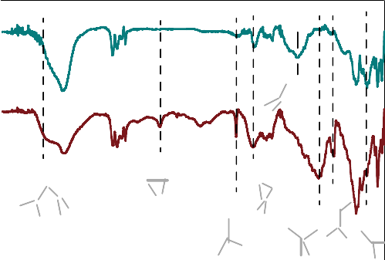Dehydrogenated

CH
OH
Transmittance (%)
Hydrogenated

F–O–H

H–H

OH

H–H–O
Ti–H Ti–2H

H–F
Intensity (a.u.)
Intensity (a.u.)

Ti–F

30 20

10 0
Shift (ppm)

50 100 150 200 250
Temperature (°C)
F O Ti H
4,000 3,000 2,000 1,000
Wavenumber (cm–1)

Fig. 4 | Mechanism analysis of hydrogen storage in Ti₂CT_{x}. a, Structures of the Ti₂C stack with the insertion of H₂ molecules. The interlayer distance for the Ti₂C sheets is fixed at 6.8 Å. b, Variation in E_{abs} for each inserted H₂. c, The 1H NMR spectra of pristine and hydrogenated Ti₂CT_{x}.
d, Temperature-programmed desorption results of Ti₂CT_{x} before and after hydrogen uptake. e, FTIR results of hydrogenated and dehydrogenated Ti₂CT_{x}.

O functional groups. The absorption peak at 2,515 cm−1 originates from the characteristic stretching of the H–H bonds of strongly complexed dihydrogen molecules, which is often observed in Kubas complexes17,41. This is the evidence of the weakly chemisorbed molecular H₂. The strong absorption at 1,801 and 1,021 cm−1 can be assigned to the Ti–H stretching and H–Ti–H bending, respec- tively, reflecting the interaction between hydrogen and the Ti atom on the surface of the Ti₂CT_{x} sheets28,41–43. The increase in the H–F vibration intensity, the decrease in the Ti–F vibration intensity and the appearance of new peaks around Ti–F in hydrogenated Ti₂CT_{x} indicate the interaction between the hydrogen species and F groups34,44,45. Neutron diffraction results show negligible change in the Ti₂CT_{x} structure after hydrogenation (Supplementary Fig. 24), which proves that the stored hydrogen is only adsorbed on the Ti₂CT_{x} surface rather than doped into the lattice of the Ti₂CT_{x} sheet. The moderate interaction between hydrogen and Ti₂CT_{x} makes the chemisorbed hydrogen easy to release46. Based on the above experimental and calculation results, the room-temperature hydrogen storage mechanism of Ti₂CT_{x} should mainly be the weak chemisorption of hydrogen on Ti atoms and the –F functional groups assisted by the nanopump effect that reduces the depen- dence on high H₂ pressure. This hydrogen storage mechanism may pave a new way for the development of practical room-temperature high-performance hydrogen storage materials.
d = 6.8 Å
E_{abs} (eV)

Conclusions
This work shows a room-temperature hydrogen storage material, namely, incompletely etched Ti₂CT_{x}, and its storage mechanism. A reversible hydrogen storage capacity of over 8 wt% is achieved at ~50–60 bar pressure, which is more than twice the capacities of previously reported room-temperature hydrogen storage mate- rials under the same pressure. The hydrogen release is fast and controllable. Moreover, Ti₂CT_{x} shows good cyclability in hydro- gen uptake/release. According to our investigation, the narrow interlayer distance and –F functional groups are the key struc- tural parameters for the hydrogen storage in Ti₂CT_{x}. They induce a nanopump-effect-assisted weak chemisorption that generates proper interaction between hydrogen and Ti₂CT_{x}, thereby enabling the large, reversible hydrogen storage in the interlayer space of the Ti₂CT_{x} sheets at near-ambient conditions. We expect that this hydrogen storage approach will be applicable to a wide range of nanomaterials, especially those with plenty of sub-nanopores and chemically modifiable inner surfaces.

Online content
Any methods, additional references, Nature Research report- ing summaries, source data, extended data, supplementary infor- mation, acknowledgements, peer review information; details of author contributions and competing interests; and statements of

data and code availability are available at https://doi.org/10.1038/ s41565-020-00818-8.
Received: 19 January 2020; Accepted: 6 November 2020;
Published: xx xx xxxx

References
- Hosseini, S. E. & Wahid, M. A. Hydrogen production from renewable and sustainable energy resources: promising green energy carrier for clean development. Renew. Sustain. Energy Rev. 57, 850–866 (2016).
- Schneemann, A. et al. Nanostructured metal hydrides for hydrogen storage.
Chem. Rev. 118, 10775–10839 (2018).
- He, T., Pachfule, P., Wu, H., Xu, Q. & Chen, P. Hydrogen carriers. Nat. Rev. Mater. 1, 16059 (2016).
- Züttel, A. Materials for hydrogen storage. Mater. Today 6, 24–33 (2003).
- Orimo, S.-i, Nakamori, Y., Eliseo, J. R., Züttel, A. & Jensen, C. M. Complex hydrides for hydrogen storage. Chem. Rev. 107, 4111–4132 (2007).
- Rowsell, J. L. & Yaghi, O. M. Effects of functionalization, catenation, and variation of the metal oxide and organic linking units on the low-pressure hydrogen adsorption properties of metal–organic frameworks. J. Am. Chem. Soc. 128, 1304–1315 (2006).
- Vajo, J. J., Skeith, S. L. & Mertens, F. Reversible storage of hydrogen in destabilized LiBH4. J. Phys. Chem. B 109, 3719–3722 (2005).
- Sakintuna, B., Lamaridarkrim, F. & Hirscher, M. Metal hydride
materials for solid hydrogen storage: a review. Int. J. Hydrogen Energy 32, 1121–1140 (2007).
- Jena, P. Materials for hydrogen storage: past, present, and future. J. Phys. Chem. Lett. 2, 206–211 (2011).
- Łodziana, Z., Dębski, A., Cios, G. & Budziak, A. Ternary LaNi4.75M0.25 hydrogen storage alloys: surface segregation, hydrogen sorption and thermodynamic stability. Int. J. Hydrogen Energy 44, 1760–1773 (2019).
- Zhong, C. et al. Microstructures and electrochemical properties of LaNi3.8–
xMnx hydrogen storage alloys. Electrochim. Acta 58, 668–673 (2011).
- Shao, H., Xin, G., Zheng, J., Li, X. & Akiba, E. Nanotechnology in Mg-based materials for hydrogen storage. Nano Energy 1, 590–601 (2012).
- Lototskyy, M. V., Yartys, V. A., Pollet, B. G. & Bowman, R. C. Metal hydride hydrogen compressors: a review. Int. J. Hydrogen Energy 39, 5818–5851 (2014).
- Gao, M. et al. Ca(BH4)2–LiBH4–MgH2: a novel ternary hydrogen storage system with superior long-term cycling performance. J. Mater. Chem. A 1, 12285–12292 (2013).
- Chen, P., Xiong, Z., Luo, J., Lin, J. & Tan, K. L. Interaction of hydrogen with metal nitrides and imides. Nature 420, 302–304 (2002).
- Zhang, J. et al. Metal hydride nanoparticles with ultrahigh structural stability and hydrogen storage activity derived from microencapsulated nanoconfinement. Adv. Mater. 29, 1700760 (2017).
- Kubas, G. J. Molecular hydrogen complexes: coordination of a σ bond to transition metals. Acc. Chem. Res. 21, 120–128 (1988).
- Morris, L. et al. A manganese hydride molecular sieve for practical hydrogen storage under ambient conditions. Energy Environ. Sci. 12, 1580–1591 (2019).
- Target Explanation Document: Onboard Hydrogen Storage for Light-Duty Fuel Cell Vehicles (The United States Department of Energy, 2017).https://www. energy.gov/eere/fuelcells/downloads/target-explanation-document-onboard- hydrogen-storage-light-duty-fuel-cell
- Naguib, M. et al. Two-dimensional nanocrystals produced by exfoliation of Ti3AlC2. Adv. Mater. 23, 4248–4253 (2011).
- Hart, J. L. et al. Control of MXenes’ electronic properties through termination
and intercalation. Nat. Commun. 10, 522 (2019).
- Zhang, C. J. et al. Oxidation stability of colloidal two-dimensional titanium carbides (MXenes). Chem. Mater. 29, 4848–4856 (2017).
- Hu, M. et al. Surface functional groups and interlayer water determine the electrochemical capacitance of Ti3C2Tx MXene. ACS Nano 12, 3578–3586 (2018).

- Yang, L. et al. Combining photocatalytic hydrogen generation and capsule storage in graphene based sandwich structures. Nat. Commun. 8, 16049 (2017).
- Patchkovskii, S. et al. Graphene nanostructures as tunable storage media for molecular hydrogen. Proc. Natl Acad. Sci. USA 102, 10439–10444 (2005).
- Ming, M. et al. Promoted effect of alkalization on the catalytic performance of Rh/alk-Ti3C2X2 (X = O, F) for the hydrodechlorination of chlorophenols in base-free aqueous medium. Appl. Catal. B 210, 462–469 (2017).
- Ahmed, B., Anjum, D. H., Hedhili, M. N., Gogotsi, Y. & Alshareef, H. N. H2O2 assisted room temperature oxidation of Ti2C MXene for Li-ion battery anodes. Nanoscale 8, 7580–7587 (2016).
- Morris, L., Trudeau, M. L., Reed, D., Book, D. & Antonelli, D. M. Thermodynamically neutral Kubas-type hydrogen storage using amorphous Cr(iii) alkyl hydride gels. Phys. Chem. Chem. Phys. 17, 9480–9487 (2015).
- Ali, W. et al. Effects of Cu and Y substitution on hydrogen storage performance of TiFe0.86Mn0.1Y0.1–xCux. Int. J. Hydrogen Energy 42, 16620–16631 (2017).
- Srivastava, S. & Upadhyaya, R. K. Investigations of AB5-type hydrogen storage materials with enhanced hydrogen storage capacity. Int. J. Hydrogen Energy 36, 7114–7121 (2011).
- Ding, L. et al. MXene molecular sieving membranes for highly efficient gas separation. Nat. Commun. 9, 155 (2018).
- Broom, D. P. & Hirscher, M. Irreproducibility in hydrogen storage material research. Energy Environ. Sci. 9, 3368–3380 (2016).
- Lai, S. et al. Surface group modification and carrier transport properties of layered transition metal carbides (Ti2CTx, T: –OH, –F and –O). Nanoscale 7, 19390–19396 (2015).
- Han, F. et al. Boosting the yield of MXene 2D sheets via a facile hydrothermal-assisted intercalation. ACS Appl. Mater. Interfaces 11, 8443–8452 (2019).
- Piñero, J. J. et al. Diversity of adsorbed hydrogen on the TiC(001) surface at high coverages. J. Phys. Chem. C 122, 28013–28020 (2018).
- Hu, Q. et al. MXene: a new family of promising hydrogen storage medium. J. Phys. Chem. A 117, 14253–14260 (2013).
- Hu, Q. et al. Two-dimensional Sc2C: a reversible and high-capacity hydrogen storage material predicted by first-principles calculations. Int. J. Hydrogen Energy 39, 10606–10612 (2014).
- Osti, N. C. et al. Evidence of molecular hydrogen trapped in two-dimensional layered titanium carbide-based MXene. Phys. Rev. Mater. 1, 024004 (2017).
- Anderson, R. J. et al. NMR methods for characterizing the pore structures and hydrogen storage properties of microporous carbons. J. Am. Chem. Soc. 132, 8618–8626 (2010).
- Hope, M. A. et al. NMR reveals the surface functionalisation of Ti3C2 MXene.
Phys. Chem. Chem. Phys. 18, 5099–5102 (2016).
- Wang, X., Andrews, L., Infante, I. & Gagliardi, L. Infrared spectra of the WH4(H2)4 complex in solid hydrogen. J. Am. Chem. Soc. 130, 1972–1978 (2008).
- Hoang, T. K. A., Morris, L., Sun, J., Trudeau, M. L. & Antonelli, D. M. Titanium hydrazide gels for Kubas-type hydrogen storage. J. Mater. Chem. A 1, 1947–1951 (2013).
- Hoang, T. K. A. & Antonelli, D. M. Exploiting the Kubas interaction in the design of hydrogen storage materials. Adv. Mater. 21, 1787–1800 (2009).
- Laptash, N. M., Maslennikova, I. G. & Kaidalova, T. A. Ammonium oxofluorotitanates. J. Fluorine Chem. 99, 133–137 (1999).
- Hancock, J. K. & Green, W. H. Vibrational deactivation of HF (v = 1) in pure HF and in HF-additive mixtures. J. Chem. Phys. 57, 4515–4529 (1972).
- Wei, T. Y., Lim, K. L., Tseng, Y. S. & Chan, S. L. I. A review on the characterization of hydrogen in hydrogen storage materials. Renew. Sustain. Energy Rev. 79, 1122–1133 (2017).

Publisher’s note Springer Nature remains neutral with regard to jurisdictional claims in published maps and institutional affiliations.
© The Author(s), under exclusive licence to Springer Nature Limited 2021

Methods
Preparing Ti2CTx. In a typical synthesis process, 2 g of commercial Ti2AlC (200 mesh, Maxthal 211, Forsman) was slowly added into 20 ml HF solution (18% concentration; Sinopharm Chemical Reagent) at room temperature. The
suspension was stirred at a speed of 300 r.p.m. for 8 h. The solid was collected by vacuum filtration and washed until the pH value reached 7. The solids were dried at 50 °C for 10 h in a vacuum to obtain the Ti2CTx powder.
Preparing L-Ti2CTx. Here 2 g of commercial Ti2AlC was slowly added into 20 ml of 18% HF solution at room temperature. The suspension was stirred at a speed of 300 r.p.m. for 24 h. The solid was collected by vacuum filtration and washed until the pH value reached 7. The solid was freeze dried overnight to obtain the L-Ti2CTx powder.
Preparing Ti3C2Tx. Here 2 g of Ti3AlC2 (200 mesh, Maxthal 312, Forsman) was slowly added into 20 ml of 12% HF solution at room temperature. The suspension was stirred at a speed of 300 r.p.m. for 8 h. The solid was collected by vacuum filtration and washed until the pH value reached 7. The solid was dried at 50 °C for 10 h in a vacuum to obtain the Ti3C2Tx powder.
Preparing L-Ti3C2Tx. Here 2 g of Ti3AlC2 was slowly added into 20 ml of 20% HF solution at room temperature. The suspension was stirred at a speed of 300 r.p.m. for 12 h at room temperature. The resulting suspension was vacuum filtered and washed several times with deionized water until the pH value reached 7. The solid was dried at 50 °C for 10 h in a vacuum to obtain the L-Ti3C2Tx powder.
Preparing single-layer Ti CT . Single-layer Ti CT nanosheets were obtained by
2
x
2
x

systems were carefully calibrated with the samples of LaNi5 and graphene. Before the hydrogen storage test, all the samples were activated by degassing at 90 °C for 30 min under a high vacuum (≤10−4 Pa) and then exposed to 50 bar hydrogen for 1 h. The hydrogenated samples were degassed again at 90 °C for 30 min in a vacuum to ensure full activation and degassing.
Visible combustion experiments. Here 120 mg pristine Ti2CTx (or hydrogenated Ti2CTx) powder was compressed into a 20-mm-diameter disc in a stainless steel mould. The disc was ignited by a candle flame. The experimental setup is shown in Supplementary Fig. 13. The infrared videos were recorded using an infrared camera (Ti480 PRO, Fluke).
Calculations of structure and adsorption energy. All the geometry optimization and total energy calculations were performed with DFT as implemented in the Vienna ab initio simulation program. The projector augmented wave method was used
to represent the non-valence core electrons. All the spin-polarized calculations were performed by a generalized gradient approximation with a Perdew–Burke– Ernzerhof electronic exchange–correlation interactions. Grimme’s DFT-D2 method is used to correct for the van der Waals interaction. A kinetic energy cut-off of
500 eV is chosen and a 5 × 5 × 1 k-point mesh for the supercell (size, 3 × 3 × 1) is used for sampling the Brillouin zones for the structural calculations. The atomic positions are fully relaxed with no constraints until the maximum force on each atom is less than 0.01 eV Å–1.
The absorption energy (Eabs) of H2 with Ti2C as the host material is calculated according to the following equation:
Eabs ¼ ðET2 CþnH2 � ET2 C � nEH2 Þ
n

sonicating the as-synthesized multilayer Ti2CTx suspension. The temperature was maintained at 25 °C and the frequency was set to 37 kHz (power amplitude, 60%). Thereafter, the suspension was centrifuged at 3,000 r.p.m. for 15 min to separate the delaminated flakes from the unexfoliated particles.
Preparing Ti C(OH) . Deionized water was heated to boil for 30 min in an Ar

where E_{T}2 CþnH2 is the total energy of the host structure absorbed with hydrogen molecules, and n is the number of newly absorbed H2. Further, E_{T}2 C is the total energy of the host structure (bare multilayer Ti2C structure or Ti2C with some H), and E_{H}2 is the total energy of free H2. The absorption energy of H atoms to the Ti2C

2 x sheet is calculated with the above formula by replacing E_{H}2 with 1/2E_{H}2 .

atmosphere to remove the dissolved O2 and CO2 before use. Further, 24 g NaOH (analytical reagent, ≥99.5%; Sinopharm Chemical Reagent) was added into boiled water to prepare a saturated NaOH solution. Then 100 mg Ti2AlC powder was added into the NaOH solution. The suspension was transferred into a 50 ml Teflon-lined autoclave and heated at 270 °C for 12 h. Then the suspension was
cooled down and the solid was collected by vacuum filtration and washed until the pH value reached 7. The powder was dried in a vacuum oven at 50 °C for 12 h.
Characterization. The XRD pattern was recorded using a powder diffractometer (Cu Kα radiation; Rigaku D/MAX 2500) with 0.02° per step in the 2θ range of 3–70°. The morphologies of the samples were investigated by using a scanning electron microscope (JSM7500, JEOL) equipped with an energy-dispersive spectrometer (Oxford, with the INCA software). Transmission electron microscopy was performed on a JEM-2100F (JEOL) instrument at an acceleration voltage of 200 kV. The sample compositions were studied using XPS (Thermo ESCALAB 250Xi X-ray photoelectron spectrometer) with an Al Kα X-ray source (photon energy, hν = 1,486.6 eV). The XPS detection was conducted before and after an
Ar+-sputtering treatment to remove the surface components, and the etching depth was 10 nm. Further, N2 and CO2 adsorption measurements were carried out using an ASAP 2460 instrument. The FTIR test was carried out using a Nicolet 6700 FTIR spectrometer, and the sample was mixed with dry KBr and then pressed into a translucent sheet for testing. The room-temperature solid-state 1H NMR spectra was recorded at 600 MHz using a Bruker AVANCE III 600 M NMR spectrometer with a magnetic field strength of 14.09 T, a chamber cavity diameter of 54 mm,
and a magnetic field stability of <9 Hz h–1. Temperature-programmed desorption was performed using an AutoChem II 2920 instrument with N2 as the carrier gas. Neutron diffraction measurements were performed using the General Purpose Powder Diffractometer at the China Spallation Neutron Source.

Hydrogen absorption–desorption measurements. A Sievert’s-type apparatus (PCT Pro-3000) was used to measure the hydrogen storage capacity and kinetics. A home-made Sievert-type volumetric apparatus was used for the stability test and to double check the hydrogen storage capacity. The reliability and accuracy of the two

Data availability
Most of the data have been provided as supplementary figures and videos along with this article. Additional data supporting this paper are available from the corresponding author upon reasonable request.

Acknowledgements
This work was financially supported by National Natural Science Foundation of China (21673014, 21975010 and 51731002). We thank X. G. Li (Peking University) for
assistance in the hydrogen storage measurement. We acknowledge the General Purpose Powder Diffractometer at the China Spallation Neutron Source for providing the neutron powder diffraction analysis.

Author contributions
J. Shui, S.L. and J.L. designed the research. S.L. and J.L. performed the experiments.
S.L. and J. Shang conducted the DFT calculation. J.L., S.L., X.L. and J. Shui co-wrote the manuscript. X.L., L.X., R.Y. and J. Shui supervised the project. All the authors discussed the results and commented on the manuscript.

Competing interests
The authors declare no competing interests.

Additional information
Supplementary information is available for this paper at https://doi.org/10.1038/ s41565-020-00818-8.
Correspondence and requests for materials should be addressed to J.S.
Peer review information Nature Nanotechnology thanks the anonymous reviewers for their contribution to the peer review of this work.
Reprints and permissions information is available at www.nature.com/reprints.

