Theory-oriented Synthesis of 2D/2D BiVO₄/MXene Heterojunction for Simultaneous Removal of Hexavalent Chromium and Methylene Blue
Peng Liu,^{[a]} Jianhong Yi,*^{[a]} Rui Bao,*^{[a]} and Heng Zhao*^{[b]}

Precise catalyst discovery by theoretical calculation is currently providing novel and promising approach to fine design and fabricate efficient photocatalysts. We demonstrated a possibility of designing 2D/2D BiVO₄/MXene heterojunction with excellent charge separation efficiency by density functional theory (DFT) and realized the preparation by hydrothermal method based on the theoretical results. As expected, the as-constructed compo- sites exhibited an unprecedented photocatalytic activity for simultaneous removal of hexavalent chromium (83.6 %) and methylene blue (88.7 %) within 120 minutes under visible light
by photogenerated electrons and holes respectively, which were 2.17- and 3.67-times compared with pristine BiVO₄. This significant improvement is ascribed to the strong interfacial interaction within the unique 2D/2D heterojunction, which greatly improves the lifetime of charge carriers by reducing the recombination and shortening the transmission distance. The present work demonstrates a good example to firstly design reasonable catalyst by theoretical calculation and then effi- ciently improve the activity for environment remediation by solar-light driven photocatalysis.

■■■Dear Author, please provide a TOC text (about three short sentences, which summarize the content of your article).
This text will appear together with the TOC figure on the first pages of the online issue, if your article will become part of this
issue.■■■

Introduction

Chromium (Cr) is a common heavy metal contamination in wastewater and soil resulting from the fast-growing industries like electroplating, pigment and leather tanneries, which is growing into a nonnegligible threat to human health. As one of the two main oxidation states of Cr element, trivalent Cr (Cr (III)) is considered to be less harmful than hexavalent chromium (Cr (VI)).^{[1,2]} Therefore, efficiently converting Cr (VI) into Cr (III) is a feasible way to relieve the pressure from the above issue and there are already many investigations about the Cr (VI) detoxification.^{[3,4]} However, considering the complexity in component of the wastewater from practical industries, organic pollutants such as methylene blue (MB) should also be completely eliminated along with heavy metal contamination in

- P. Liu, Prof. J. Yi, Prof. R. Bao
Faculty of Materials Science and Engineering Kunming University of Science and Technology No. 304 Xuefu Road, Kunming 650093 (P. R. China)
E-mail: yijianhong@kmust.edu.cn baorui@kmust.edu.cn
- Dr. H. Zhao
Department of Chemical and Petroleum Engineering University of Calgary
University Drive, NW, Calgary, Alberta T2 N 1 N4 (Canada) E-mail: heng.zhao1@ucalgary.ca
 Supporting information for this article is available on the WWW under https://doi.org/10.1002/cctc.202100315

order to meet the basic requirements of drinking water. Herein, efficient and facile methods should be developed for the simultaneous removal of these pollutants.^{[5]}
Semiconductor photocatalysis, derived from photogener- ated reductive electrons and oxidative holes, has been recog- nized as a green and sustainable method for wastewater treatment.^{[6,7]} However, the photocatalytic efficiency is always limited by the many factors like fast recombination of electrons and holes, slow reaction kinetics and underutilized solar energy. Many strategies have already been developed regarding the above issues like junction construction,^{[8,9]} vacancies introduction,^{[10–12]} and facet control etc.^{[13–16]} However, for the simultaneous removal of Cr (VI) by photogenerated electrons (reduction reaction) and MB by photogenerated holes (oxida- tion reaction), the charge separation is still the crucial factor that limits the improvement in photocatalytic efficiency. From this point of view, constructing a Schottky junction at the interface between a semiconductor and a metal cocatalyst stands out as this heterojunction structure is extremely efficient for the spatial separation of charge carriers.^{[17–19]}
Bismuth vanadate (BiVO₄) is a widely used photocatalyst due to its attractive properties like narrow band gap (2.4 eV), visible light responsiveness, non-toxicity, high stability and thanks to the strong oxidation ability, BiVO₄ has already been investigated for wastewater treatment by decomposing organic pollutants.^{[20–23]} Even though two-dimensional (2D) structure endows BiVO₄ with better performance by shortening the transfer distance of charge carriers, the photocatalytic efficiency for simultaneous reduction reaction and oxidation reaction is still at a bottleneck because of the recombination of electrons and holes. Herein, choosing a proper cocatalyst to form the Schottky junction with BiVO₄ would significantly improve the photocatalytic efficiency. To rationally construct an efficient Schottky junction, the matching in work function of the main

ChemCatChem 2021, 13, 1 – 9 1
© 2021 Wiley-VCH GmbH

semiconductor and the cocatalyst should be emphatically considered.^{[24–26]} Ti₃C₂T_{x}, one of the typical MXenes, has been recognized as a novel and promising cocatalyst for efficient charge separation due to the metallicity property and high work function.^{[27–29]} What is more interesting is that the work function of Ti₃C₂T_{x} could be regulated by the surface termina- tion group,^{[30,31]} which provides a theoretical possibility to fine design a rational Schottky junction in the composite of BiVO₄ and Ti₃C₂T_{x} by changing the termination functional group.
Herein, we firstly screen the photocatalysts by DFT to predict the effects of surface termination groups of Ti₃C₂T_{x} on the band structure, work function and Cr (VI) adsorption energy. The results indicate that MXene with —O or —OH dominated surface terminating groups are the best candidates to combine with BiVO₄ to form the efficient Schottky junction. The screened photocatalysts were then synthesized by hydrothermal method based on the theoretical results. As expected, the as-con- structed photocatalysts achieved unprecedented photocatalytic activity for simultaneous removal of hexavalent chromium (83.6 %) and methylene blue (88.7 %) within 120 minutes under visible light. The excellent photocatalytic performance is ascribed to the efficiently spatial separation of photogenerated
electrons and holes, which separately triggered the Cr (VI) reduction and MB oxidation. This present work demonstrates a good example of rationally designing photocatalyst with the favor of theoretical calculation and is shedding new light on efficient treatment of wastewater by solar-light driven photo- catalysis.

Results and Discussion

Efficient Schottky junction constructed by a semiconductor photocatalyst and a cocatalyst requires the working function of the latter should be higher than that of the former and the cocatalyst should process favorable conductivity. Herein, theo- retical calculations were firstly conducted to accelerate the catalyst screening. BiVO₄ exhibits intermittent band structure near the Fermi level with ~ 2.244 eV band gap (Figure 1a) while Ti₃C₂O₂ and Ti₃C₂(OH)₂ show continuous band structures near the Fermi level (Figure 1(b, c)). Meanwhile, another two types of MXenes: Ti₃C₂ and Ti₃C₂F₂ also exhibit similar band character- istics (Figure S1(a, c)), indicating the metallic nature of MXenes and negligible effect of the surface terminating groups on

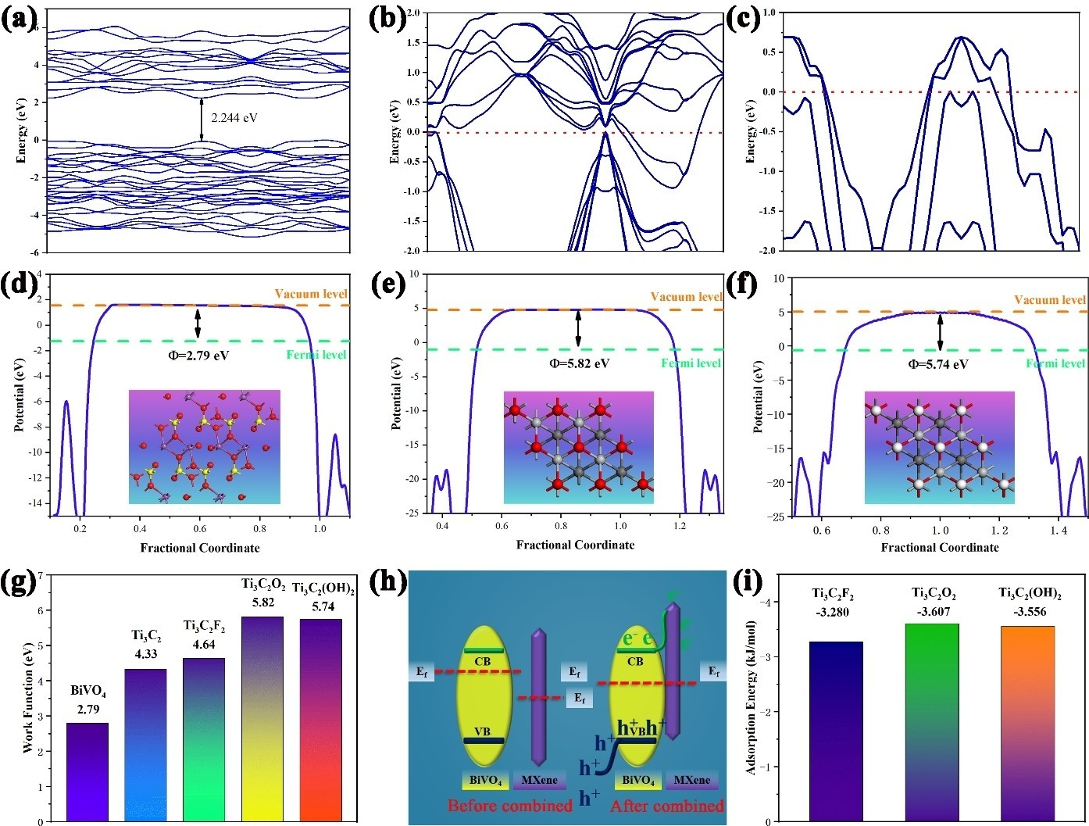

Figure 1. The calculated band structure and work function of BiVO₄ (a, d), Ti₃C₂O₂ (b, e) and Ti₃C₂(OH)₂ (c, f). Comparison of work function between BiVO₄ and MXenes terminated by different surface groups (g) and predicted scheme of band bending based on theoretical calculations (h). The calculated adsorption energy between Cr O ^{2—} and different surface groups terminated MXenes (i)
2 7

conductivity. Pristine BiVO₄, Ti₃C₂O₂ and Ti₃C₂(OH)₂ are sepa- rately endowed with 2.79 eV, 5.82 eV and 5.74 eV of working function (Figure 1(d-f)) while corresponding values of Ti₃C₂ and Ti₃C₂F₂ are 4.33 eV and 4.64 eV (Figure S1(b, d)), respectively. Figure 1(g) summarizes the work functions for BiVO₄ and MXenes with different terminating groups. It could be noticed that all MXenes exhibit higher work function than BiVO₄. Therefore, it could be expected that the presence of energy level difference will regulate the Fermi levels until an equilibrium is achieved at the interface of MXenes and BiVO₄. Then, the built-in electric field will be subsequently introduced as the driving force for carrier separation (Figure 1(h)).
Based on the above analysis, MXenes are the electron reservoir to capture the photogenerated electrons from BiVO₄ for Cr (VI) reduction. The accessibility of Cr₂O₇^{2—} to MXenes surface will definitely be a crucial factor for photocatalytic efficiency of Cr (VI) reduction. Herein, the adsorption energy of Cr O ^{2—} on MXenes with different terminating groups was then calculated (Figure S2). Ti₃C₂O₂ and Ti₃C₂(OH)₂ exhibit more negative adsorption energies of —3.607 kJ/mol and —3.556 kJ/ mol respectively (Figure 1(i)), indicating that the Cr₂O₇^{2—} is more easily adsorbed on their surfaces. Therefore, it could be expected that composites with Ti₃C₂O₂ and Ti₃C₂(OH)₂ as cocatalysts will show better photocatalytic ability for Cr (VI) reduction from the perspective of theoretical calculations.
2 7
The crystallinity and composition of all the samples were then investigated by XRD. The disappearance of typical XRD peaks of Ti₃AlC₂ after etching proves the total removal of the Al layer in Ti₃C₂T_{x} MXene (Figure 2(a)). Noticeably, the (0 0 2) peak
of the Ti₃AlC₂ became broad and shifted toward lower angles, indicating the successful exfoliation of Ti₃C₂T_{x} MXene. Pristine BiVO₄ is in monoclinic crystal phase (PDF#83-1699) and the decoration of MXene does not change the crystal structure (Figure 2(b)). No typical diffraction peak of Ti₃C₂T_{x} MXene is observed in BVO-TC composites due to the low loading and high dispersion of Ti₃C₂T_{x} MXene on the BiVO₄ surface. But the presence of Ti₃C₂T_{x} MXene could be revealed by UV-vis absorbance spectra (Figure 2(c)). Pristine BiVO₄ exhibits an absorption edge at around 502 nm, corresponding to the direct band gap of 2.47 eV (Figure 2(d)), which is consistent with the previous report.^{[33]} BVO-TC composites show enhanced absorb- ance intensities in the visible light region compared with that of the pure BiVO₄. Besides, the absorbance edge slightly shifts to longer wavelength, indicating the presence of Ti₃C₂T_{x} MXene extends the light harvesting as well as broader visible light absorption.^{[34]}
The microstructure and component distribution were then characterized by SEM and TEM. The Ti₃C₂T_{x} exhibits loosely stacked and multi-layer structures as a result of the etch treatment as shown in Figure 3(a). This special morphology further indicates the successful removal of Al layers. The ultrasonic treatment of the multi-layer Ti₃C₂T_{x} successfully realizes the exfoliation to form twist ultrafine Ti₃C₂T_{x} MXene nanosheet (Figure 3(b)). The pristine BiVO₄ exhibits 2D plate structure (Figure S3) while the composite with Ti₃C₂T_{x} MXene (BVO-TC9) keeps the plate structure with a thickness of ~ 40 nm of BiVO₄. The ultrafine Ti₃C₂T_{x} MXene nanosheet could be clearly identified on the surface of BiVO₄ with uniform distribution

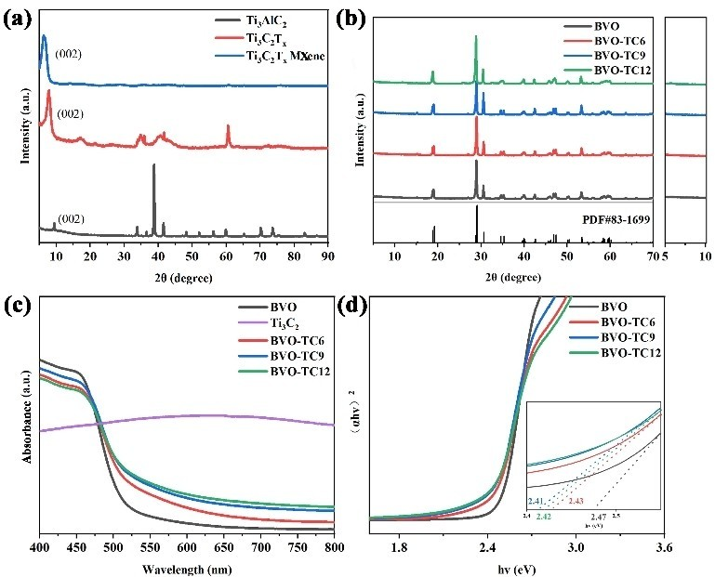

Figure 2. XRD patterns of the etched Ti₃C₂T_{x} Mxene (a) and composites with BiVO₄ (b). The UV/vis DRS of as-prepared catalysts(c) and corresponding Tauc plots by transformed Kubelka-Munk function (d).

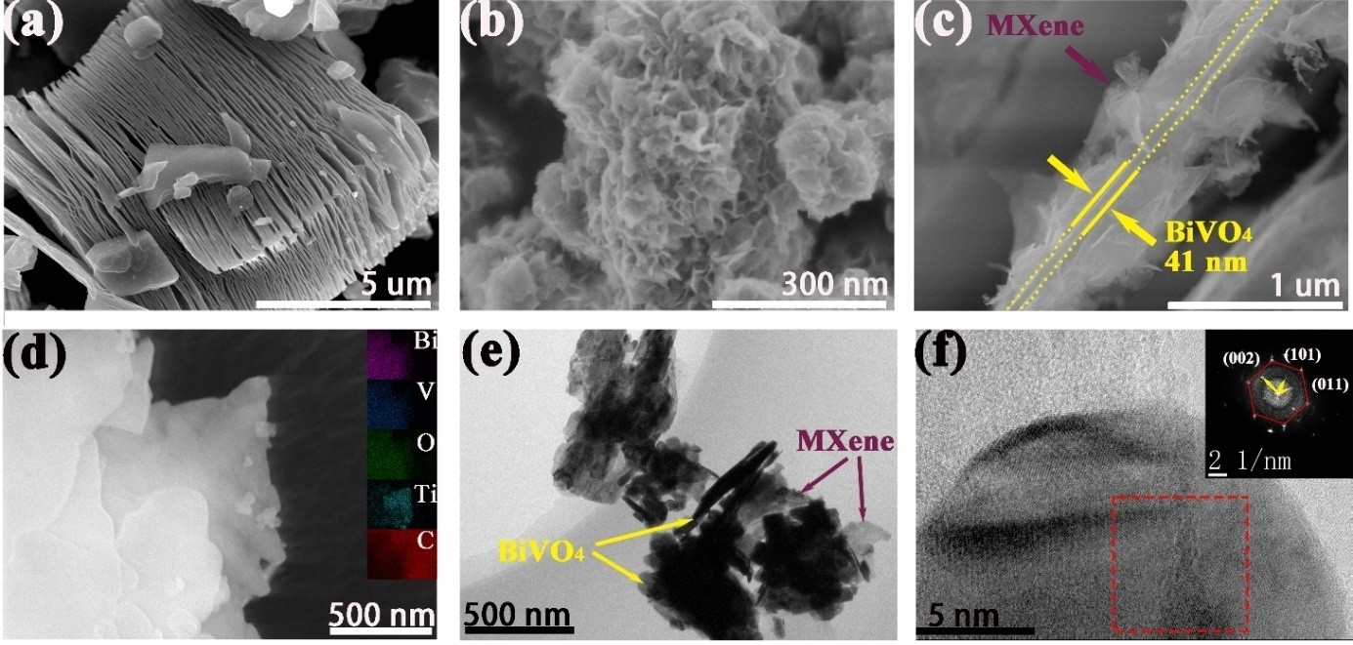

Figure 3. The SEM images of Ti₃C₂T_{x} (a), Ti₃C₂T_{x} MXene (b), BVO-TC9 (c) and HAADF-STEM image with corresponding EDS element mappings (d). Low (e) and high (f) resolution TEM images of BVO-TC9 with SAED pattern.

(Figure 3(c)), which could be further revealed by the elemental mappings (Figure 3(d)). Ti₃C₂T_{x} MXene with the ultrathin sheet structure is further proved by TEM results (Figure S4(a, b)) and the selected area electron diffraction (SAED) pattern presents symmetrical hexagonal diffraction spots, indicating the hexagon nature of Ti₃C₂T_{x} MXene.^{[35]} The 2D-2D stack structure of BiVO₄ plate and ultrafine Ti₃C₂T_{x} MXene nanosheet could be clearly identified in the composite of BVO-TC9 (Figure 3(e)). The SAED pattern with two sets of diffraction patterns indicates the presence of hexagonal Ti₃C₂T_{x} MXene and monoclinic BiVO₄ with typically exposed facets of (0 0 2), (1 0 1) and (0 1 1) (Figure 3(f)).
The surface termination group of Ti₃C₂T_{x} MXene and the interaction with BiVO₄ were then investigated by XPS. All XPS results were calibrated with respect to the C 1s (284.6 eV) as a reference and no other contamination species were observed (Figure 4(a)). Ti₃C₂T_{x} MXene exhibits a typical Ti—F chemical bond with the binding energy of 684.6 eV while the Ti—F chemical bond disappeared during the hydrothermal reaction to prepare BVO-TC9 composite, indicating that the F-terminated group on the surface of MXene was reacted (Figure 4(b)). The Ti2p spectrum of Ti₃C₂T_{x} MXene could be deconvoluted into
seven peaks corresponding to Ti—C (460.8 eV, 455.1 eV),^{[35]} Ti²⁺
(462.6 eV, 456 eV),^{[36]} Ti—F (459.3 eV) and Ti—O (464.8 eV,
458.9 eV) (Figure 4(c)).^{[37]} The detected Ti—O bond in BVO-TC9 indicates the replacement of —F by —O (or —OH) on Ti₃C₂T_{x} MXene during the hydrothermal reaction. Noticeably, a neg-

junction could be confirmed.^{[38]} The differential charge density shows the concentrated negative charge (yellow) on MXene while positive charge (green) on BiVO₄, which further confirms the electron transfer from BiVO₄ to Ti₃C₂O₂ MXene due to the formed Schottky junction (Figure 4(g)).
As the formed Schottky junction could realize the spatial separation of electrons and holes in the composites of BiVO₄ and Ti₃C₂T_{x} MXene, simultaneous reduction reaction and oxidation reaction could theoretically happen on the surface of MXene and BiVO₄ separately. To prove this hypothesis, photo- catalytic experiments of MB and Cr (VI) synergistic redox were investigated. Pristine BiVO₄ also shows the ability to simulta- neously reduce Cr (VI) and degrade MB, but the activity is much lower than the BVO-TCx composites (Figure 5). BVO-TC9 achieves 83.6 % and 88.7 % removal of Cr (VI) and MB in 120 minutes, which are 2.17 times and 3.67 times of the photo- catalytic efficiency of pristine BiVO₄, respectively. To quantify the degradation rate, the reaction kinetics is described using a pseudo-first-order model in Equation (1):

—lnC=C₀ ¼ k_{app}t (1)
where C and C₀ are the concentration of MB or Cr O ^{2—} at time t (min), k_{app} (min^{—1}) is the apparent reaction rate constant. The results revealed that the BVO-TC9 photocatalyst shows the greatest k_{app} value (0.01461 min^{—1} for MB, and 0.01621 min^{—1} for Cr₂O ^{2—} ) vs. the k_{app} value of pure BiVO₄ (0.00206 min^{—1} for MB,
2
7
2
7
7

ative shift of Ti—O bond was observed on BVO-TC9 compared with Ti₃C₂T_{x} MXene while Bi 4 f, V 2p and O 1s peaks in BVO-TC9 showed positive shift (Figure 4(d-f)). The shift in binding energy of chemical bond indicates the rearrangement of electron cloud. Herein, the electrons transfer from BiVO₄ to the Ti₃C₂T_{x} MXene in BVO-TC9 composite due to the formation of Schottky
and 0.00701 min^{—1} for Cr O ^{2—}) (Figure 5(b, d)). The optimal addition amount of Ti₃C₂T_{x} is 9 mg. Insufficient or excessive Ti₃C₂T_{x} loading will result in the deteriorated activity. This may be because insufficient Ti₃C₂T_{x} is not enough to force carrier separation, and excessive MXene will cause “shielding effect”.^{[34]} Furthermore, comparative photocatalytic experiments of chemi-

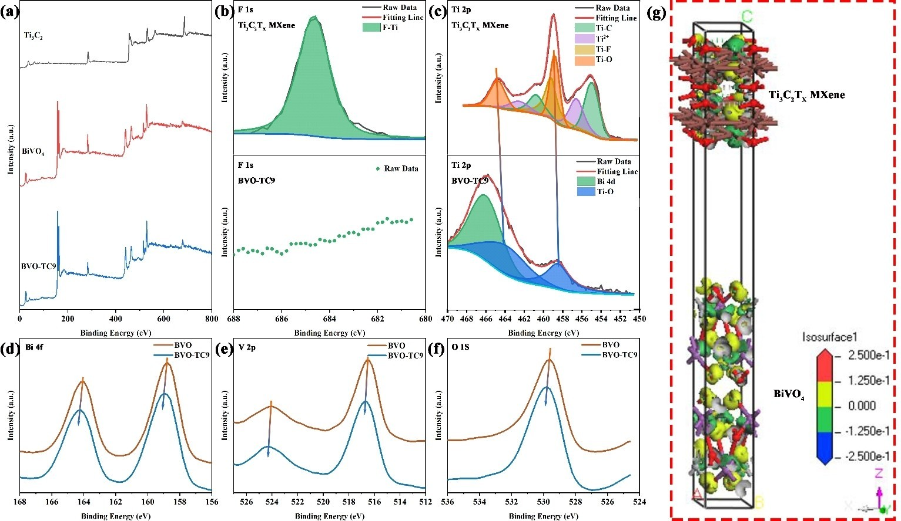

Figure 4. Survey XPS spectra of as-prepared catalysts (a). High resolution XPS spectrum of F 1s (b) and Ti 2p (c) of Ti3 C2Tx MXene and BVO-TC9. High resolution XPS spectrum of Bi 4 f (d), V 2p (e) and O 1s (f) of BiVO₄ and BVO-TC9. (g) The electron density difference at the interface of BiVO₄/Ti₃C₂O₂ MXene.

cally compounded BVO-TC9 and physically mixed BVO-TC9M were also carried out (see Figure S6). It could be found that the superiority of BVO-TC9 over BVO-TC9M in MB and Cr (VI) photoredox is due to the intimate interface formed by the chemical compound.
Photoelectrochemical measurement is an in-depth proof for charge separation to explain the corresponding photocatalytic performance. All the samples exhibit excellent light response
ability during the light-on and light-off cycles (Figure 5(e)). Obviously, all the BVO-TC samples show remarkable ■■high- er■■ photocurrent intensities than that of BiVO₄ while Ti₃C₂T_{x}
MXene has been reported to produce negligible photocurrent under irradiation according to previous work.^{[39]} Herein, the increase in photocurrent density of composites compared with pristine BiVO₄ is ascribed to the promotion of electron-hole separation by T_{i3}C₂T_{x} MXene. Thanks to the formed Schottky junction in BVO-TC9 composite, the charge transfer exhibits much reduced impedance (Figure5(f)). Steady photolumines- cence (PL) at an excitation wavelength of 325 nm was investigated to further demonstrate the charge separation caused by Schottky junction. Obviously, the BVO-TC9 catalyst exhibits substantially depressed PL emissions compared with that of pristine BVO, further confirming the better charge transfer ability within the BVO-TC nanosheets (Figure 5(g)).
According to the above results and analysis, a possible photocatalytic mechanism is proposed and illustrated in Scheme 1. As an n-type semiconductor, BiVO₄ has a Femi level near the conduction band,^{[40]} whereas Ti₃C₂T_{x} MXene has a higher work function and lower (more positive) Femi level than BiVO₄. The Fermi levels will approach each other at the interface
in composite and eventually reach an equilibrium, which will result in the electrons in the conduction band (CB) of BiVO₄ transfer to Ti₃C₂T_{x} MXene.^{[41]} At the same time, the unmigrated positive charges are still on the valance band (VB) of BiVO₄ and a space charge layer is formed at the interface with the upward bending of CB and VB for BiVO₄.^{[42]} Hence, a Schottky junction is formed between Ti₃C₂T_{x} MXene and BiVO₄. This junction will facilitate electron transfer to Ti₃C₂T_{x} MXene and realize the spatial charge separation. The introduced Ti₃C₂T_{x} MXene not only acts as the electron reservoir to capture the photo- generated electrons from BiVO₄ but also increases light harvest- ing as well as extends light absorption region. More impor- tantly, formed 2D-2D stack structure greatly improves the charge transfer efficiency. As a result, simultaneous removal of Cr (VI) and MB is realized efficiently on the surface of Ti₃C₂T_{x} MXene and BiVO₄ under visible light irradiation, respectively.

Conclusion

In summary, 2D/2D BiVO₄/Ti₃C₂T_{x} MXene composites as photo- catalyst were successfully fabricated under theoretical guidance. Simultaneous removal of toxic Cr (VI) and MB was efficiently realized on the surface of Ti₃C₂T_{x} MXene and BiVO₄ respectively due to the synergistic effects of the Schottky junction, built-in electric field, spatial charge separation, efficient charge transfer and enhanced light harvesting. The present work demonstrates a good example for theory-oriented catalyst design and sheds new light on simultaneously removing toxic heavy metal ions

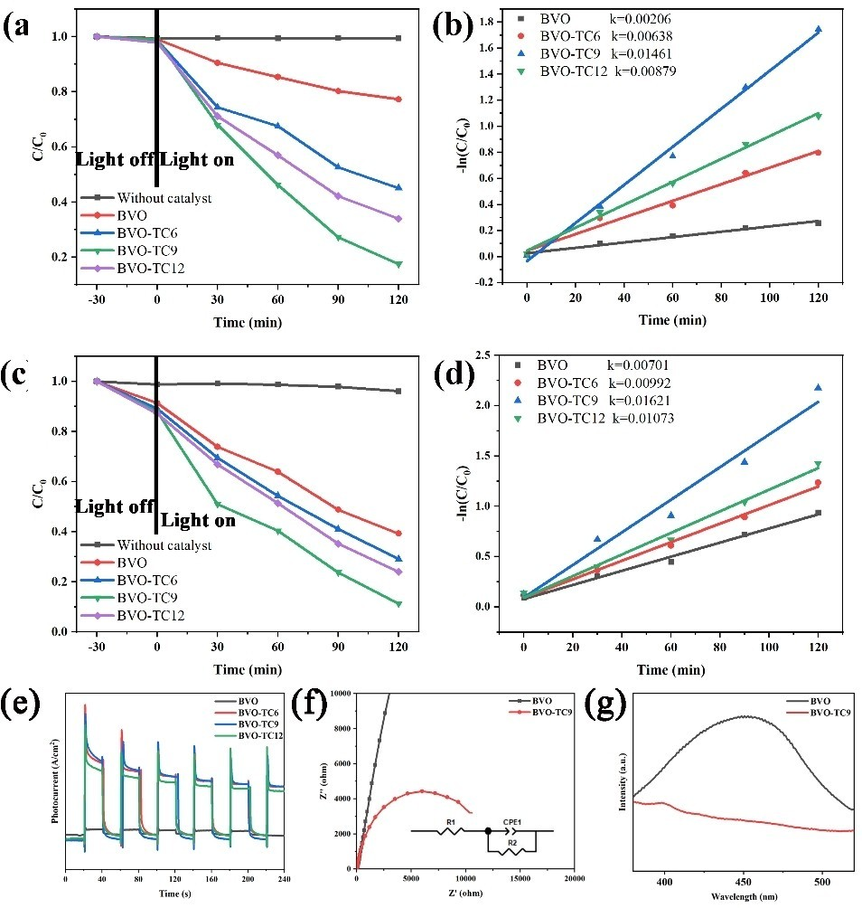

Figure 5. Photocatalytic curve (a) and first order plots for the photoreduction of Cr (VI) (b), photocatalytic curve (c) and first order plots for the photodegradation of MB (d), the transient photocurrent responses (e), EIS spectra (f) and PL spectra (g) of as-prepared catalysts.

and organic pollutants for environment remediation by solar- light driven photocatalysis.

Experimental Section

Compute details
Density functional theory (DFT) was carried out for the band structure and work function analysis by using the CASTEP package of Materials Studio. The Perdew-Burke-Ernzerhof (PBE) of the generalized gradient approximation (GGA) was used as the exchange-correlation function. An energy cutoff of 380 eV and a

Monkhorst-Pack k-point mesh of 5 × 5 × 1 was used to perform geometry optimization and electronic property calculations. The energy and force convergence criteria were set as 5 × 10^{—6} eV/atom and 0.01 eV/Å, respectively, and the SCF tolerance is 5 × 10^{—7} eV/ atom. The Adsorption Locator module in Materials Studio was used to calculate adsorption energy. The total calculation cycle was set to 3, with 15,000 steps per cycle. Both van der Waals forces and electrostatic forces were considered. For the electrostatic force terms, the Ewald & Group summation method was adopted with an accuracy of 0.001 kcal/mol, for the van der Waals terms, atom- based summation method is adopted with a cutoff distance of
12.5 Å. In order to get closer to the surface properties and avoid the influence of the periodic structure, a 20 Å thick vacuum slab is

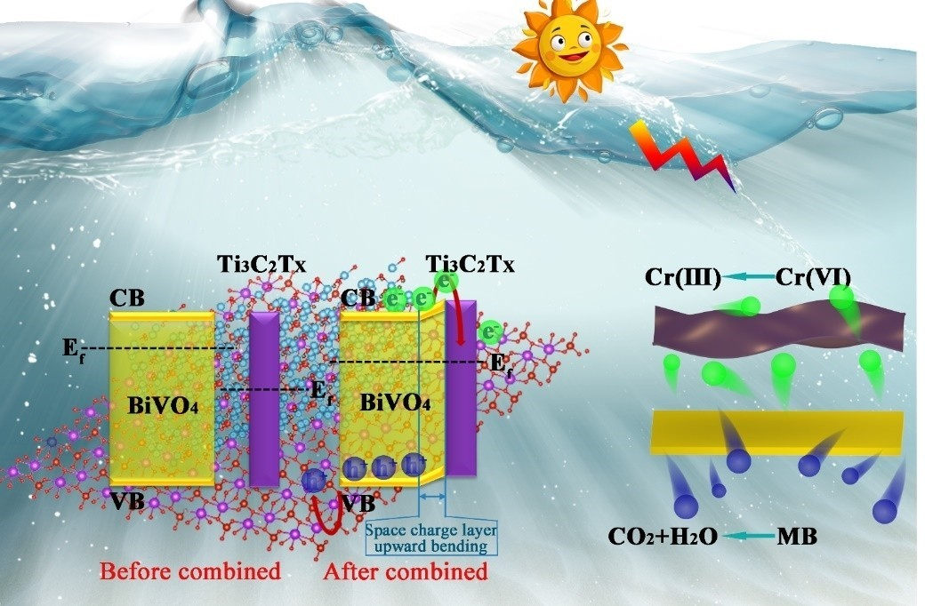

Scheme 1. Possible photocatalytic mechanism of the BVO-TC composite photocatalyst.

added on z direction to the calculation of work function and adsorption energy.

Photocatalyst preparation
Ti₃AlC₂ (MAX phase) powders (200 mesh; purity 98 %) were
Beijing Forsman Scientific Co. Ltd,

was also prepared as a control by the same procedure without added MXene.
The physically mixed BVO-TC was prepared by hand grinding. First, BiVO₄ and MXene in the same proportions as BVO-TC9 were added to the agate mortar, and after 20 minutes of uniform grinding, the powder was collected to obtain a physically mixed BVO-TC,

purchased from
and other
denoted as BVO-TC9M.

analytical grade chemical reagents were purchased from Shanghai Macklin Co., Ltd. without any further purification. 4 g LiF was added into 40 mL 9 M HCl, after stirring for a while, 4 g of Ti₃AlC₂ was slowly added to avoid an instantaneous violent reaction, and then the mixture was continuously stirred at 35 °C for 24 h. All the above operations are carried out in a fume hood, and the reaction vessel is a 150 mL Teflon bottle with a lid, while the lid is not completely tightened during the entire etching process. After a day and night, the suspension was centrifuged and washed with deionized water until pH > 6.0. The muddy precipitate was collected after filtration and washed with deionized water three times to remove residual LiF. The total water consumption was about two liters. Finally, the dark purple precipitate of multilayer Ti₃C₂T_{x} was obtained with metallic luster after freeze-dried at —50 °C for 24 hours (Scheme S1).
0.75 g Ti₃C₂T_{x} was exfoliated to prepare ultrafine Ti₃C₂T_{x} MXene with few layer or monolayer in 150 mL deionized water by treated with pulsed ultrasound for 2 h under ice bath and continuous N₂ bubble (ultrasonic power is 150 W, 3 s on/off). Then the suspension was centrifuged at 3500 rpm for 1 h and the upper liquid was freeze- dried to obtain the final product.
80 mg Bi(NO₃)₃ · 5H₂O and 100 mg Na₃VO₄ · 12H₂O were separately added to 40 mL of deionized water to prepare precursor A and B. A certain amount of Ti₃C₂T_{x} MXene was added to precursor A with vigorous stirring for 30 min. Then precursor B was added dropwise with continuous stirring for another 30 minutes. The mixture was transferred to a stainless-steel autoclave lined with Teflon and heated at 160 °C for 12 hours. The final composite was obtained after centrifuged, washed with deionized water for three times and
vacuum dried overnight. The obtained BiVO₄-Ti₃C₂T_{x} MXene composite photocatalyst is denoted as BVO-TCx (x= 6, 9 and 12, representing 6 mg, 9 mg and 12 mg Ti₃C₂T_{x} MXene). Pristine BiVO₄

Microstructural characterization
The crystallographic structure and phases were characterized by X- ray diffraction (XRD) (D/max 2400 X-ray diffraction) with Ni-filtered Cu K_{α} radiation. The morphology of as-prepared samples was observed by using a QUANTA200 field emission scanning electron microscope (FESEM) and transmission electron microscope (TEM, JEM-2010F-JEOL) with an accelerating voltage of 200 kV. The binding energies and surface termination groups were examined by X-ray photoelectron spectrometer (XPS, ESCALAB MK II) with Al K radiation. The ultraviolet visible diffuse reflectance spectra were characterized by ultraviolet visible (UV-vis) spectrophotometer (Shimadzu UV-3600 plus) using BaSO₄ as reference. The photo- luminescence (PL) spectra of the samples were recorded by a fluorescence spectrophotometer (FLS920) with an excitation wave- length of 325 nm. The electrochemical tests were carried out on the electrochemical workstation (CS310, Wuhan Corrtest).
—

Photocatalytic activity evaluation
The photocatalytic test was carried out in a mixed solution containing 50 ml 20 ppm MB and 50 ml 10 ppm K₂Cr₂O₇. The pH value was adjusted to ~ 3.0 to avoid the formation of Cr(OH)₃. The experiment details can refer to our previous report.^{[32]} The concentration of Cr (VI) is determined by measuring the absorption intensity of the reaction solution at a wavelength of 540 nm using DPC chromogenic method, while the concentration of MB is determined by the absorbance of the reaction solution before color reaction.

Photoelectrochemical measurement
Fluorine-doped tin oxide (FTO) glasses (1 cm × 2 cm) were pre- washed by acetone, alcohol, deionized water for 15 minutes by sonication, and then dried with N₂ flow. The working electrode was prepared by dip-coating 0.1 mL photocatalyst slurry (20 mg photo- catalyst was mixed with 2 mL of ethylene glycol and 2 mL of ethanol) on the FTO with a working area of 1 cm². Photo- electrochemical measurements were performed in a standard three-electrode system by using the prepared FTO with photo- catalyst films as the working electrode, a Pt foil as the counter electrode, Ag/AgCl (saturated in KCl) as the reference electrode and
0.5 M Na₂SO₄ as the electrolyte.

Acknowledgements

This work is supported by the Chinese National Natural Science Foundation (Grand No. 52064032), the Yunnan science and technology projects (Grant No. 2019ZE001, No. 202002AB080001), Yunnan Ten Thousand Talents Plan Young & Elite Talents Project (YNWR-QNBJ-2018-005).

Conflict of Interest

The authors declare no conflict of interest.
Keywords: DFT · 2D/2D heterojunction · Ti₃C₂T_{x} MXene · Cr (VI) detoxification · Methylene blue oxidation

- Y. Deng, L. Tang, G. Zeng, Z. Zhu, M. Yan, Y. Zhou, J. Wang, Y. Liu, J. Wang, Appl. Catal. B 2017, 203, 343–354.
- F. Jing, R. Liang, J. Xiong, R. Chen, S. Zhang, Y. Li, L. Wu, Appl. Catal. B
2017, 206, 9–15.
- V. K. Gupta, A. Rastogi, A. Nayak, J. Colloid Interface Sci. 2010, 342, 135– 141.
- P. Miretzky, A. F. Cirelli, J. Hazard. Mater. 2010, 180, 1–19.
- H. Yu, S. Chen, X. Quan, H. Zhao, Y. Zhang, Environ. Sci. Technol. 2008,
42, 3791–3796.
- Q. Wang, R. Jin, C. Yin, M. Wang, J. Wang, S. Gao, Sep. Purif. Technol.
2017, 172, 303–309.
- Q. Wang, X. Chen, K. Yu, Y. Zhang, Y. Cong, J. Hazard. Mater. 2013, 246– 247, 135–144.
[13] L. Lin, Z. Lin, J. Zhang, X. Cai, W. Lin, Z. Yu, X. Wang, Nat. Catal. 2020, 3, 649–655.
[14] S. Selcuk, A. Selloni, Nat. Mater. 2016, 15, 1107–1112.
- J. Li, W. Zhang, M. Ran, Y. Sun, H. Huang, F. Dong, Appl. Catal. B 2019,
243, 313–321.
- J. Li, X. Dong, Y. Sun, W. Cen, F. Dong, Appl. Catal. B 2018, 226, 269–277.
- S. Pu, Y. Hou, H. Chen, D. Deng, Z. Yang, S. Xue, R. Zhu, Z. Diao, W. Chu,
Catalysts, DOI:10.3390/catal8060251.
- Q. Wang, P. Dong, Z. Huang, X. Zhang, Chem. Phys. Lett. 2015, 639, 11– 16.
- C. Ma, Z. Yang, W. Wang, M. Zhang, X. Hao, S. Zhu, S. Chen, J. Mater. Chem. C 2020, 8, 2888–2898.
[20] A. Kudo, K. Omori, H. Kato, J. Am. Chem. Soc. 1999, 121, 11459–11467.
- A. Iwase, Y. H. Ng, Y. Ishiguro, A. Kudo, R. Amal, J. Am. Chem. Soc. 2011,
133, 11054–11057.
- T. Tachikawa, T. Ochi, Y. Kobori, ACS Catal. 2016, 6, 2250–2256.
- W. Zhu, M. Shen, G. Fan, A. Yang, J. R. Meyer, Y. Ou, B. Yin, J. Fortner, M. Foston, Z. Li, Z. Zou, B. Sadtler, ACS Appl. Nano Mater. 2018, 1, 6683– 6691.
- Y. Xu, C. Cheng, S. Du, J. Yang, B. Yu, J. Luo, W. Yin, E. Li, S. Dong, P. Ye, X. Duan, ACS Nano 2016, 10, 4895–4919.
- L. Wang, J. Ge, A. Wang, M. Deng, X. Wang, S. Bai, R. Li, J. Jiang, Q. Zhang, Y. Luo, Y. Xiong, Angew. Chem. Int. Ed. 2014, 53, 5107–5111; Angew. Chem. 2014, 126, 5207–5211.
- L. G. Devi, R. Kavitha, Appl. Surf. Sci. 2016, 360, 601–622.
- Z. Kang, Y. Ma, X. Tan, M. Zhu, Z. Zheng, N. Liu, L. Li, Z. Zou, X. Jiang, T. Zhai, Y. Gao, Adv. Electron. Mater. 2017, 3, 1700165.
- Z. Wang, H. Kim, H. N. Alshareef, Adv. Mater. 2018, 30, 1706656.
- M. Mariano, O. Mashtalir, F. Q. Antonio, W. H. Ryu, B. Deng, F. Xia, Y. Gogotsi, A. D. Taylor, Nanoscale 2016, 8, 16371–16378.
- A. Agresti, A. Pazniak, S. Pescetelli, A. Di Vito, D. Rossi, A. Pecchia, M. Auf der Maur, A. Liedl, R. Larciprete, D. V. Kuznetsov, D. Saranin, A. Di Carlo, Nat. Mater. 2019, 18, 1228–1234.
- C. Peng, P. Wei, X. Li, Y. Liu, Y. Cao, H. Wang, H. Yu, F. Peng, L. Zhang, B. Zhang, K. Lv, Nano Energy 2018, 53, 97–107.
[32] P. Liu, J. Yi, R. Bao, D. Fang, New J. Chem. 2019, 43, 7482–7490.
- V. I. Merupo, S. Velumani, G. Oza, M. Makowska-Janusik, A. Kassiba,
Mater. Sci. Semicond. Process. 2015, 31, 618–623.
- X. Xie, N. Zhang, Z. R. Tang, M. Anpo, Y. J. Xu, Appl. Catal. B 2018, 237, 43–49.
[35] Z. Pan, F. Cao, X. Hu, X. Ji, J. Mater. Chem. A 2019, 7, 8984–8992.
- M. Yu, S. Zhou, Z. Wang, J. Zhao, J. Qiu, Nano Energy 2018, 44, 181–190.
- J. Halim, K. M. Cook, M. Naguib, P. Eklund, Y. Gogotsi, J. Rosen, M. W. Barsoum, Appl. Surf. Sci. 2016, 362, 406–417.
- T. Cai, L. Wang, Y. Liu, S. Zhang, W. Dong, H. Chen, X. Yi, J. Yuan, X. Xia, C. Liu, S. Luo, Appl. Catal. B 2018, 239, 545–554.
- S. Cao, B. Shen, T. Tong, J. Fu, J. Yu, Adv. Funct. Mater. 2018, 28, 1800136.
- M. S. Rogalski, S. B. Palmer, Solid state physics, 2014.
- H. Yan, J. Yang, G. Ma, G. Wu, X. Zong, Z. Lei, J. Shi, C. Li, J. Catal. 2009,
266, 165–168.
[42] J. Yang, D. Wang, H. Han, C. Li, Acc. Chem. Res. 2013, 46, 1900–1909.

- C. Tang, E. Liu, J. Wan, X. Hu, J. Fan, Appl. Catal. B 2016, 181, 707–715.
- S. Ida, A. Takashiba, S. Koga, H. Hagiwara, T. Ishihara, J. Am. Chem. Soc.
2014, 136, 1872–1878.
- M. Mittal, A. Gupta, O. P. Pandey, Sol. Energy 2018, 165, 206–216.

- L. Pan, M. Ai, C. Huang, L. Yin, X. Liu, R. Zhang, S. Wang, Z. Jiang, X. Zhang, J. J. Zou, W. Mi, Nat. Commun. 2020, 11, 1–9.
- X. Hao, Y. Wang, J. Zhou, Z. Cui, Y. Wang, Z. Zou, Appl. Catal. B 2018,
221, 302–311.
Manuscript received: February 27, 2021
Revised manuscript received: March 29, 2021
Accepted manuscript online: April 6, 2021 Version of record online: ■■■, ■■■■

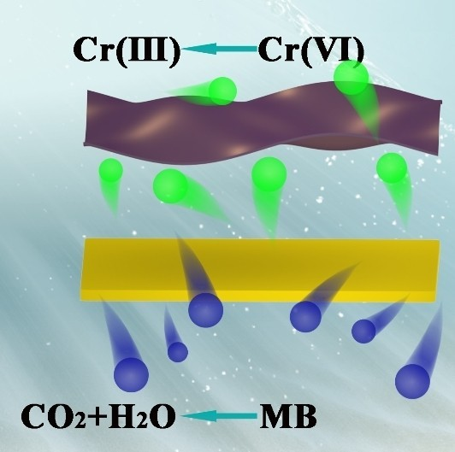
FULL PAPERS

P. Liu, Prof. J. Yi*, Prof. R. Bao*, Dr. H. Zhao*
1 – 9
Theory-oriented Synthesis of 2D/ 2D BiVO₄/MXene Heterojunction
for Simultaneous Removal of Hex- avalent Chromium and Methylene Blue

&&&Dear Author, please provide a TOC text (about three short sentences, which summarize the content of your article). This text will

appear together with the TOC figure on the first pages of the online issue, if your article will become part of this issue.&&&

 Theory-oriented synthesis of 2D/2D BiVO4/MXene heterojunction for simultaneous removal of hexavalent chromium and methylene blue (Peng Liu,Jianhong Yi, Rui Bao, Heng Zhao from Kunming
University of Science and Technology @UCalgary)

Share your work on social media! ChemCatChem has added Twitter as a means to promote your article. Twitter is an online microblogging service that enables its users to send and read short messages and media, known as tweets. Please check the pre-written tweet in the galley proofs for accuracy. If you, your team, or institution have a Twitter account, please include its handle @username. Please use hashtags only for the most important keywords, such as #catalysis, #nanoparticles, or #proteindesign. The ToC picture and a link to your article will be added automatically, so the tweet text must not exceed 250 characters. This tweet will be posted on the journal's Twitter account (follow us @ChemCatChem) upon publication of your article in its final (possibly unpaginated) form. We recommend you to re-tweet it to alert more researchers about your publication, or to point it out to your institution's social media team.

ORCID (Open Researcher and Contributor ID)
Please check that the ORCID identifiers listed below are correct. We encourage all authors to provide an ORCID identifier for each coauthor. ORCID is a registry that provides researchers with a unique digital identifier. Some funding agencies recommend or even require the inclusion of ORCID IDs in all published articles, and authors should consult their funding agency guidelines for details. Registration is easy and free; for further information, see http://orcid.org/.

Peng Liu

Prof. Jianhong Yi
Prof. Rui Bao http://orcid.org/0000-0002-5826-2316 Dr. Heng Zhao

