

Environmental Research 193 (2021) 110587
Contents lists available at ScienceDirect

Environmental Research
journal homepage: www.elsevier.com/locate/envres

Facile hydrothermal synthesis of rod-like Nb₂O₅/Nb₂CT_{x} composites for  visible-light driven photocatalytic degradation of organic pollutants
Ce Cui a, Ronghui Guo a,*, Erhui Ren a, Hongyan Xiao a, Xiaoxu Lai a, Qin Qin a,
Shouxiang Jiang b, Hong Shen a, Mi Zhou a, Wenfeng Qin c
a College of Biomass Science and Engineering, Sichuan University, Chengdu, 610065, China
b Institute of Textiles and Clothing, The Hong Kong Polytechnic University, Kowloon, Hong Kong, China
c Aviation Engineering Institute, Civil Aviation Flight University of China, Guanghan, China

A R T I C L E I N F O

Keywords:
Nb₂CT_{x}
Rod-like Nb₂O₅/Nb₂CT_{x} Hydrothermal oxidation Photocatalytic degradation Organic pollutants
A B S T R A C T

The MXene-based transition metal oxide composite is a potential candidate for photocatalysts. Rod-like pseu- dohexagonal phase Nb₂O₅/Nb₂CT_{x} composites were synthesized by a simple hydrothermal oxidation of 2D layered Nb₂CT_{x}. The Nb₂O₅/Nb₂CT_{x} composites show superior photocatalytic activity for 98.5% of degradation of Rhodamine B (RhB) for 120 min and 91.2% of tetracycline hydrochloride (TC-HCl) for 180 min under visible light irradiation. The Schottky junction is formed between Nb₂O₅ nanorods and Nb₂CT_{x} and the photo-generated carriers are effectively separated, enhancing the photocatalytic activity of the Nb₂O₅/Nb₂CT_{x}. High photoactivity and cycle stability of Nb₂O₅/Nb₂CT_{x} composites indicate that hydrothermal oxidation of 2D layered Nb₂CT_{x} is an alternative to prepare efficient photocatalyst for degradation of organic pollutants.

Introduction
In recent years, worldwide water pollution caused by discharge or improper handling of organic pollutants such as dyes and antibiotics has become a huge challenge to ecosystem and human life (Adhikari et al., 2019; Di et al., 2015; Lin et al., 2017b; Rimoldi et al., 2017). The pho- tocatalysts with high specific surface area and excellent photoactivity are highly efficient materials to removing contaminants from water. Nb₂O₅, as a typical transition metal oxide semiconductor photocatalyst exhibits good chemical stability, nontoxicity and commercial avail- ability (Chen et al., 2017; Hong et al., 2016; Li et al., 2013; Oliveira et al., 2014; Zhang et al., 2018). Nevertheless, Nb₂O₅ suffers charge recombination of photogenerated electrons and holes, resulting in
MXenes, as a new family of 2D materials, exhibit excellent structural stability, electrical conductivity and surface hydrophilicity (Ding et al., 2017; Ran et al., 2017; Wang et al., 2018; Zhao et al., 2019). MXene have been served as cocatalysts for photocatalysts to accelerate the separation of charge carriers (Liu et al., 2018; Wang et al., 2016). Recently, the heterogeneous compounds composed of MXene and cor- responding oxides have been used in the field of photocatalysis (Peng et al., 2017; Shahzad et al., 2018). A hybrid composed of (001) TiO₂ nanosheets and layered Ti₃C₂ MXene exhibits enhanced photocatalytic degradation of dyes (Peng et al., 2016). Nb₂CT_{x} MXene has been used as a promising co-catalyst for photocatalytic hydrogen evolution of TiO₂. Nb₂CT_{x} was more beneficial to improve photocatalytic activity of TiO₂ than Ti₃C₂T_{x} (Wang et al., 2016). Recently, Nb₂O₅/C/Nb₂C hybrid

limited photocatalytic efficiency (Wang et al., 2019). Therefore, con-
material was synthesized by one-step CO₂ oxidation technique of

struction of heterojunctions is an effective method to enhance the photoactivity of Nb₂O₅. Currently, some heterojunctions such as g-C₃N₄/Nb₂O₅, TiO₂/Nb₂O₅ and rGO/Nb₂O₅ have been used in photo- oxidation of pollutants and photocatalytic hydrogen generation (da Silva et al., 2017; Li et al., 2019a; Li et al., 2019b; Ren et al., 2019; Yi et al., 2019). However, molecular-scale interfacial heterojunction causes defect-induced recombination of photogenerated carriers, which affects photocatalytic performance.
Nb₂CT_{x} for hydrogen production (Su et al., 2018). However, the morphology of Nb₂O₅ cannot be effectively controlled to further improve the photocatalytic activity of the composite. Generally, the activity of Nb₂O₅ can be significantly affected by its shape and surface structure (Du et al., 2018; Wang et al., 2019). Nb₂O₅ with nanowires, nanospheres, nanorods and other special shape can increase their spe- cific surface area, thereby enhancing photocatalytic performance (Jiang et al., 2018; Li et al., 2013; Qamar et al., 2015; Zhang et al., 2018; Zhao

* Corresponding author.
E-mail address: ronghuiguo214@126.com (R. Guo).
https://doi.org/10.1016/j.envres.2020.110587
Received 17 February 2020; Received in revised form 30 October 2020; Accepted 2 December 2020
Available online 9 December 2020
0013-9351/© 2020 Elsevier Inc. All rights reserved.

et al., 2012). Although the composites of Nb₂O₅ and Nb₂CT_{x} were fabricated for charge storage and hydrogen production (Liu et al., 2018; Zhang et al., 2016a), however, the complex of Nb₂O₅ and Nb₂CT_{x} with special morphology for photocatalytic degradation of organic pollutants have not been reported.
In this study, the layered Nb₂CT_{x} was used to fabricate rod-like Nb₂O₅/layered Nb₂CT_{x} (Nb₂O₅/Nb₂CT_{x}) composite through a facile hydrothermal oxidation with no additional Nb source (Fig. 1). The Nb₂O₅ nanorods were grown on the surface of Nb₂CT_{x} during hydro- thermal oxidation of Nb₂CT_{x}. The visible-light photocatalytic activity of Nb₂O₅/Nb₂CT_{x} composites was evaluated by decomposition of the representative rhodamine B (RhB) and tetracycline hydrochloride (TC- HCl).

Experimental
  - Materials and reagents

Hydrofluoric acid (HF, content 40.0%), rhodamine B (RhB) and tetracycline hydrochloride (TC-HCl) were provided by Chengdu Kelong chemical reagent factory Co., Ltd., China. Nb₂AlC (200 M) was pur- chased from Forsman Scientific (Beijing) Co., Ltd.
≥
  - Synthesis of layered Nb₂CT_{x}

In order to synthesize layered Nb₂CT_{x}, 1 g Nb₂AlC was placed into 60 mL HF solution (content 40.0%) and stirred at 55 ◦C for 90 h. The resulting suspension was centrifuged with deionized water for several times until pH ≥ 6. The layered Nb₂CT_{x} sediment was then dried.
≥
  - Synthesis of Nb₂O₅/Nb₂CT_{x}

60 mg layered Nb₂CT_{x} was added in 150 mL deionized water and stirred for 1 h to form suspension. The suspension was then transferred into an autoclave for hydrothermal oxidation at 200 ◦C for 12 h, 18 h and 30 h, respectively. The Nb₂O₅/Nb₂CT_{x} samples were then obtained and denoted as Nb₂CT_{x}-12, Nb₂CT_{x}-18 and Nb₂CT_{x}-30, respectively.
For comparison, the pure Nb₂O₅ was prepared by calcination of Nb₂CT_{x} in air at 800 ◦C for 2 h and denoted as C–Nb₂O₅.

  - Characterization

Morphologies of the Nb₂CT_{x}-12, Nb₂CT_{x}-18, Nb₂CT_{x}-30 and
C–Nb₂O₅ were observed by a field emission scanning electron micro- scopy (SEM) (JSM-5900LV) and transmittance electron microscopy (TEM) (Tecnai G-F20). XRD patterns were recorded on an X-ray diffractometer under Cu Kα radiation (λ 1.54 Å) at 40 kV and 40 mA. X-ray photoelectron spectroscopy (Thermo Scientific Escalab 250Xi) was used to determine chemical composition of Nb₂CT_{x}-30. Raman spectra were obtained by Andor SR-500i spectrometer with laser exci- tation at λ = 532 nm. The BET surface areas were obtained by a Micromeritics Gemini VII 2390 system. UV–vis diffuse reflectance spectra (DRS) in the range of 200-800 nm were carried out on a UV–Vis spectrophotometer (UV-2700, Shimadzu, Japan). Fluorescence spec- trometer (FLS1000, Edinburgh) was used to measure photo- luminescence (PL) spectra at an excitation source of 325 nm. Electron paramagnetic resonance (EPR, Bruker EMXplus) spectrometer was used to detect the active species and the DMPO was used as capture agents for
and •OH.
=

  - Photoelectrochemical properties measurement

Photoelectrochemical measurements were conducted in a standard three-electrode system using an electrochemical workstation (CHI 660 E, China). ITO with coated samples, platinum plate and Ag/AgCl elec- trode were used as working electrode, counter electrode and reference electrode, respectively. The preparation of the working electrode was listed as follows. 4 mg of photocatalysts were added in the mixed 500 μL
solution of Nafion/ethanol (1:4) and sonication for 1 h. The photo- catalysis dispersion (5 μL) was coated on the ITO glass (1 cm2). 0.2 mol L—1 Na₂SO₄ was used as the electrolyte for the electrochemical imped-
ance spectroscopy (EIS), Mott-Schottky (M-S) curve and photocurrent measurement.

  - Photocatalytic degradation measurement

The photocatalytic degradation properties of Nb₂O₅/Nb₂CT_{x} for RhB dye and TC-HCl were evaluated in a glass vessel under visible-light irradiation using a 500 W Xe lamp (GXZ500, Shanghai, China). 25 mg
of the photocatalyst was placed into 25 mL solution of pollutant (10 mg
L—1). The suspension was magnetically stirred in the dark for 30 min to arrive at the adsorption-desorption equilibrium. For the photocatalytic degradation tests, 5 mL solution was taken out every 10 min and sepa- rated by filtration. The residual concentrations of RhB and TC-HCl in solution was tested using a 4802 double beam UV–vis spectrophotom- eter according to their absorbance at 550 nm and 356 nm, respectively.

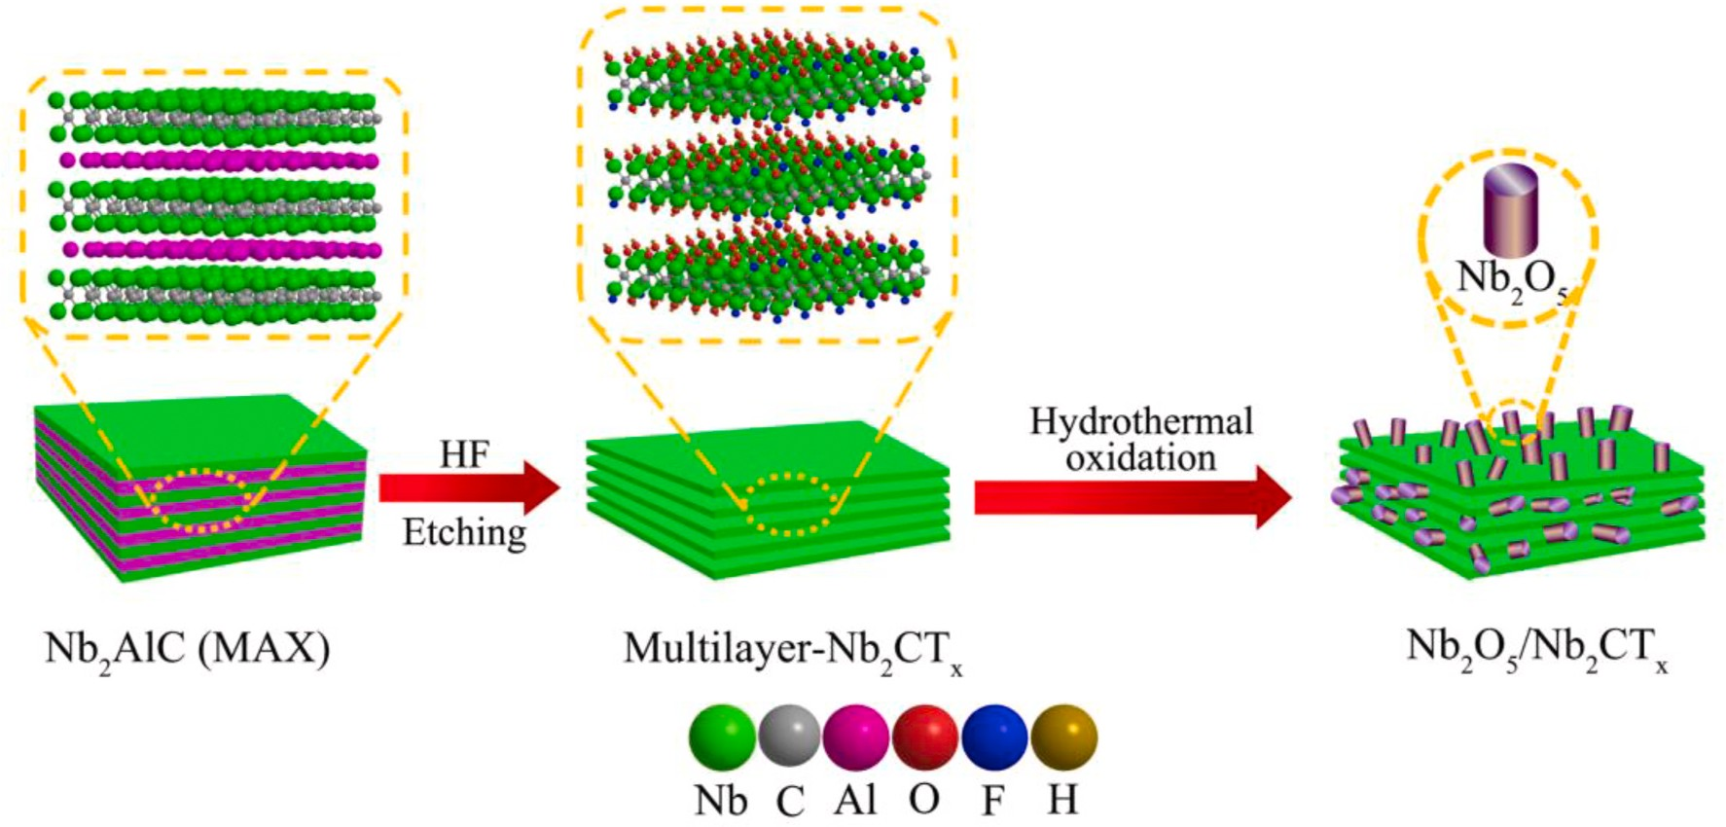
Fig. 1. Illustration of preparation of rod-like Nb₂O₅/Nb₂CT_{x} composites.

The stability and reusability of the photocatalyst were evaluated by photodegrading RhB for five cycles. For recycling test, the catalysts were rinsed with deionized water and ethanol for several times and dried under vacuum at 60 ◦C before each test. In order to evaluate the main active species in the photocatalytic reaction, t-butanol, benzoquinone
(BQ) and EDTA-2Na were selected as trapping reagent of hydroxyl radicals (•OH), superoxide radical (•OH₂—) and holes (h+), respectively.
The concentrations of trapping reagent are both 1 mmol/L, and the trapping experimental processes are similar to the photocatalytic ac- tivity test.

Results and discussion

X-ray diffraction (XRD) patterns of the Nb₂AlC and Nb₂CT_{x} are shown in Fig. 2a. Compared with the (002) peak at 12.8◦ of Nb₂AlC, the newly emerged low-angle (002) peak of Nb₂CT_{x} is typical for MXene (Lin et al., 2017a). In addition, XRD pattern of Nb₂CT_{x} reveals disap- pearance of the most intense peaks of Nb₂AlC at 2θ 39◦, which implies thoroughly removal of interlayer Al (Mashtalir et al., 2015). The (002) peak of Nb₂CT_{x} significantly broadens and shifts toward a lower 2θ angle of 9.3◦, suggesting that the layered Nb₂CT_{x} MXene is formed. Fig. 2b shows XRD patterns of Nb₂CT_{x} after hydrothermal oxidation. Charac- teristic peaks at 22.5◦, 28.2◦, 36.6◦, 46.1◦, 50.1◦, 54.8◦ and 55.7◦ correspond to (001), (100), (101), (002), (110), (102) and (111) planes of the pseudohexagonal phase of Nb₂O₅, respectively (Yang et al., 2017; Zhao et al., 2012). As the hydrothermal time prolongs, the intensity of diffraction peak of Nb₂O₅ increases, revealing that the crystallite sizes of Nb₂O₅ increase. Enhancement of the relative peak intensity of the (001) peak illustrates a significantly preferred orientation of the (001) crystal face in the Nb₂O₅ materials (Chen et al., 2017). The diffraction peaks of
≈
Nb₂CT_{x} cannot be observed in the XRD patterns of Nb₂CT_{x}-12, Nb₂CT_{x}-18 and Nb₂CT_{x}-30, indicating that the surface of the Nb₂CT_{x} is completely covered by Nb₂O₅. The characteristic peaks of pseudohex- agonal phase Nb₂O₅ and orthorhombic phase Nb₂O₅ are observed in XRD pattern of C–Nb₂O₅, indicating the presence of mixed phases in C–Nb₂O₅. The catalytic activity of pseudohexagonal phase Nb₂O₅ is higher than that of orthorhombic phase Nb₂O₅, indicating that the cat- alytic activity of Nb₂O₅ depends on its crystalline phases (Murayama
et al., 2014). In addition, the Raman spectra of Nb₂CT_{x}-30 and C–Nb₂O₅ are presented in Fig. S1. The characteristic peaks at 239 cm—1 and 709 cm—1 of Nb₂CT_{x}-30 and C–Nb₂O₅ are assigned to Nb₂O₅. Peaks at 529, 903 and 1558 cm—1 corresponding to the characteristics of Nb₂CT_{x} can
be obviously observed in Raman spectrum of Nb₂CT_{x}-30. The results reveal that the Nb₂CT_{x} is partially oxidized during the hydrothermal treatment and Nb₂O₅ is formed on the Nb₂CT_{x}.
SEM images of the Nb₂AlC, Nb₂CT_{x}, Nb₂O₅/Nb₂CT_{x} composites and
C–Nb₂O₅ are shown in Fig. 3 and Fig. S2. Compared with the bulk Nb₂AlC (Fig. S2a), the Nb₂CT_{x} (Fig. S2b) is composed of numerous stacked layers. Fig. 3a–c show the morphologies of Nb₂O₅/Nb₂CT_{x} composites. The Nb₂O₅ nanorods are grown on the surface of the Nb₂CT_{x} layers after hydrothermal oxidation for 12 h as shown in Fig. 3a. The formation of Nb₂O₅ nanorods can be explained by the fact that Nb₂O₅ are firstly nucleated on the external or interior Nb₂CT_{x} layers during hydrothermal treatment and the F group on the surface of Nb₂CT_{x} can be regarded as directing reagent (Zhang et al., 2016b). The number of high energy (001) facets is increased during the continuous crystal growth due to the lower energy of (101) planes adsorbing F group. Accordingly, Nb₂O₅ nanorods with abundant (001) facets are formed (Dong et al., 2017; Li et al., 2019b; Zhou et al., 2013). The amount of Nb₂O₅ nanorods increase (Fig. 3b and c) with the rise of the time of hydrothermal oxidation because prolonged oxidation time is beneficial to growth of Nb₂O₅ along the rod orientation. However, the Nb₂O₅ particles obtained from Nb₂CT_{x} by calcination (C–Nb₂O₅) are agglomerated into a whole bulk as shown in Fig. 3d. Fig. 3e shows SEM of Nb₂CT_{x}-30 sample and corresponding element mapping of Nb, O and C. The distribution of O and Nb elements is homogeneous, indicating that Nb₂O₅ nanorods are grown uniformly on the surface of the Nb₂O₅/Nb₂CT_{x} composite. A small amount of C element is distributed on the surface of the Nb₂CT_{x}-30, indicating Nb₂CT_{x} is completely covered with Nb₂O₅ nanorods. In addition, abundant C elements on the edge come from the background.
TEM images of Nb₂O₅/Nb₂CT_{x} composite (Nb₂CT_{x}-30) are shown in
Fig. 3f–h and the rod-like Nb₂O₅ can be obviously observed. The red circle in Fig. 3f shows the interface of Nb₂O₅ and Nb₂CT_{x}, which indicate the successfully growth of Nb₂O₅ nanorods on the Nb₂CT_{x}. The HRTEM image of Nb₂O₅/Nb₂CT_{x} sample (Fig. 3g) shows the crystalline structure with a lattice spacing of 0.394 nm, which match well with the (001) plane of Nb₂O₅. The (001) plane exposes a mass of active sites, which is conductive to improving the photocatalytic activity (Jiang et al., 2018). In addition, the interplanar spacing of 0.214 nm corresponds to the
(421) plane of Nb₂CT_{x} as shown in Fig. 3g and h (Jin et al., 2019). XPS spectra of Nb₂CT_{x}, Nb₂CT_{x}-30 and C–Nb₂O₅ are illustrated in
Fig. 4. The Nb 3 d is fitted with three doublets (Nb 3d_{5/2}-Nb 3d_{3/2}) (Fig. 4a). The binding energies peaks at 207.1 (Nb 3d_{5/2}) and 209.9 eV (Nb 3d_{3/2}) in the XPS spectrum of Nb 3 d component are attributed to the strong Nb spin-orbital doublet, which is consistent with the binding energies of Nb₂O₅ (Liu et al., 2018). The Nb₂O₅ exist in Nb₂CT_{x} because Nb₂CT_{x} is slowly oxidized in air to form ultrasmall clusters on the sur- face (Liu et al., 2018). Several weak peaks in the XPS spectrum of Nb₂CT_{x} sample are assigned to Nb(4+)-O, Nb(3+)-O and Nb(I, II)–C bonds. The XPS spectrum of Nb₂CT_{x}-30 is only fitted with one doublets peak, which corresponds to the binding energies of Nb₂O₅. Peaks of

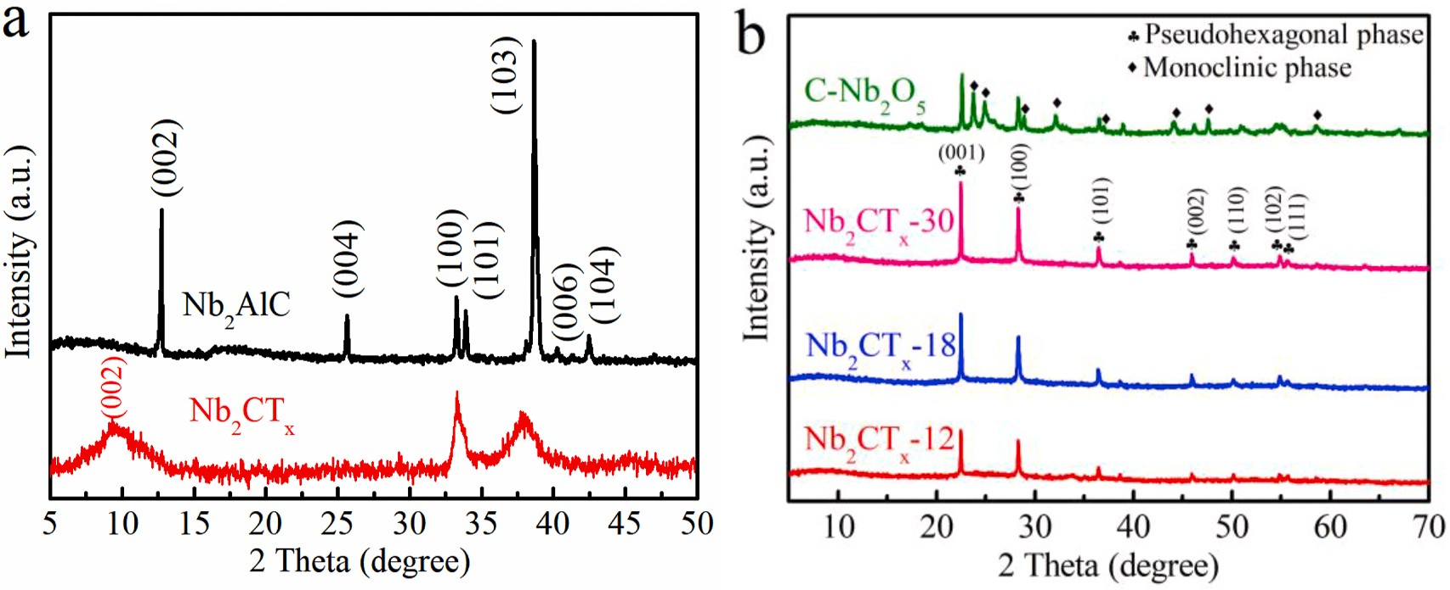
Fig. 2. XRD patterns of (a) Nb₂AlC, Nb₂CT_{x} and (b) Nb₂CT_{x}-12, Nb₂CT_{x}-18, Nb₂CT_{x}-30 and C–Nb₂O₅.

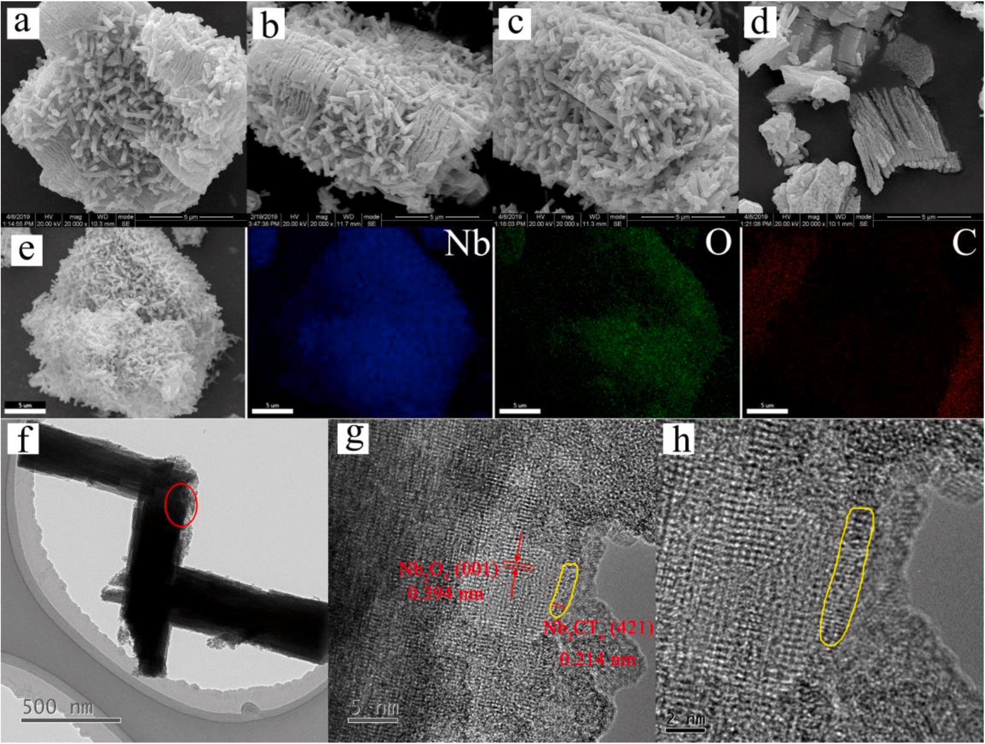
Fig. 3. SEM images of (a)–(c) Nb₂CT_{x}-12, Nb₂CT_{x}-18, Nb₂CT_{x}-30 and (d) C–Nb₂O₅; (e)SEM image of Nb₂CT_{x}-30 and corresponding elemental mapping images of Nb, O and C; (f)–(h) TEM image and HRTEM image of Nb₂CT_{x}-30.

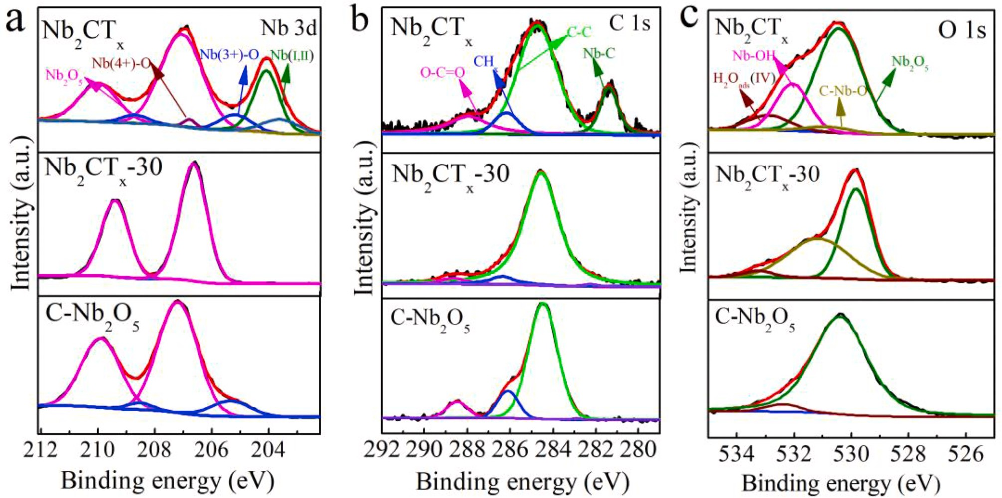
Fig. 4. High-resolution XPS peak of (a) Nb 3 d, (b) C1s, and (c) O 1s peaks in Nb₂CT_{x}, Nb₂CT_{x}-30 and C–Nb₂O₅.

Nb₂CT_{x} are not observed in the Nb₂CT_{x}-30 spectrum, which reveals that the surface of Nb₂CT_{x}-30 is completely covered with Nb₂O₅. The C 1s spectrum of Nb₂CT_{x} is fitted by four components located at 281.4, 284.7,
286.2 and 288.0 eV, corresponding to Nb–C, C–C, CH_{x} and O–C–O
bonds, respectively (Hu et al., 2019) (Fig. 4b and Table S1). The O 1s region of Nb₂CT_{x} at 530.4, 530.8, 532.0 and 533.3 eV correspond to Nb₂O₅, C–Nb–O, Nb–OH and H₂O_{ads}(Ⅳ), respectively (Fig. 4c). How- ever, Nb–OH bonds cannot be found in Nb₂CT_{x}-30 and C–Nb₂O₅ because the OH groups on the surface disappear after oxidation of Nb₂CT_{x}. In addition, the enhanced intensity of C–Nb–O bond in Nb₂CT_{x}-30 suggests the increased interaction at the interface of Nb₂O₅–Nb₂CT_{x}.
In order to evaluate the surface areas of Nb₂CT_{x}-30 and C–Nb₂O₅, the nitrogen adsorption/desorption isotherms of Nb₂CT_{x}-30 and C–Nb₂O₅
are illustrated in Fig. 5a. The specific surface area of Nb₂CT_{x}-30 and C–Nb₂O₅ are calculated to be 14.075 m2g-1 and 3.967 m2g-1, respec- tively. The pore-diameter distribution curves are shown in Fig. 5b. It can
be observed that the pore diameter of C–Nb₂O₅ exceeds 100 nm, while the size of Nb₂CT_{x}-30 is about 10 nm. Compared with the bulk C–Nb₂O₅, specific surface area of Nb₂CT_{x}-30 is higher than that of C–Nb₂O₅ because plenty of Nb₂O₅ nanorods are grown on the surface of Nb₂CT_{x}- 30, which provides abundant small pores. The improved specific surface area of Nb₂CT_{x}-30 exposes more activity sites and small pore diameter facilitates the absorption and reactant of active species on their surface, contributing to improve photocatalytic activity.
The optical absorption properties of the Nb₂CT_{x}, Nb₂O₅/Nb₂CT_{x} composites and C–Nb₂O₅ were measured by UV–vis DRS. The Nb₂O₅/ Nb₂CT_{x} composites exhibit a strong absorption in the visible-light region as shown in Fig. 6a due to the full-spectrum absorption of Nb₂CT_{x} (Li et al., 2019b). It can be observed that the Nb₂O₅/Nb₂CT_{x} composites possess absorption in the visible-light region, which contributes to enhance the photoactivity in the visible-light region. In addition, the absorption intensity of Nb₂CT_{x}-12, Nb₂CT_{x}-18 and Nb₂CT_{x}-30 decrease successively in the wide visible range due to the extension of hydro- thermal oxidization time, which cause that more Nb₂CT_{x} is conversed to Nb₂O₅. The C–Nb₂O₅ exhibits significant absorption in the UV region, but no light absorption in the visible-light region. The band-gap energy of the Nb₂O₅/Nb₂CT_{x} composites and C–Nb₂O₅ were determined by using the Tauc plots method as formula (1).
1/n
eV, 3.13 eV and 3.14 eV, respectively. The difference in band gap be- tween Nb₂O₅/Nb₂CT_{x} composites and C–Nb₂O₅ is resulted from their different crystalline phase, moreover, the photocatalytic activity of orthorhombic phase Nb₂O₅ (C–Nb₂O₅) is conspicuously lower than that of pseudohexagonal phase (Nb₂O₅/Nb₂CT_{x}) as previous literature re- ported (Qi et al., 2013). The corresponding absorption edges (λ_{g}, λ_{g} = 1240/E_{g}) for C–Nb₂O₅, Nb₂CT_{x}-12, Nb₂CT_{x}-18 and Nb₂CT_{x}-30 are 423 nm, 408 nm, 396 nm and 395 nm, respectively, which are calculated according to the band gap energy. Although all the Nb₂CT_{x}/Nb₂O₅ samples possess narrower absorption edge than C–Nb₂O₅, the presence of Nb₂CT_{x} of Nb₂CT_{x}/Nb₂O₅ samples can enhance the visible light ab- sorption ability.
The photoelectrochemical performance of all the as-prepared sam- ples was investigated by transient photocurrent responses and electro- chemical impedance spectroscopy (EIS). The photocurrent-time (I-t) curves of the samples with repeated on-off cycles of visible light irra- diation are shown in Fig. 6c. Generally, stronger photocurrent intensity indicates more effective separation and migration of photoinduced charge carriers (Li et al., 2019b). The Nb₂CT_{x}-30 composite exhibits strongest photocurrent response, which implies that Nb₂CT_{x}-30 com- posite exhibits higher separation and transfer efficiency of photo- generated charge carriers. However, the Nb₂CT_{x} shows high current density but no photocurrent response characteristics, indicating no photocatalytic activity. The transfer and recombination abilities of photogenerated electron-hole pairs of the photocatalysts is further estimated by electrochemical impedance spectroscopy (EIS) (Liu et al., 2019). The smaller arc radius on the EIS Nyquist plot signifies smaller charge transfer resistance on the working electrode surface and higher electron-hole pair separation efficiency. Compared with Nb₂CT_{x}-12, Nb₂CT_{x}-18, Nb₂CT_{x}-18 and C–Nb₂O₅, the EIS curve of Nb₂CT_{x} shows negligible arc radius due to the intrinsic conductivity of Nb₂CT_{x} (Fig. 6d). The arc radius of Nb₂CT_{x}-30 is smaller than that of Nb₂CT_{x}-12 Nb₂CT_{x}-18 and C–Nb₂O₅, indicating Nb₂CT_{x}-30 has higher photoin- duced electrons transfer efficiency. In addition, the photoluminescence
(PL) spectra of Nb₂CT_{x}, C–Nb₂O₅ Nb₂CT_{x}-12, Nb₂CT_{x}-18 and Nb₂CT_{x}-30
samples are shown in Fig. S3. It is obvious that the PL emission intensity of C–Nb₂O₅ is significantly higher than those of Nb₂CT_{x}/Nb₂O₅ com- posites, suggesting that the formed heterojunction interface between
Nb₂O₅ to Nb₂CT_{x} can effectively inhibit the charge recombination. The

(αhv) = A(hv — E_{g}) (1)
Nb₂CT_{x} possess no response characteristic in visible light range, thus the

where α, h, v, A and E_{g} are the absorption coefficient, Planck constant, light frequency, material-dependent constant and the band gap of semiconductor, respectively. “n” represents the transition of semi-
conductor having value of n 2 for indirect semiconductor (Nb₂O₅) (da Silva et al., 2017). The [αhv]1/2 vs. hv plots (Fig. 6b) show the band gaps of C–Nb₂O₅, Nb₂CT_{x}-12, Nb₂CT_{x}-18 and Nb₂CT_{x}-30 are 2.93 eV, 3.04
=
generated intensity of PL peak is weak. The results of photocurrent-time curves, electrochemical impedance spectroscopy and photo- luminescence spectra indicate that Nb₂CT_{x}-30 exhibits superior photoactivity.
Fig. 7 shows the photocatalytic degradation activities of Nb₂CT_{x}, Nb₂O₅/Nb₂CT_{x} composites and C–Nb₂O₅ for RhB. The absorption of RhB in the presence of photocatalysts reach adsorption/desorption

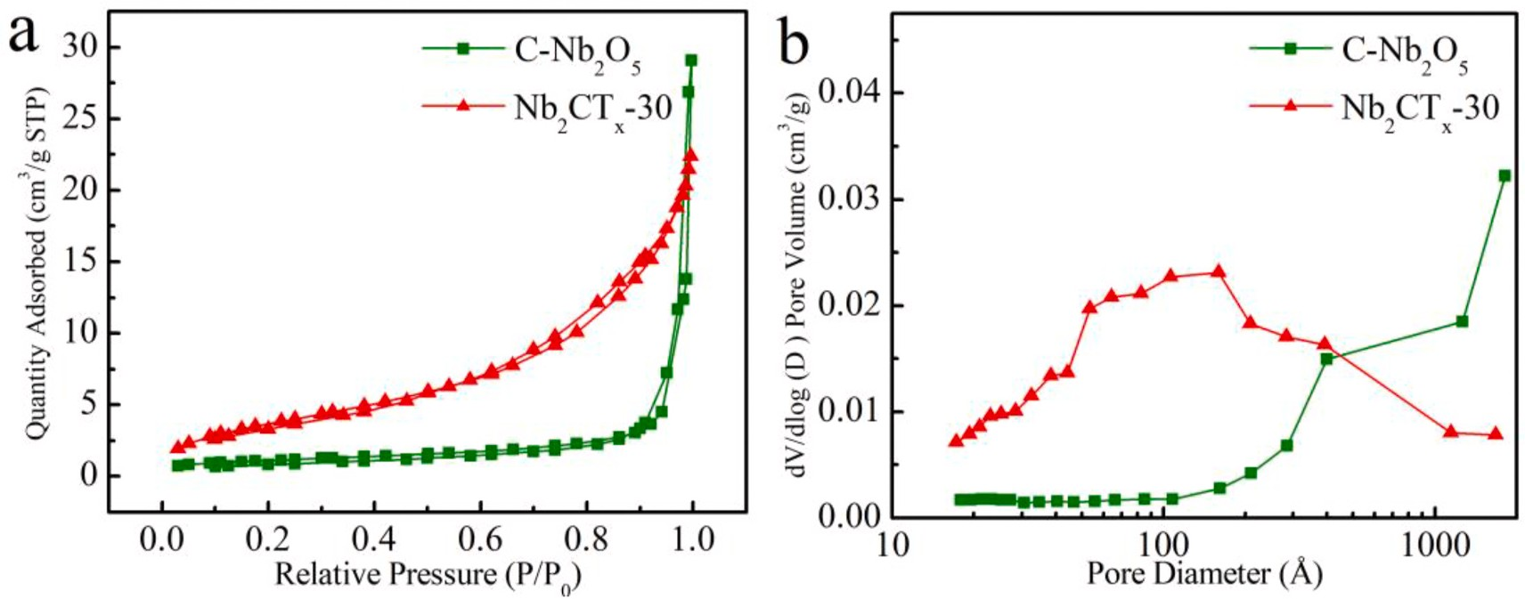
Fig. 5. (a) Nitrogen adsorption/desorption isotherms and (b) pore diameter distribution of Nb₂CT_{x}-30 and C–Nb₂O₅.

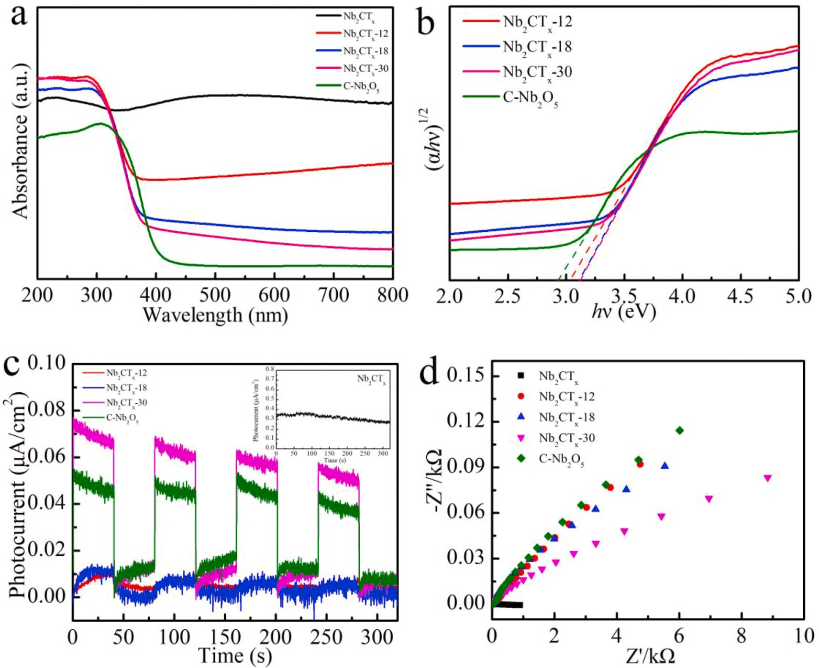
Fig. 6. (a) UV–vis diffuse reflection spectra, (b) plots of (αhv)1/2 versus photon energy, (c) the transient photocurrent responses and (d) electrochemical impedance spectroscopy of Nb₂CT_{x}, Nb₂CT_{x}-12, Nb₂CT_{x}-18, Nb₂CT_{x}-30 and C–Nb₂O₅.

equilibrium in the dark for 30 min. The concentration of RhB decreases to 15.3% in the presence of Nb₂CT_{x} due to the slightly adsorption of Nb₂CT_{x} as shown in Fig. 7a. The photocatalytic degradation efficiency of C–Nb₂O₅ is 24.9% because of the low photoactivity of C–Nb₂O₅ under visible light irradiation. The degradations efficiencies of RhB in the presence of Nb₂CT_{x}-12, Nb₂CT_{x}-18 and Nb₂CT_{x}-30 are 26.9%, 77.5% and 98.5%, respectively (Fig. 7b). The active site of the Nb₂O₅/Nb₂CT_{x} composites is obviously improved for the prolongation of hydrothermal treatment time due to the increase of content of Nb₂O₅ on the surface of the Nb₂CT_{x}, thereby enhancing the photocatalytic degradation effi- ciency. Especially, the photocatalytic degradation efficiency of Nb₂CT_{x}- 30 is superior to that of C–Nb₂O₅ because of the formation of a heter- ojunction between the Nb₂O₅ and Nb₂CT_{x}, resulting in rapid transfer and separation of photogenerated carriers. In addition, the Nb₂O₅ nanorods on the surface of Nb₂CT_{x}, possesses a high specific surface area and exposes more active sites which contributes to the adsorption and degradation of RhB. The reaction kinetics of RhB degradation in the presence of Nb₂CT_{x}, C–Nb₂O₅ and Nb₂O₅/Nb₂CT_{x} composites are illus- trated in Fig. 7c and d. The rate constant (k) of photocatalytic degra-
dation of RhB in the presence of Nb₂CT_{x}, Nb₂CT_{x}-12, Nb₂CT_{x}-18, Nb₂CT_{x}-30 and C–Nb₂O₅ are 0.00099 min—1, 0.0012 min—1, 0.011
min—1, 0.035 min—1 and 0.002 min—1, respectively, suggesting that the Nb₂O₅/Nb₂CT_{x} composites exhibit excellent photocatalytic activity.
The effect of pH in pollutants solution during photocatalytic degra- dation and stability of photocatalysts is an important factor for photo- catalysts in practical application. Fig. 8a shows the influence of pH on the photocatalytic degradation of RhB in the presence of Nb₂CT_{x}-30. The photocatalytic degradation efficiencies are 97.7%, 91.4%, 91.7%, 70.5% and 18.1% at pH from 3 to 11, respectively. The result reveals that the
RhB degradation efficiency of Nb₂CT_{x}-30 is higher in acidic solution. The isoelectric point of Nb₂O₅ is 2.8 as previous literature reported (Chandiran et al., 2014), thus negative charged Nb₂CT_{x}-30 can adsorb more RhB with diethylamine groups (since its pKa is 3.1) in strong acidic solution (Lops et al., 2019). However, the adsorption of RhB containing carboxyl groups can be inhibited due to the electrostatic repulsion in weakly acidic and alkaline solutions, which results in the decrease of photocatalytic efficiency. The reusability and stability of Nb₂CT_{x}-30 photocatalyst for degradation of RhB for five cycles under visible light irradiation are presented in Fig. 8b. The degradation ratio of Nb₂CT_{x}-30 for RhB is still 87.6% after five cycles. Compared with the first cycle, the decrease of degradation ratio is resulted from the generated interme- diate products absorbed on the surface of photocatalysts and blocked some active sites (Yuan et al., 2020). To further evaluate the stability of the materials during the recycling progress, the XRD patterns of fresh Nb₂CT_{x}-30 and recycled samples are shown in Fig. S4. The position and intensity of the characteristic peaks suggest that the phase structure of photocatalyst is maintained. Overall, the Nb₂CT_{x}-30 photocatalyst pos- sesses a good reusability and photocatalytic stability and show great potential for practical application.
The photocatalytic degradation activities of Nb₂CT_{x}, Nb₂O₅/Nb₂CT_{x} composites and C–Nb₂O₅ for tetracycline hydrochloride (TC-HCl) are illustrated in Fig. 9. Photocatalytic degradation efficiency of TC-HCl in the presence of Nb₂CT_{x} and C–Nb₂O₅ after visible light irradiation for 180 min is only 23.6% and 28.5%, respectively. However, the photo- catalytic degradation efficiency of TC-HCl by Nb₂CT_{x}-12, Nb₂CT_{x}-18 and Nb₂CT_{x}-30 are 72.2%, 74.2% and 91.2%, respectively. Photo- catalytic activity of Nb₂O₅/Nb₂CT_{x} composites for TC-HCl is superior to those of Nb₂CT_{x} and C–Nb₂O₅. In addition, the degradation rate of

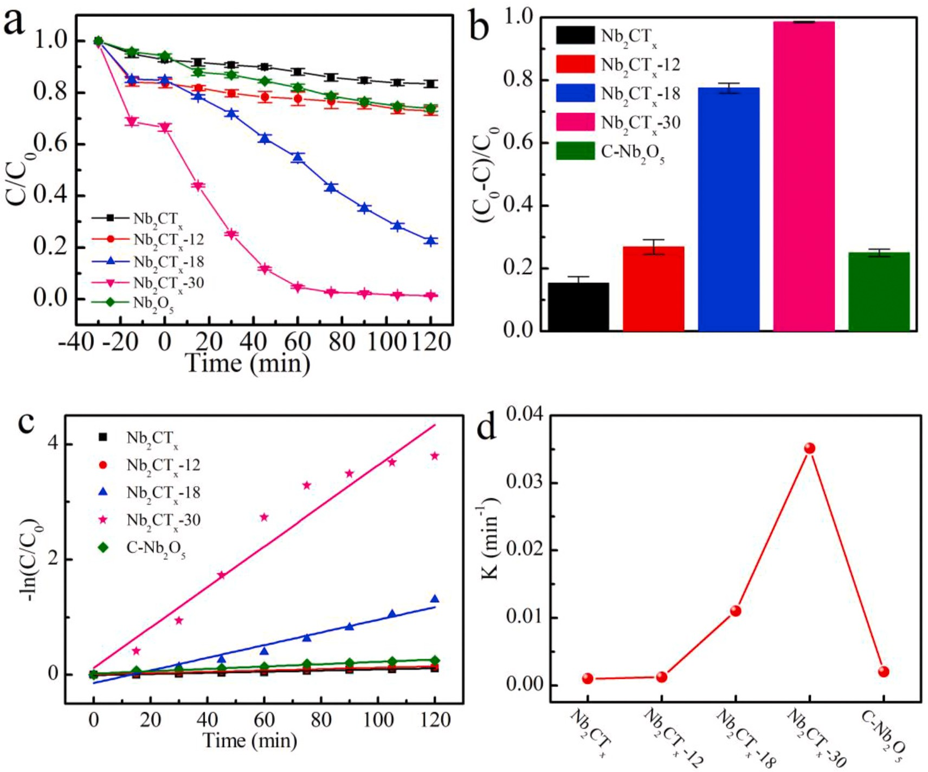
Fig. 7. (a) The photocatalytic degradation process and (b) photocatalytic degradation efficiency of RhB in the presence of Nb₂CT_{x}, Nb₂CT_{x}-12, Nb₂CT_{x}-18, Nb₂CT_{x}- 30 and C–Nb₂O₅ under visible light irradiation, (c) the corresponding first-order kinetic plots, (d) the rate constant of RhB degradation.

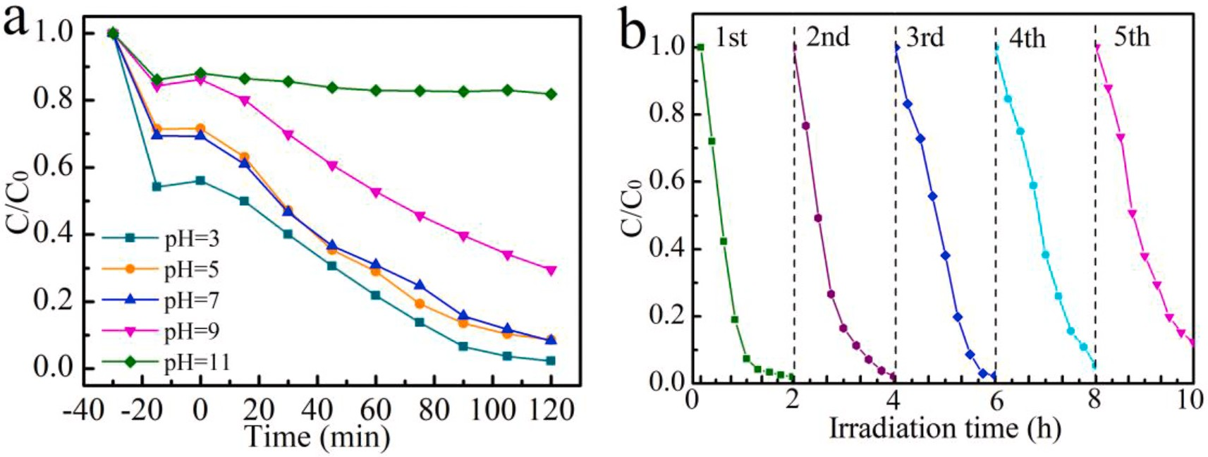
Fig. 8. (a) The photocatalytic degradation of RhB at various pH values from 3 to 11 and (b) five photocatalytic degradation cycles of RhB in the presence of Nb₂CT_{x}- 30 under visible light irradiation.

Nb₂CT_{x}-30 sample is 13.5 times and 6.8 times as high as Nb₂CT_{x} and C–Nb₂O₅, respectively (Fig. 9b). The effect of pH on degradation of TC- HCl are shown in Fig. 9c. The degradation performance of Nb₂CT_{x}-30 on TC-HCl in different pH values was further studied. It is obvious that the photocatalytic degradation efficiency become lower at higher pH value (Fig. 9c). The phenomenon can be explained by the fact that the negative charge on the surface of the tetracycline increases with the rise of pH, resulting in an increase in the electrostatic repulsion with the catalyst and further affecting the photocatalytic efficiency (Zhang et al., 2020).

Five-cycle experiments for TC-HCl degradation were conducted to test the durability of the Nb₂CT_{x}-30 composite. The TC-HCl photocatalytic degradation efficiency of the Nb₂CT_{x}-30 composite decreases by 5.6% after 5 recycling tests as shown in Fig. 9d, demonstrating the outstanding stability of Nb₂CT_{x}-30 composite. Compared with other Nb₂O₅-based photocatalysts (Fig. S5), Nb₂CT_{x}-30 possesses superior degradation efficiency for RhB and TC-HCl. The result indicates that Nb₂O₅/Nb₂CT_{x} composite materials exhibit enhanced visible-light-response photoactivity.

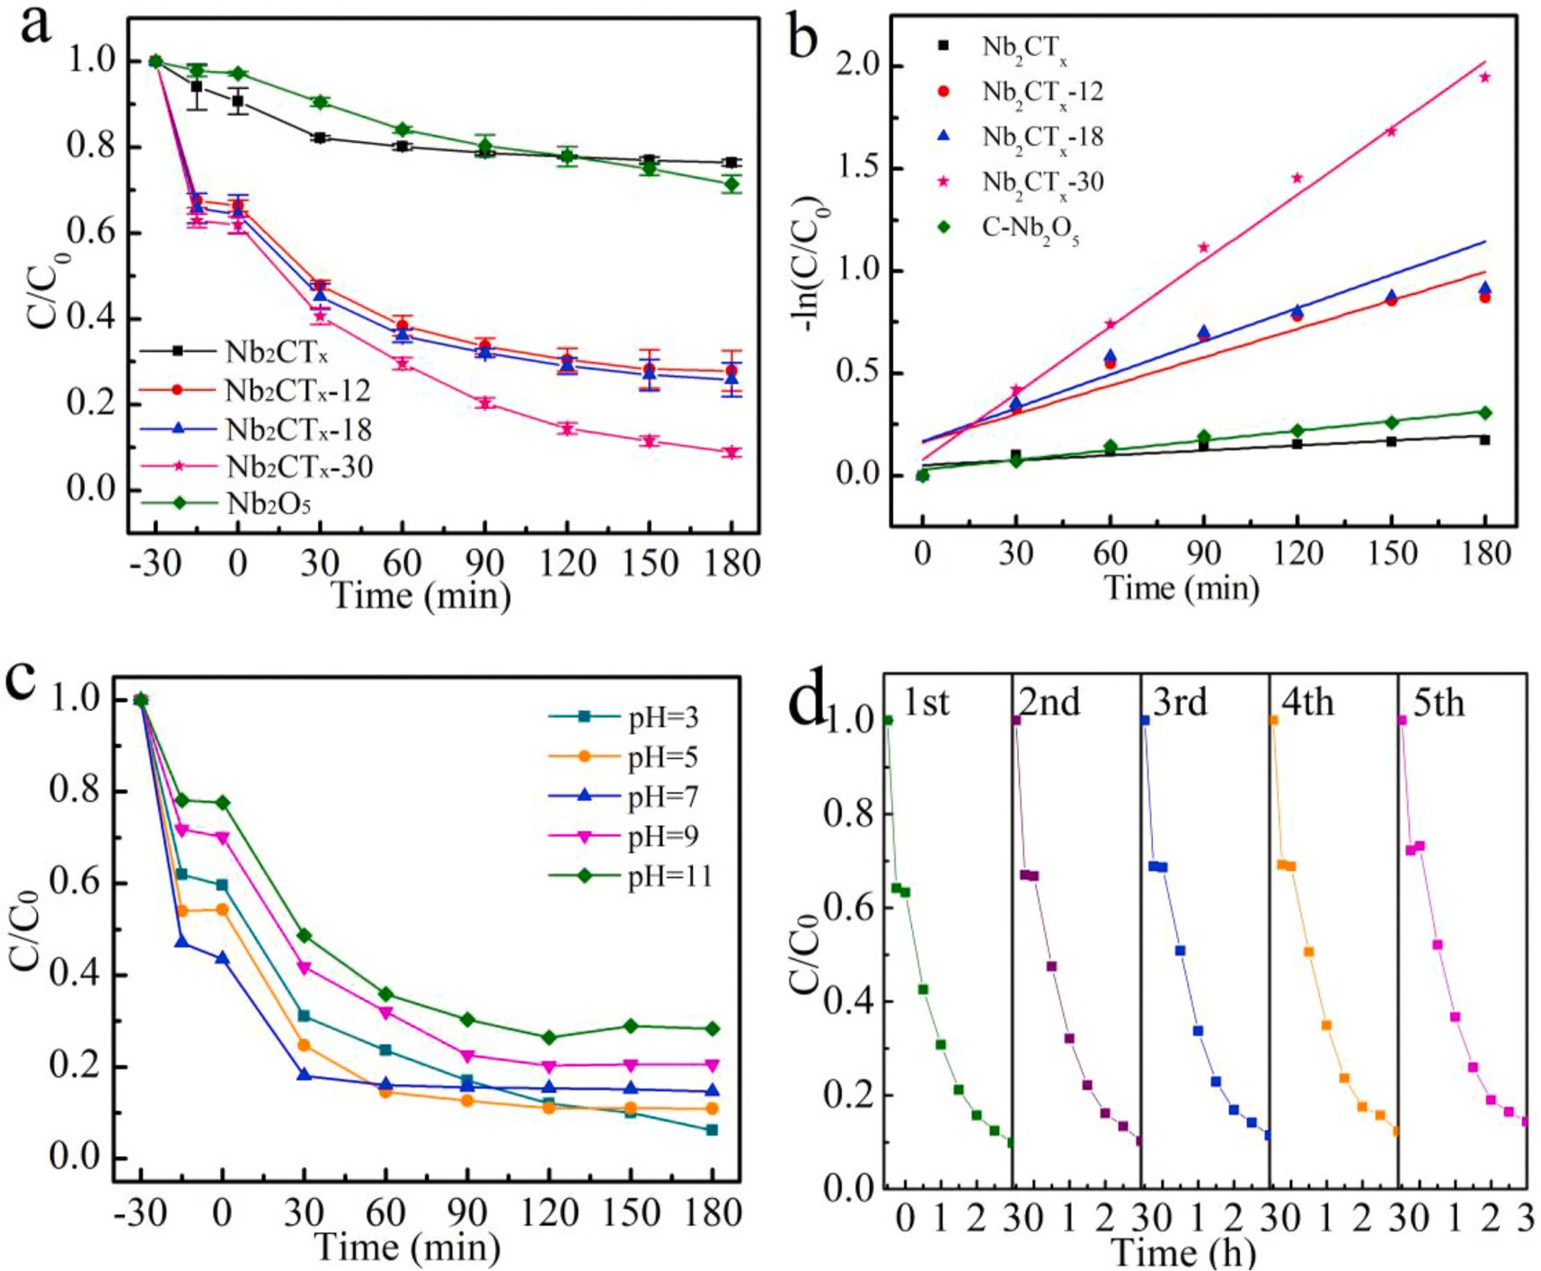
Fig. 9. (a) The photocatalytic degradation of TC-HCl and (b) corresponding.

first-order kinetic plots in the presence of Nb₂CT_{x}, Nb₂CT_{x}-12, Nb₂CT_{x}-18, Nb₂CT_{x}-30 and C–Nb₂O₅; (c) The photocatalytic degrada- tion of TC-HCl at various pH values from 3 to 11 and (d) five photo- catalytic degradation cycles of TC-HCl in the presence of Nb₂CT_{x}-30 under visible light irradiation.
In order to reveal the photocatalytic mechanism of rod-like Nb₂O₅/ Nb₂CT_{x} composites, free radicals trapping experiments were performed (Fig. 10). The effects of reactive oxygen species (ROS) of superoxide
radical anions (•OH₂—), hydroxyl radicals (•OH) and hole (h+) were
investigated by introducing benzoquinone (BQ), t-butanol and EDTA- 2Na as the scavengers, respectively (da Silva et al., 2017). The photo- catalytic degradation rate of RhB is only 35.1% when the EDTA-2Na is added, which is far lower than degradation rate (98.5%) without scav-
enger. The obvious inhibiting effect indicates that the h+ is main reac-
tive species in the photocatalysis process. The degradation rate of RhB is 44.9% and photocatalytic degradation process is inhibited significantly when benzoquinone (BQ) is used as •OH—2 scavenger. The result suggests
that the •OH—2 also play the important role in the photocatalytic process.
The photocatalytic degradation rate of RhB decreases from to 98.5%– 78.2% when the t-butanol is added, which indicates that the •OH is not the main reactive species.
EPR measurement is performed to further evaluate the active species in Nb₂CT_{x}-30 photocatalyst. No obvious signals of DMPO-•OH—2 adduct
and DMPO-•OH adduct are detected in the Nb₂CT_{x}-30 photocatalyst under dark condition as shown in Fig. 10b and c. However, four signals with the relative intensity ratio of 1:1:1:1 for is obviously detected under visible light irradiation for 3 min (Fig. 10b). Four characteristic peaks with relative intensity ratio of 1:2:2:1 corresponding to •OH are
observed under visible light irradiation for 3 min as shown in Fig. 10c. The EPR results confirm •OH—2 and •OH are active species for the
photocatalytic degradation of organic pollutants.
In order to understand the photocatalytic mechanism, the electronic structure of Nb₂CT_{x}-30 composite was analyzed. Mott-Schottky (MS) curve (Fig. S6) shows the conduction band (CB) potential of Nb₂CT_{x}-30. It can be found that the MS curve possesses a positive slope, suggesting that Nb₂CT_{x}-30 is a typical n-type semiconductor (Cui et al., 2015). The flat band potential obtained from the intercept of the tangent of the MS curves on the x-axis is 0.77 V (vs Ag/AgCl, pH 7). Generally, the CB potential of n-type semiconductor is very close to the flat band potential. The relationship of normal hydrogen electrode potential (NHE) and Ag/AgCl electrode potential is shown in formula (2) (Liu et al., 2020).
— =
E (NHE) = E (Ag/AgCl) — Eθ + 0.059 pH (2)
where Eθ (Ag/AgCl, at pH = 7) = 0.197 V. The CB potential of Nb₂CT_{x}- 30 is determined as – 0.554 V (vs NHE, pH = 7) according to formula (2).
The valence band (VB) potential of Nb₂CT_{x}-30 can be calculated according to the formula (3).
E_{VB}= E_{CB}+E_{g} (3)
where E_{g} is the band gap of the semiconductor. The band gap is 3.14 eV for Nb₂CT_{x}-30 based on the curve of (αhv)1/2 versus photon energy plotted (Fig. 6b). Therefore, the VB potential of Nb₂CT_{x}-30 is 2.586 V.
A possible photocatalytic mechanism of rod-like Nb₂O₅/Nb₂CT_{x} composites for the degradation reaction is proposed (Fig. 11). The electrons are excited into CB of Nb₂O₅ nanorods and produce electron- hole pairs under visible irradiation. Most of the photoinduced elec- trons are then transferred from the CB of Nb₂O₅ to Nb₂CT_{x} due to the low Fermi level and the electrical conductivity of Nb₂CT_{x}. A Schottky barrier may be then established through the interface of Nb₂O₅ and Nb₂CT_{x}

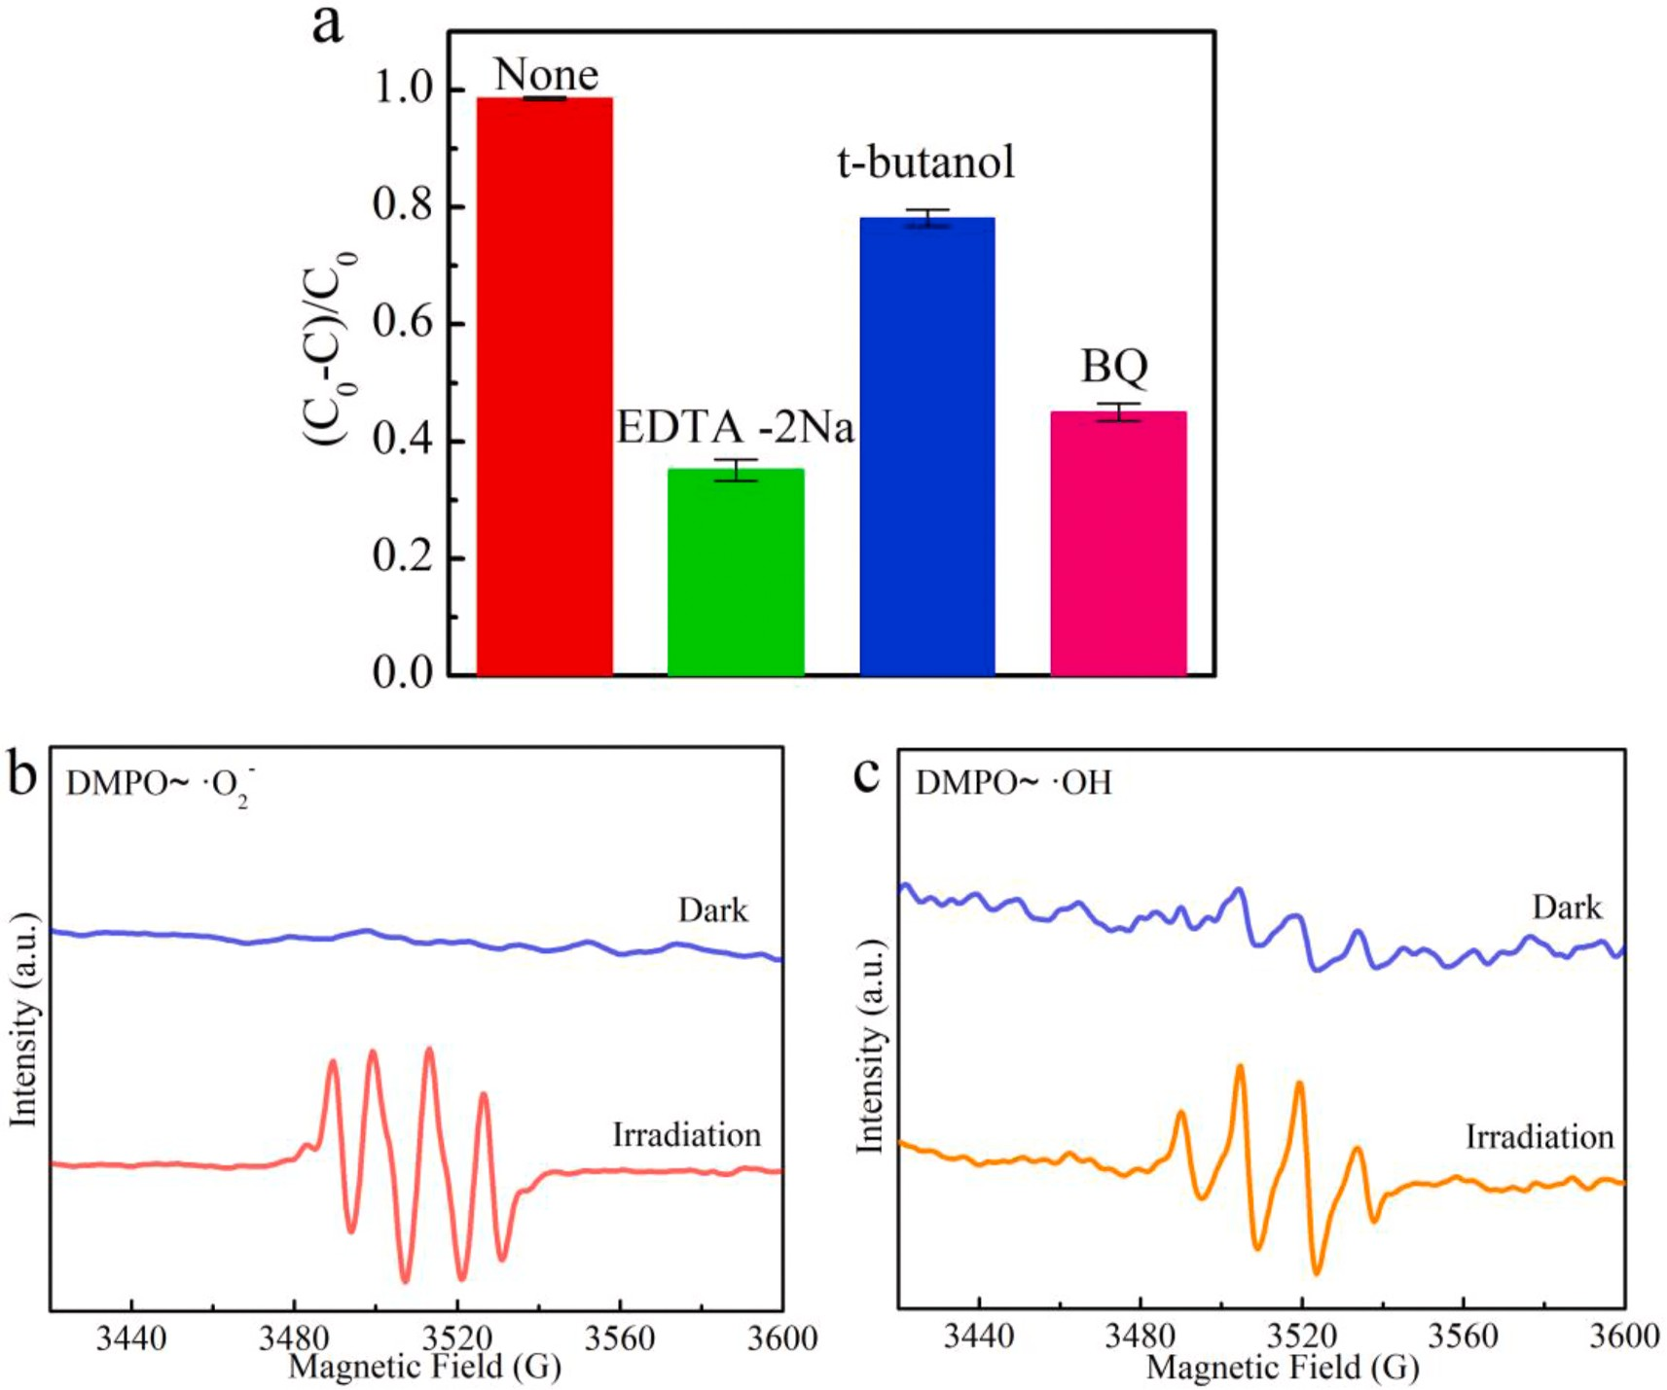
Fig. 10. (a) Tripping experiment of active species for the photocatalytic degradation of RhB over Nb₂CT_{x}-30 in the presence of different scavengers, (b) and (c) EPR spectra of Nb₂CT_{x}-30 for and •OH, respectively.

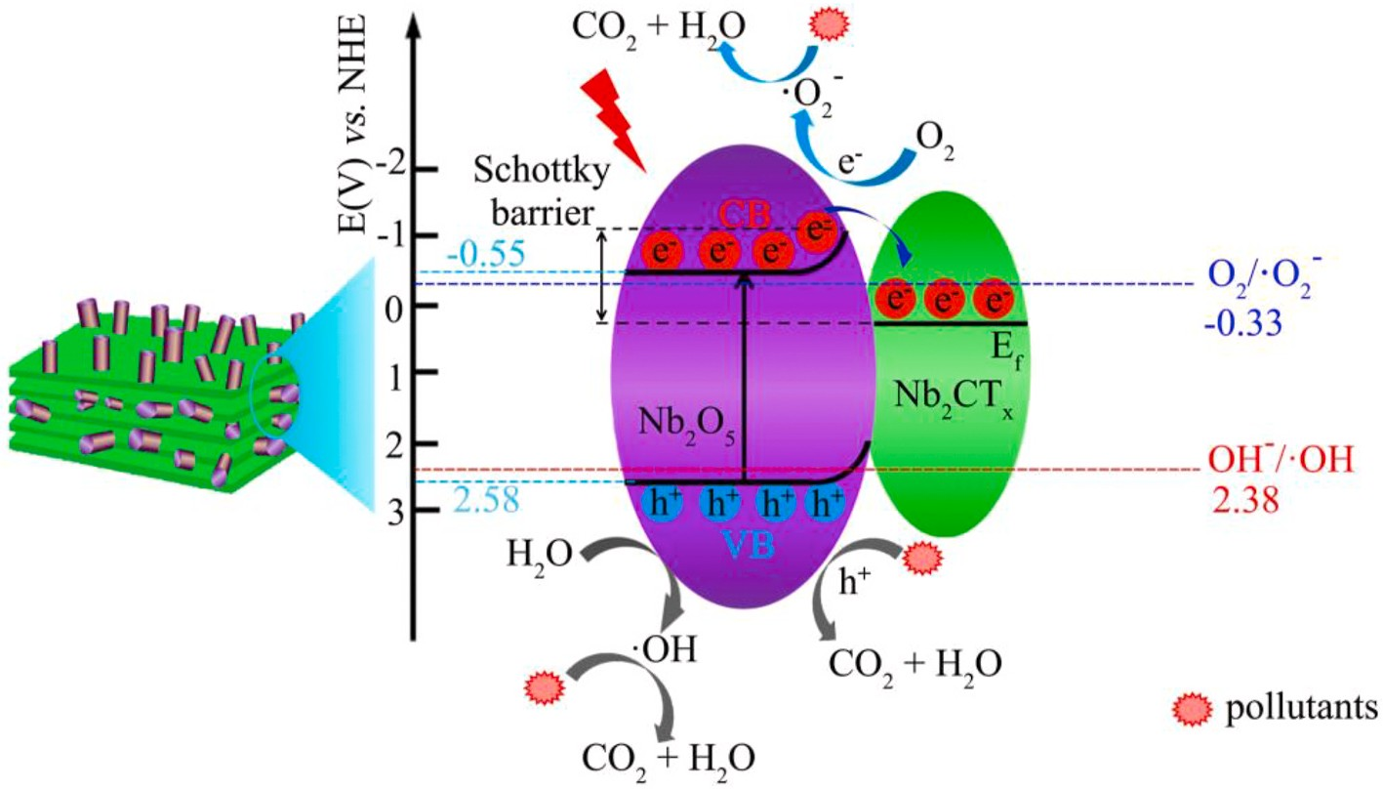
Fig. 11. Possible mechanism for separation and transfer of photogenerated charges of the Nb₂O₅/Nb₂CT_{x} hybrids in the photocatalytic process.

because of the more negative Fermi level Nb₂CT_{x} than the (CB) of Nb₂O₅ (Liu et al., 2018). The Schottky barrier at the interface between Nb₂O₅ and Nb₂CT_{x} could effectively inhibit the electrons from flowing back to Nb₂O₅, which contribute to separate the photogenerated electrons and
hole. The remainder electrons on the CB of Nb₂O₅ can reduce O₂ to •OH—2
because the CB potential of Nb₂O₅ is more negative than the reduction
potential of O₂/•OH₂— (—0.33 V vs NHE) (Yan et al., 2019). The holes located on the VB can directly react with pollutants and also oxidize H₂O to •OH because VB potential of Nb₂O₅ is more positive than oxidization potential of OH/•OH (2.38 V vs NHE) (Gao et al., 2021; Wang et al., 2020). In the system of rod-like Nb₂O₅/Nb₂CT_{x} composites, the Nb₂CT_{x} serves as trap of electrons to inhibit the recombination of electron-hole

pairs. In addition, the holes and generated •OH and •OH₂— radicals can continuously decompose the pollutants.

Conclusions

Rod-like Nb O /Nb CT composites were prepared by a facile hy-

performance sodium/potassium ion batteries with enhanced capacities. ACS Nano 11, 4792–4800.
Du, Y.C., Zhang, S.H., Wang, J.S., Wu, J.S., Dai, H.X., 2018. Nb₂O₅ nanowires in-situ grown on carbon fiber: a high-efficiency material for the photocatalytic reduction of Cr(VI). J. Environ. Sci. 66, 358–367.
Gao, X., Niu, J., Wang, Y., Ji, Y.F., Zhang, Y.L., 2021. Solar photocatalytic abatement of tetracycline over phosphate oxoanion decorated Bi₂WO₆/polyimide composites.

2 5 2 x J. Hazard Mater. 403, 123860.

drothermal oxidation method. The rod-like structure exhibits larger specific surface area, which leads to more exposed active sites under visible light irradiation. The prepared Nb₂O₅/Nb₂CT_{x} composites exhibit excellent photocatalytic efficiency for degradation of RhB and TC-HCl than C–Nb₂O₅. The sample Nb₂CT_{x}-30 degrades 98.5% of RhB for 120 min and 91.2% of TC-HCl for 180 min. In addition, the Nb₂O₅/ Nb₂CT_{x} composite shows excellent reusability and stability. The results suggest that rod-like Nb₂O₅/Nb₂CT_{x} can be used as a promising material for the degradation of dyes and antibiotic contaminants.

Declaration of competing interest

The authors declare that they have no known competing financial interests or personal relationships that could have appeared to influence the work reported in this paper.

Acknowledgments

This work was financially supported by The National Natural Science Foundation of China and The Civil Aviation Administration of China (NO. U1833118), Sichuan Science and Technology Program (2019YFG0244).

Appendix A. Supplementary data

Supplementary data to this article can be found online at https://doi. org/10.1016/j.envres.2020.110587.

Credit author statement
We make a solemn commitment that the research of “Facile hydro- thermally synthesis of rod-like Nb₂O₅/Nb₂CT_{x} composite for visible- light driven photocatalytic degradation of organic pollutants” was been done independently by our team. The data of the manuscript is true and valid. The manuscript has not been submitted to any journal except Environmental Research.

References
Adhikari, S., Selvaraj, S., Kim, D.-H., 2019. Construction of heterojunction photoelectrode via atomic layer deposition of Fe₂O₃ on Bi₂WO₆ for highly efficient photoelectrochemical sensing and degradation of tetracycline. Appl. Catal. B Environ. 244, 11–24.
Chandiran, A.K., Nazeeruddin, M.K., Gratzel, M., 2014. The role of insulating oxides in blocking the charge carrier recombination in dye-sensitized solar cells. Adv. Funct. Mater. 24, 1615–1623.
Chen, J., Wang, H., Huang, G.L., Zhang, Z.Q., Han, L.F., Song, W., Li, M.Y., Zhang, Y.H., 2017. Facile synthesis of urchin-like hierarchical Nb₂O₅ nanospheres with enhanced visible light photocatalytic activity. J. Alloys Compd. 728, 19–28.
Cui, H.L., Zhu, G.L., Xie, Y., Zhao, W., Yang, C.Y., Lin, T.Q., Gu, H., Huang, F.Q., 2015.
Black nanostructured Nb₂O₅ with improved solar absorption and enhanced photoelectrochemical water splitting. J. Mater. Chem. A. 3, 11830–11837.
da Silva, G.T.S.T., Carvalho, K.T.G., Lopes, O.F., Ribeiro, C., 2017. g-C₃N₄/Nb₂O₅ heterostructures tailored by sonochemical synthesis: enhanced photocatalytic performance in oxidation of emerging pollutants driven by visible radiation. Appl. Catal. B Environ. 216, 70–79.
Di, J., Xia, J.J., Ge, Y.P., Li, H.P., Ji, H.Y., Xu, H., Zhang, Q., Li, H.M., Li, M.N., 2015.
Novel visible-light-driven CQDs/Bi₂WO₆ hybrid materials with enhanced photocatalytic activity toward organic pollutants degradation and mechanism insight. Appl. Catal. B Environ. 168–169, 51–61.
Ding, L., Wei, Y.Y., Wang, Y.J., Chen, H.B., Caro, J., Wang, H.H., 2017. A two- dimensional lamellar membrane: MXene nanosheet stacks. Angew. Chem. Int. Ed. 56, 1825–1829.
Dong, Y.F., Wu, Z.-S., Zheng, S.H., Wang, X.H., Qin, J.Q., Wang, S., Shi, X.Y., Bao, X.H.,
2017. Ti₃C₂ MXene-derived sodium/potassium titanate nanoribbons for high-
Hong, Y.Z., Li, C.S., Zhang, G.Y., Meng, Y.D., Yin, B.X., Zhao, Y., Shi, W.D., 2016.
Efficient and stable Nb₂O₅ modified g-C₃N₄ photocatalyst for removal of antibiotic pollutant. Chem. Eng. J. 299, 74–84.
Hu, Y., Chen, W., Lei, T.Y., Zhou, B., Jiao, Y., Yan, Y.C., Du, X.C., Huang, J.W., Wu, C.Y.,
Wang, X.P., Wang, Y., Chen, B., Xu, J., Wang, C., Xiong, J., 2019. Carbon quantum dots-modified interfacial interactions and ion conductivity for enhanced high current density performance in lithium-sulfur batteries. Adv. Energy Mater. 9, 1802955.
Jiang, Y., Xie, X., Chen, Y., Liu, Y.J., Yang, R., Sui, G.X., 2018. Hierarchically structured cellulose aerogels with interconnected MXene networks and their enhanced microwave absorption properties. J. Mater. Chem. C. 6, 8679–8687.
Jin, Z.Y., Fang, Y.F., Wang, X.X., Xu, G.F., Liu, M.L., Wei, S., Zhou, C.L., Zhang, Y.L.,
Xu, Y.H., 2019. Ultra-efficient electromagnetic wave absorption with ethanol- thermally treated two-dimensional Nb₂CT_{x} nanosheets. J. Colloid Interface Sci. 537, 306–315.
Li, B.S., Lai, C., Zeng, G.M., Huang, D.L., Qin, L., Zhang, M.M., Cheng, M., Liu, X.G., Yi, H., Zhou, C.Y., Huang, F.L., Liu, S.Y., Fu, Y.K., 2019a. Black phosphorus, a rising star 2D nanomaterial in the post-graphene era: synthesis, properties, modifications, and photocatalysis applications. Small 15, 1804565.
Li, L.H., Deng, J.X., Yu, R.B., Chen, J., Wang, Z., Xing, X.R., 2013. Niobium pentoxide hollow nanospheres with enhanced visible light photocatalytic activity. J. Mater. Chem. A. 1, 11894–11900.
Li, Y.J., Yin, Z.H., Ji, G.R., Liang, Z.Q., Xue, Y.J., Guo, Y.C., Tian, J., Wang, X.Z., Cui, H.
Z., 2019b. 2D/2D/2D heterojunction of Ti₃C₂ MXene/MoS₂ nanosheets/TiO₂ nanosheets with exposed (001) facets toward enhanced photocatalytic hydrogen production activity. Appl. Catal. B Environ. 246, 12–20.
Lin, H., Gao, S.S., Dai, C., Chen, Y., Shi, J.L., 2017a. A two-dimensional biodegradable niobium carbide (MXene) for photothermal tumor eradication in NIR-I and NIR-II biowindows. J. Am. Chem. Soc. 139, 16235–16247.
Lin, L., Wang, H.Y., Xu, P., 2017b. Immobilized TiO₂-reduced graphene oxide nanocomposites on optical fibers as high performance photocatalysts for degradation of pharmaceuticals. Chem. Eng. J. 310, 389–398.
Liu, J.J., Xiong, C.B., Jiang, S.J., Wu, X., Song, S.Q., 2019. Efficient evolution of reactive oxygen species over the coordinated π-delocalization g-C₃N₄ with favorable charge transfer for sustainable pollutant elimination. Appl. Catal. B Environ. 249, 282–291.
Liu, T.Y., Yang, G.J., Wang, W., Wang, C.X., Wang, M., Sun, X.N., Xu, P., Zhang, J.T.,
2020. Preparation of C₃N₅ nanosheets with enhanced performance in photocatalytic methylene blue (MB) degradation and H₂-evolution from water splitting. Environ. Res. 188, 109741.
Liu, Y.X., Luo, R., Li, Y., Qi, J.W., Wang, C.H., Li, J.S., Sun, X.Y., Wang, L.J., 2018.
Sandwich-like Co₃O₄/MXene composite with enhanced catalytic performance for Bisphenol A degradation. Chem. Eng. J. 347, 731–740.
Lops, C., Ancona, A., Di Cesare, K., Dumontel, B., Garino, N., Canavese, G., Hernandez, S., Cauda, V., 2019. Sonophotocatalytic degradation mechanisms of Rhodamine B dye via radicals generation by micro- and nano-particles of ZnO. Appl. Catal. B Environ. 243, 629–640.
Mashtalir, O., Lukatskaya, M.R., Zhao, M.Q., Barsoum, M.W., Gogotsi, Y., 2015. Amine- assisted delamination of Nb₂C MXene for Li-ion energy storage devices. Adv. Mater. 27, 3501–3506.
Murayama, T., Chen, J.L., Hirata, J., Matsumoto, K., Ueda, W., 2014. Hydrothermal synthesis of octahedra-based layered niobium oxide and its catalytic activity as a solid acid. Catal. Sci. Technol. 4, 4250–4257.
Oliveira, L.C.A., Oliveira, H.S., Mayrink, G., Mansur, H.S., Mansur, A.A.P., Moreira, R.L., 2014. One-pot synthesis of CdS@Nb₂O₅ core-shell nanostructures with enhanced photocatalytic activity. Appl. Catal. B Environ. 152–153, 403–412.
Peng, C., Wang, H.J., Yu, H., Peng, F., 2017. (111) TiO_{2-x}/Ti₃C₂ : synergy of active facets, interfacial charge transfer and Ti3+ doping for enhance photocatalytic activity.
Mater. Res. Bull. 89, 16–25.
Peng, C., Yang, X.F., Li, Y.H., Yu, H., Wang, H.J., Peng, F., 2016. Hybrids of two- dimensional Ti₃C₂ and TiO₂ exposing {001} facets toward enhanced photocatalytic activity. ACS Appl. Mater. Interfaces 8, 6051–6060.
Qamar, M., Abdalwadoud, M., Ahmed, M.I., Azad, A.M., Merzougui, B., Bukola, S., Yamani, Z.H., Siddiqui, M.N., 2015. Single-Pot synthesis of 〈001〉-Faceted N-doped Nb₂O₅/reduced graphene oxide nanocomposite for efficient photoelectrochemical water splitting. ACS Appl. Mater. Interfaces 7, 17954–17962.
Qi, S.S., Zuo, R.Z., Liu, Y., Wang, Y., 2013. Synthesis and photocatalytic activity of electrospun niobium oxide nanofibers. Mater. Res. Bull. 48, 1213–1217.
Ran, J.R., Gao, G.P., Li, F.-T., Ma, T.-Y., Du, A.J., Qiao, S.-Z., 2017. Ti₃C₂ MXene co-
catalyst on metal sulfide photo-absorbers for enhanced visible-light photocatalytic hydrogen production. Nat. Commun. 8, 13907.
Ren, K., Ren, C.D., Luo, Y., Xu, Y.J., Yu, J., Tang, W.C., Sun, M.L., 2019. Using van der Waals heterostructures based on two-dimensional blue phosphorus and XC (X Ge, Si) for water-splitting photocatalysis: a first-principles study. Phys. Chem. Chem. Phys. 21, 9949–9956.
=
Rimoldi, L., Meroni, D., Cappelletti, G., Ardizzone, S., 2017. Green and low cost tetracycline degradation processes by nanometric and immobilized TiO₂ systems. Catal. Today 281, 38–44.

Shahzad, A., Rasool, K., Nawaz, M., Miran, W., Jang, J., Moztahida, M., Mahmoud, K.A., Lee, D.S., 2018. Heterostructural TiO₂/Ti₃C₂T_{x} (MXene) for photocatalytic degradation of antiepileptic drug carbamazepine. Chem. Eng. J. 349, 748–755.
Su, T.M., Peng, R., Hood, Z.D., Naguib, M., Ivanov, I.N., Keum, J.K., Qin, Z.Z., Guo, Z.H., Wu, Z.L., 2018. One-step synthesis of Nb₂O₅/C/Nb₂C (MXene) composites and their use as photocatalysts for hydrogen evolution. ChemSusChem 11, 688–699.
4+
Wang, C.D., Chen, S.M., Xie, H., Wei, S.Q., Wu, C.Q., Song, L., 2019. Atomic Sn decorated into vanadium carbide MXene interlayers for superior lithium storage. Adv. Energy Mater. 9, 1802977.
Wang, H., Peng, R., Hood, Z.D., Naguib, M., Adhikari, S.P., Wu, Z.L., 2016. Titania composites with 2 D transition metal carbides as photocatalysts for hydrogen production under visible-light irradiation. ChemSusChem 9, 1490–1497.
Wang, H., Wu, Y., Yan, X.Z., Zeng, G.M., Zhou, J., Wang, X., Chew, J.W., 2018. Clay- inspired MXene-based electrochemical devices and photo-electrocatalyst: state-of- the-art progresses and challenges. Adv. Mater. 30, 1704561.
Wang, Y.T., Zhu, C.Z., Zuo, G.C., Guo, Y., Xiao, W., Dai, Y.X., Kong, J.J., Xu, X.M., Zhou, Y.X., Xie, A.M., Sun, C., Xian, Q.M., 2020. 0D/2D Co₃O₄/TiO₂ Z-Scheme
heterojunction for boosted photocatalytic degradation and mechanism investigation. Appl. Catal. B Environ. 278, 119298.
Yan, W., Yan, L., Jing, C.Y., 2019. Impact of doped metals on urea-derived g-C₃N₄ for photocatalytic degradation of antibiotics: structure, photoactivity and degradation mechanisms. Appl. Catal. B Environ. 244, 475–485.
Yang, H.L., Xu, H.H., Wang, L.B., Zhang, L., Huang, Y.H., Hu, X.L., 2017. Microwave- assisted rapid synthesis of self-assembled T-Nb₂O₅ nanowires for high-energy hybrid supercapacitors. Chemistry 23, 4203–4209.
Yi, J.J., Li, H.P., Gong, Y.J., She, X.J., Song, Y.H., Xu, Y.G., Deng, J.J., Yuan, S.Q., Xu, H.,
Li, H.M., 2019. Phase and interlayer effect of transition metal dichalcogenide

cocatalyst toward photocatalytic hydrogen evolution: the case of MoSe₂. Appl. Catal. B Environ. 243, 330–336.
Yuan, R.R., Qiu, J.L., Yue, C.L., Shen, C., Li, D.W., Zhu, C.Q., Liu, F.Q., Li, A.M., 2020.
Self-assembled hierarchical and bifunctional MIL-88A(Fe)@ZnIn₂S₄ heterostructure as a reusable sunlight-driven photocatalyst for highly efficient water purification. Chem. Eng. J. 401, 126020.
Zhang, C., Beidaghi, M., Naguib, M., Lukatskaya, M.R., Zhao, M.-Q., Dyatkin, B., Cook, K.
M., Kim, S.J., Eng, B., Xiao, X., Long, D.H., Qiao, W.M., Dunn, B., Gogotsi, Y., 2016a. Synthesis and charge storage properties of hierarchical niobium pentoxide/carbon/ niobium carbide (MXene) hybrid materials. Chem. Mater. 28, 3937–3943.
Zhang, C.J., Kim, S.J., Ghidiu, M., Zhao, M.-Q., Barsoum, M.W., Nicolosi, V., Gogotsi, Y., 2016b. Layered orthorhombic Nb₂O₅@Nb₄C₃T_{x} and TiO₂@Ti₃C₂T_{x} hierarchical composites for high performance Li-ion batteries. Adv. Funct. Mater. 26, 4143–4151.
Zhang, Q.C., Jiang, L., Wang, J., Zhu, Y.F., Pu, Y.J., Dai, W.D., 2020. Photocatalytic degradation of tetracycline antibiotics using three-dimensional network structure perylene diimide supramolecular organic photocatalyst under visible-light irradiation. Appl. Catal. B Environ. 277, 119122.
Zhang, Y., Zhao, H., Zhao, X.F., Lin, J.N., Li, N., Huo, Z.Y., Yan, Z.F., Zhang, M., Hu, S.,
2018. Narrow-bandgap Nb₂O₅ nanowires with enclosed pores as high-performance photocatalyst. Sci. China Mater. 62, 203–210.
Zhao, L.J., Wang, K., Wei, W., Wang, L.L., Han, W., 2019. High-performance flexible sensing devices based on polyaniline/MXene nanocomposites. Info 1, 407–416.
Zhao, Y., Eley, C., Hu, J.P., Foord, J.S., Ye, L., He, H.Y., Tsang, S.C.E., 2012. Shape-
dependent acidity and photocatalytic activity of Nb₂O₅ nanocrystals with an active TT (001) surface. Angew. Chem. Int. Ed. 51, 3846–3849.
Zhou, W.J., Yin, Z.Y., Du, Y.P., Huang, X., Zeng, Z.Y., Fan, Z.X., Liu, H., Wang, J.Y.,
Zhang, H., 2013. Synthesis of few-layer MoS₂ nanosheet-coated TiO₂ nanobelt heterostructures for enhanced photocatalytic activities. Small 9, 140–147.

