
Soft Matter

PAPER
View Article Online
View Journal | View Issue



Cite this: Soft Matter, 2020, 16, 162

Received 3rd October 2019, Accepted 10th November 2019
DOI: 10.1039/c9sm01985e

rsc.li/soft-matter-journal
Fabrication of novel MXene (Ti₃C₂)/polyacrylamide nanocomposite hydrogels with enhanced mechanical and drug release properties†
Peng Zhang,ª Xiu-Jie Yang,  *ª Peng Li,ª Yingyuan Zhao^{b} and Qingshan Jason Niu ª

A highly stretchable nanocomposite (NC) hydrogel was fabricated via in situ free radical polymerization of acrylamide. In particular, an exfoliated two-dimensional MXene (Ti₃C₂) nanosheet was utilized as a crosslinker instead of traditional organic crosslinkers. The exfoliated Ti₃C₂ nanosheets were confirmed by atomic force microscopy (AFM) and dynamic light scattering (DLS) measurements. Compared with traditional organic crosslinked N,N-methylene bisacrylamide (BIS)/polyacrylamide (PAM) hydrogels (fracture strength of 32.0 kPa and elongation of 109.6%), the synthesized Ti₃C₂/PAM NC hydrogels exhibited greatly improved mechanical properties with fracture strengths of 66.5 to 102.7 kPa, compressive strengths of 400.6 to 819.4 kPa and elongations at break of 2158.6% to 3047.5% as the Ti₃C₂ content increases from 0.0145% to 0.0436%. The enhanced mechanical performances can be attributed to the honeycomb-like fine structure with uniform pores as well as more flexible polymer
chains in NC hydrogel networks. When loaded with drugs, Ti₃C₂/PAM NC hydrogels exhibited good sustained-release performance, higher drug loading amounts (97.5–127.7 mg g^{—1}) and higher percentage releases (62.1–81.4%), greatly superior to those of the BIS/PAM hydrogel (46.4 mg g^{—1}, 45.0%). Our work reveals the application of MXene materials in the fabrication of NC hydrogels with enhanced mechanical
and drug release behaviors.

Introduction
Published on 13 November 2019. Downloaded on 1/9/2020 4:47:48 PM.
Polymer hydrogels are a class of three-dimensional crosslinked hydrophilic polymer networks with high water content. The applications of hydrogels have been developed in the fields of tissue engineering, drug carriers, and chemical sensors.^{1–3} However, the scope of their applications is often severely limited due to the modest mechanical performances.^{4–6} In order to improve the mechanical properties, a series of new hydrogels⁷ have been developed such as topological (TP) hydrogels,⁸ nanocomposite (NC) hydrogels^{9–12} and double network (DN) hydrogels.^{13–15} Among these, NC hydrogels, prepared through a relatively simple technology, can not only greatly improve the mechanical properties, but also significantly improve the swelling ratio.

ª State Key Laboratory of Heavy Oil Processing, School of Chemical Engineering, China University of Petroleum, Qingdao, Shandong 266580, China.
E-mail: yangxiujie@upc.edu.cn
^{b} College of Chemical Engineering and Safety, Binzhou University, Binzhou 256603, China
† Electronic supplementary information (ESI) available: Compositions of reactants for as-prepared Ti₃C₂/PAM and BIS/PAM hydrogels, XRD patterns of hydrogels, mechanical properties of NC hydrogels reported in the literature, and UV-Vis spectra of chloramphenicol in vitro released from hydrogels. See DOI: 10.1039/c9sm01985e
The simultaneously enhanced mechanical and swelling properties could provide a stable environment for drug immigration and protect them from denaturation.¹⁶ By introducing rigid nano- particles into polymer networks, a series of high-strength and tough NC hydrogels have been prepared by physical interactions (hydrogen bonding and electrostatic interaction) or chemical crosslinking between nanoparticles and polymer networks. Haraguchi et al. reported the first example of poly(N-isopropylacryl- amide) NC hydrogels employing nanoclay as the crosslinker which showed improved mechanical properties (tensile strength of 41 kPa and elongation at break of 1424%) and swelling/de-swelling abilities.⁹ Owing to the layered structure and unique properties, two-dimensional (2D) nanomaterials are employed for the fabrication of NC hydrogels and widely studied by researchers over the past decades.^{17,18} However, NC hydrogels such as biocompatible layered double hydroxide (LDH) crosslinked hydro- gels are vulnerable to acid and suffered dissolving, limiting their application as drug carriers.¹⁹ Besides, these investigations mainly focused on clay,^{9,20,21} graphene oxide (GO)^{22,23} and LDHs,^{24–26} and there are rare reports on other 2D nanomaterials.
MXenes are a new family of 2D transition metal carbides/
nitrides produced by selective chemical etching of ‘‘A’’ from the MAX phase, where M is a transition metal, A is a IIIA or IVA

element and X is C or N.^{27–30} Gogotsi and Barsoum²⁸ first reported the preparation of Ti₃C₂ layers by selective etching of Al in Ti₃AlC₂ by HF, indicating their acid resistance. After the removal of Al, dangling bonds are formed on the outer layer of the M_{n+1}X_{n} structure, which can easily combine with –OH and/or –F groups in solution. The large number of –OH and –F groups on the surface of Ti₃C₂ facilitate further functional modification.³¹ In addition, monolayer MXene nanosheets with graphene-like structure can be obtained by means of organic solvent intercalation or sonication, which is of great significance for expanding the application of MXene materials.^{29,30} Benefitting from the unique 2D structure, excellent conductivity, biocom- patibility, ion intercalation ability and hydrophilicity, MXenes are widely used in chemical sensing,³² energy storage,^{33–35} catalysis,^{36–39} and environmental restoration.^{39,40} Recently, Zhang and Liu⁴¹ reported the application of Ti₃C₂ as a light absorbent in cellulose hydrogels for biomedicine, which is crosslinked by epichlorohydrin. Nevertheless, Ti₃C₂ has never been reported as a crosslinker.
Published on 13 November 2019. Downloaded on 1/9/2020 4:47:48 PM.
Herein, we report a NC hydrogel prepared from Ti₃C₂ and acrylamide via in situ free radical polymerization. To the best of our knowledge, this is the first report on the utilization of Ti₃C₂ as a crosslinker for the preparation of NC hydrogels. Compared with traditional organic crosslinked hydrogels, the as-prepared Ti₃C₂/polyacrylamide (PAM) NC hydrogels with ultralow Ti₃C₂ con- tents exhibit excellent mechanical properties, swelling behaviors and much better sustained drug release performance. More importantly, the Ti₃C₂/PAM NC hydrogels show good acid resistance in HCl solution (pH = 1.2), endowing them with practical applications under acidic conditions. The microstructures of the as-prepared hydrogels are discussed as well.

Experimental
  - Materials
Ti₃AlC₂ was obtained from Forsman Scientific (Beijing) Co. Ltd. Hydrofluoric acid, hydrochloric acid and acrylamide were purchased from Sinopharm Chemical Reagent Co. Ltd, China. Potassium persulfate (KPS), N,N-methylene bisacrylamide (BIS) and chloramphenicol were purchased from Aladdin Reagent Co., China. All agents were used as obtained without further purification. Deionized water was used throughout the experiment.

  - Instruments
Scanning electron microscopy (SEM) was performed using a HITACHI S-4800 instrument to obtain morphological images of the products. X-ray diﬀraction (XRD) was carried out using a D8 advance diﬀractometer to evaluate the crystal structure of the prepared products. Atomic force microscopy (AFM) was carried out using an ICON2-SYS instrument to determine the thickness and morphology of the Ti₃C₂ nanosheets. The size of the Ti₃C₂ nanosheets was determined by dynamic light scattering (DLS) using a BT-90. X-ray photoelectron spectroscopy (XPS) was per- formed to determine the binding energy of elements on an ESCA- LAB 250 XI. The as-prepared hydrogels were freeze-dried before SEM
and XRD analyses. The mechanical properties of the hydrogels were investigated using an HY-0580 (Shanghai Heng Yi Testing Instruments Co. Ltd, China). UV-Vis absorption spectroscopy was performed using a UV-2700 (Shimadzu, Japan).

  - Synthesis of Ti₃C₂/PAM NC hydrogels
Ti₃C₂/PAM NC hydrogels were prepared by in situ free radical polymerization. In a typical synthesis process, Ti₃C₂ was obtained by etching 600 mg Ti₃AlC₂ with 10 mL HF (30%) under vigorous stirring for 24 h. Then the product was centri- fuged, rinsed repeatedly with water and ethanol, and dried for 12 h at 60 1C in a vacuum oven. A certain amount of Ti₃C₂ was dispersed in 50 mL water by ultrasonication for 72 h to form
Ti₃C₂ aqueous suspensions (0.2 g L^{—1}, 0.4 g L^{—1} and 0.6 g L^{—1}).
8 mL of the Ti₃C₂ suspension and 2 g acrylamide were mixed in a glass bottle placed in an ice water bath in a N₂ atmosphere for 30 min to exclude oxygen gas. Subsequently, 1 mL of the redox initiator (KPS, 15 mg mL^{—1}) was added into the mixture to
initiate the in situ free radical polymerization without utilizing
any organic crosslinkers. Then the mixture was allowed to react in the ice water bath under the protection of N₂ for 15 min. Finally, the whole mixture was transferred into a 6 mm diameter tube for 24 h to form hydrogels. The obtained hydrogels were denoted as T_{n}PAM hydrogels, where n represents the concentration
(×10) of the Ti₃C₂ aqueous suspension. Freeze-dried hydrogels
(xerogels) were prepared for swelling and drug release tests.

  - Synthesis of organic crosslinked BIS/PAM NC hydrogels
For comparison, a traditional organic crosslinked BIS/PAM hydro- gel was prepared by an analogous procedure in the absence of Ti₃C₂. 8 mL of the Ti₃C₂ aqueous suspension was replaced with 8 mL BIS (15 mg) solution. The detailed reactant amounts are listed in Table S1 (ESI†).

  - Mechanical measurements
For the tensile tests, clubbed samples with 6 mm diameter and 60 mm length were prepared. The distance between two clamps was kept at B25 mm and the tensile speed was 40 mm min^{—1}. Columned hydrogels with 15 mm height and 15 mm diameter
were prepared for compressive measurements. The compressive performances were estimated at a strain up to 85%.

  - Swelling measurements
The swelling properties of hydrogels were evaluated by immersing B0.1 g xerogels in 100 g water at room temperature. At given time intervals, the swollen samples were taken out from water, wiped immediately and then weighed. The swelling ratio at time t, Q_{t} (g g^{—1}), was calculated using eqn (1), and the equilibrium swelling ratio Q_{e} (g g^{—1}) was calculated using eqn (2).
Q_{t} = (W_{t} — W₀)/W₀ (1)
Q_{e} = (W_{e} — W₀)/W₀ (2)
where W_{t} is the mass of the swollen samples at time t; W₀ is the mass of xerogels; W_{e} is the mass of the swollen samples at swelling equilibrium.

  - Estimation of drug release in hydrogels
Chloramphenicol is a broad-spectrum antimicrobial agent. However, its application is severely restricted owing to its toxicity. The development of eﬀective drug carriers and retaining the activity of the drug at the site of action are urgently needed.⁴² Herein, chloramphenicol was selected as a model hydrophobic drug to investigate the drug sustained release eﬀect of as-prepared
hydrogels. A certain amount of xerogels (B0.1 g) was immersed in 50 mL chloramphenicol solution (2 g L^{—1}) for 60 h to allow drug molecules to migrate into the hydrogel networks. The
concentration of chloramphenicol was determined by UV-Vis spectroscopy at an absorbance of l = 278 nm and calculated by regression analysis based on the standard curve. The drug loading amount of hydrogels L (mg g^{—1}) was calculated using
eqn (3).
L = (C₀V₀ — C_{t}V_{t})/W₀ (3)
where C₀ (g L^{—1}) and C_{t} (g L^{—1}) are the concentration of chloramphenicol at initial time and time t, respectively; V₀ (mL) and V_{t} (mL) represent the initial volume and volume at t of chloramphenicol solution, respectively. And W₀ is the mass of xerogels.
The swollen hydrogels were taken out from the chloramphenicol solutions and washed with distilled water to remove the surficial chloramphenicol molecules. The in vitro release of chloramphenicol from the hydrogels was performed in hydrochloric acid solution (200 mL, pH = 1.2) at 37 1C. 3 mL of the solution was withdrawn at given time intervals and measured to calculate the percentage of chloramphenicol release from the hydrogels.

Results and discussion
  - Formation of NC hydrogels
Ti₃C₂ was prepared and exfoliated through a typical method according to the literature.²⁸ Ti₃C₂/PAM NC hydrogels were fabricated by in situ free radical polymerization of acrylamide in an aqueous suspension of Ti₃C₂ nanosheets. The schematic illustration of the preparation of Ti₃C₂/PAM hydrogels is depicted in Scheme 1. Here, it is worth noting that Ti₃C₂/PAM hydrogels were synthesized at ultralow Ti₃C₂ contents (0.0145– 0.0436%) without adding any traditional organic crosslinkers. The exfoliation and dispersion of 2D Ti₃C₂ nanosheets in solution play a key role in the fabrication of Ti₃C₂/PAM NC hydrogels. Ti₃C₂ was prepared by etching the Al layer in bulk
Ti₃AlC₂ with 30% HF solution for 24 h at room temperature. The SEM images before (Fig. 1A) and after etching (Fig. 1B) show the exfoliated multilayer Ti₃C₂ after removing the sand-
wiched Al layer. The bulk Ti₃C₂ exhibits an accordion-like structure with a thickness of B4 mm (Fig. 1B). The highly dispersed Ti₃C₂ nanosheet suspension was obtained by long-
term sonication of the acquired Ti₃C₂ multilayer solution. The AFM image shows that the multilayer Ti₃C₂ sheets are fully exfoliated (Fig. 1C) and the thickness of the layered Ti₃C₂
nanosheets is 11.4 nm (the inset image in Fig. 1C), which is much thinner than bulk Ti₃C₂ (B4 mm). The size of the Ti₃C₂ nanosheets is about 300–400 nm, which is in accordance with
the DLS result (Fig. 1D). The XPS results show the binding energy of Ti 2p, Al 2p, O 1s and C 1s before and after HF etching treatment (Fig. 1E–H). The absence of Al 2p after etching indicates the complete removal of the Al layer in Ti₃AlC₂ as shown in Fig. 1F. The binding energy of C 1s for Ti₃C₂ (Fig. 1G) at 282.0, 284.1, 284.9 and 286.3 eV corresponds to Ti–C, C–C, C–OH and CQO, respectively.^{30,43} The O 1s peaks of Ti₃C₂ (Fig. 1H) located at 529.9, 531.6 and 532.9 eV can be ascribed to Ti–O (TiO_{X}), Ti–O (TiO₂) and O–H (Ti₃C₂(OH)_{X}).³⁶ The XPS results imply the formation of –OH groups after etching treatment.
Freeze-dried BIS/PAM, Ti₃C₂/PAM hydrogels (xerogels) were prepared for structural characterization. The XRD patterns of Ti₃AlC₂, Ti₃C₂ and Ti₃C₂/PAM xerogels are shown in Fig. 2. As for the raw Ti₃AlC₂ materials, a series of sharp peaks located at 9.51, 19.21, 34.01, 36.71, 39.01, 41.81, 48.51, 52.41, 56.51 and 60.21
can be ascribed to the (002), (004), (101), (103), (104), (105),
(107), (108), (109), and (112) crystal planes of Ti₃AlC₂ (JCPDS card 00-052-0875), respectively. After etching by HF, an obvious loss in the crystallinity and structural order of Ti₃C₂ can be clearly observed in Ti₃C₂ diﬀraction patterns. A similar phenomenon was also reported in the literature.^{30,44} And the disappearance of the
(104) peak corresponding to the characteristic peak of Ti₃AlC₂ demonstrates the complete removal of the Al layer in Ti₃AlC₂,³³ which is consistent with the XPS results (Fig. 1F). It can also be observed that the (002) plane in the patterns of Ti₃C₂ shifted to smaller angles, indicating a higher c lattice parameter, resulting from the replacement of the Al layer with –OH and/or –F.⁴⁵ In the case of Ti₃C₂/PAM NC hydrogels, an obvious isolated and broad peak appeared at 20.61. No characteristic diffraction peaks of Ti₃C₂ can be observed in Ti₃C₂/PAM xerogels (Fig. 2 and Fig. S1, ESI†), elucidating the fact that no bulk Ti₃C₂ exists in the matrix of Ti₃C₂/ PAM NC hydrogels and Ti₃C₂ nanosheets are well distributed in the hydrogel networks without aggregation. Additionally, the

Published on 13 November 2019. Downloaded on 1/9/2020 4:47:48 PM.

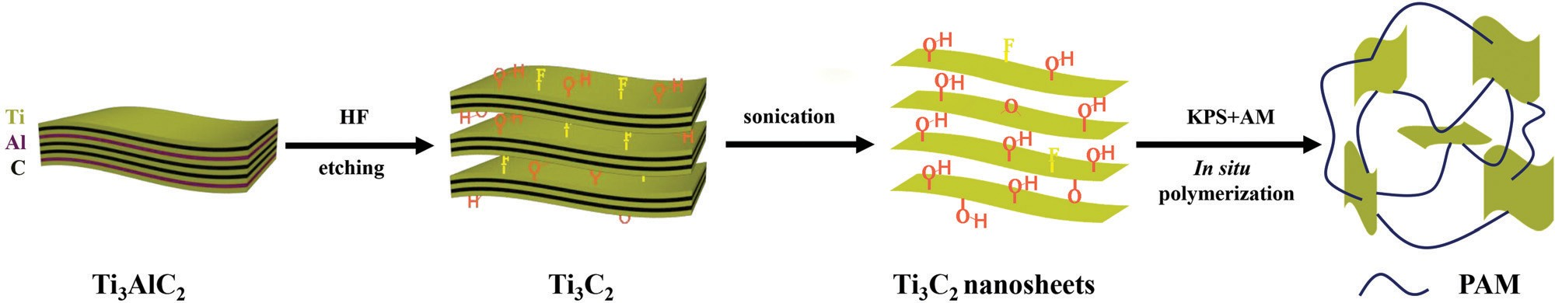
Scheme 1 Preparation procedures of Ti₃C₂/PAM hydrogels by in situ free radical polymerization with Ti₃C₂ nanosheets as a crosslinker.

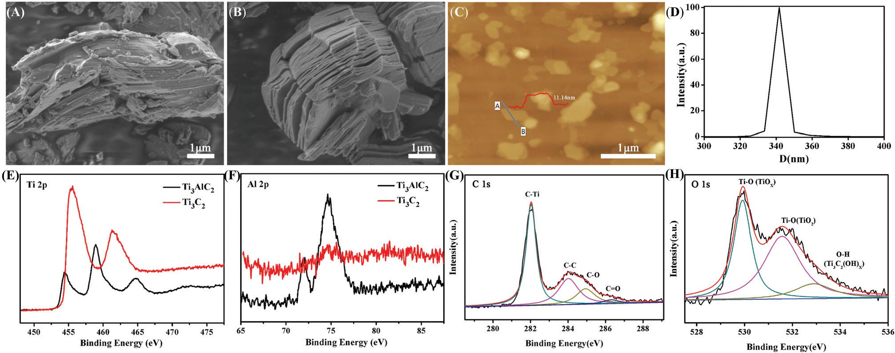
Fig. 1 SEM images of (A) Ti₃AlC₂ and (B) bulk Ti₃C₂. (C) AFM images of Ti₃C₂ nanosheets, and the inset image in AFM shows the thickness of Ti₃C₂ nanosheets. (D) DLS of the Ti₃C₂ nanosheet suspension. XPS spectra of Ti₃C₂ before and after etching, (E) Ti 2p, (F) Al 2p and XPS spectra of (G) C 1s and
(H) O 1s for Ti₃C₂.

Published on 13 November 2019. Downloaded on 1/9/2020 4:47:48 PM.
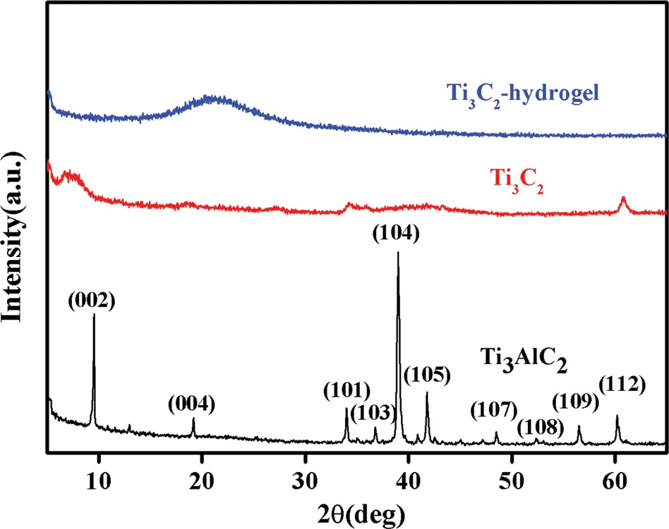
Fig. 2 XRD patterns of Ti₃AlC₂, Ti₃C₂ and Ti₃C₂/PAM hydrogels (T₆PAM).

ultralow content of Ti₃C₂ is also responsible for the absence of the Ti₃C₂ diffraction peaks.
The SEM images of BIS/PAM and Ti₃C₂/PAM NC xerogels are shown in Fig. 3. Evidently, the BIS/PAM xerogel exhibits quite diﬀerent structures from the Ti₃C₂/PAM NC xerogel. The micro- structure of the BIS/PAM xerogel appears with irregular and collapsed pores of 1–3 mm after the removal of water from the matrix (Fig. 3B). Moreover, the pores are sandwiched by solid bulk structures (Fig. 3A). This structural inhomogeneity always occurs in organic crosslinked hydrogels,⁴⁶ especially when the concentration of the crosslinker is high.⁴⁷ Unlike the BIS/PAM xerogel, the Ti₃C₂/PAM NC xerogel shows a honeycomb-like fine structure with a uniform pore distribution in the range of 2–3 mm (Fig. 3C and D). The pores and structure are much more uniform and regular than those of the BIS/PAM xerogel. The uniform and fine structures of Ti₃C₂/PAM NC hydrogels are beneficial for stress release and migration of drug molecules, promising enhanced
mechanical properties and drug release performances.^{25,48} Additionally, no obvious aggregation of bulk Ti₃C₂ can be observed in Ti₃C₂/PAM NC hydrogel networks, demonstrating that Ti₃C₂ nanosheets are well dispersed during Ti₃C₂/PAM NC hydrogel formation, which is in good accordance with XRD characterization (Fig. 2). Furthermore, the energy dispersive spectroscopy (EDS) mapping images of elements C and Ti (Fig. 3E and F) for T₂PAM confirm that Ti₃C₂ nanosheets are uniformly distributed in the network of Ti₃C₂/PAM NC hydro- gels, acting as crosslinkers.
  - Mechanical properties
Tensile and compressive tests were performed to evaluate the mechanical properties of as-synthesized hydrogels. The as-prepared Ti₃C₂/PAM NC hydrogels can withstand high degrees of defor- mations, such as elongation, bending, knotting and com- pression (Fig. 4). The Ti₃C₂/PAM NC hydrogels can be easily elongated over ten times and have a high level of 180 degrees bending (Fig. 4A and B). No fractures were observed on the surface of the Ti₃C₂/PAM NC hydrogels, even when they were made into a knot followed by elongation (Fig. 4C and D). Under high pressure, Ti₃C₂/PAM NC hydrogels showed an obvious strain without any breakage or damage. In addition, the hydro- gels can automatically and rapidly recover after removing the compression force (Fig. 4E–G). Tensile and compressive tests were performed to quantitatively evaluate the mechanical properties of the as-prepared hydrogels (Fig. 4H and I). The obtained values including elongation at break (l_{ts}), fracture strength (s_{f}) and compressive strength (s_{c}) are listed in Table 1. In the case of tensile properties, the Ti₃C₂/PAM NC hydrogels exhibit much higher break elongation and fracture strength (2158.6–3047.5%, 66.5–102.7 kPa) than organic crosslinked BIS/ PAM hydrogels (109.6%, 32.0 kPa). The participation of Ti₃C₂ dramatically improves the tensile properties of the hydrogels. Besides, Ti₃C₂/PAM NC hydrogels also exhibit dramatically high

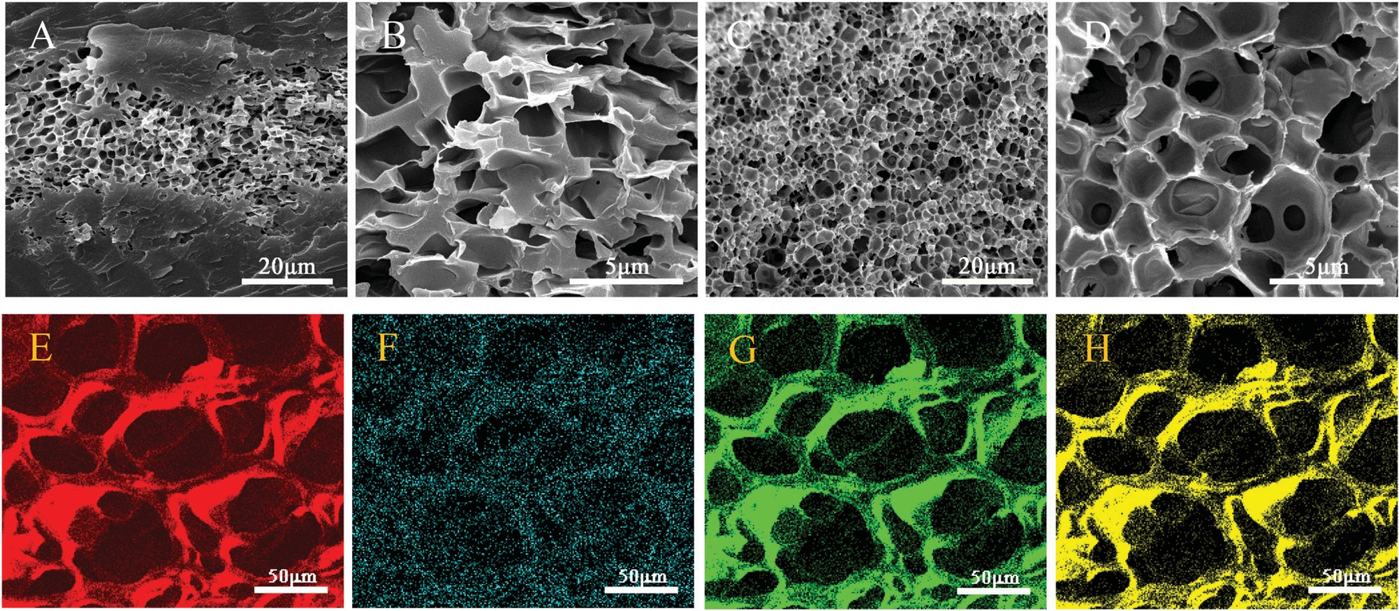
Fig. 3 SEM images of (A and B) BIS/PAM (T₀PAM) xerogels, (C and D) Ti₃C₂/PAM (T₆PAM) xerogels. EDS mapping images of C (E), Ti (F), N (G) and O (H) for T₂PAM xerogels.

Published on 13 November 2019. Downloaded on 1/9/2020 4:47:48 PM.
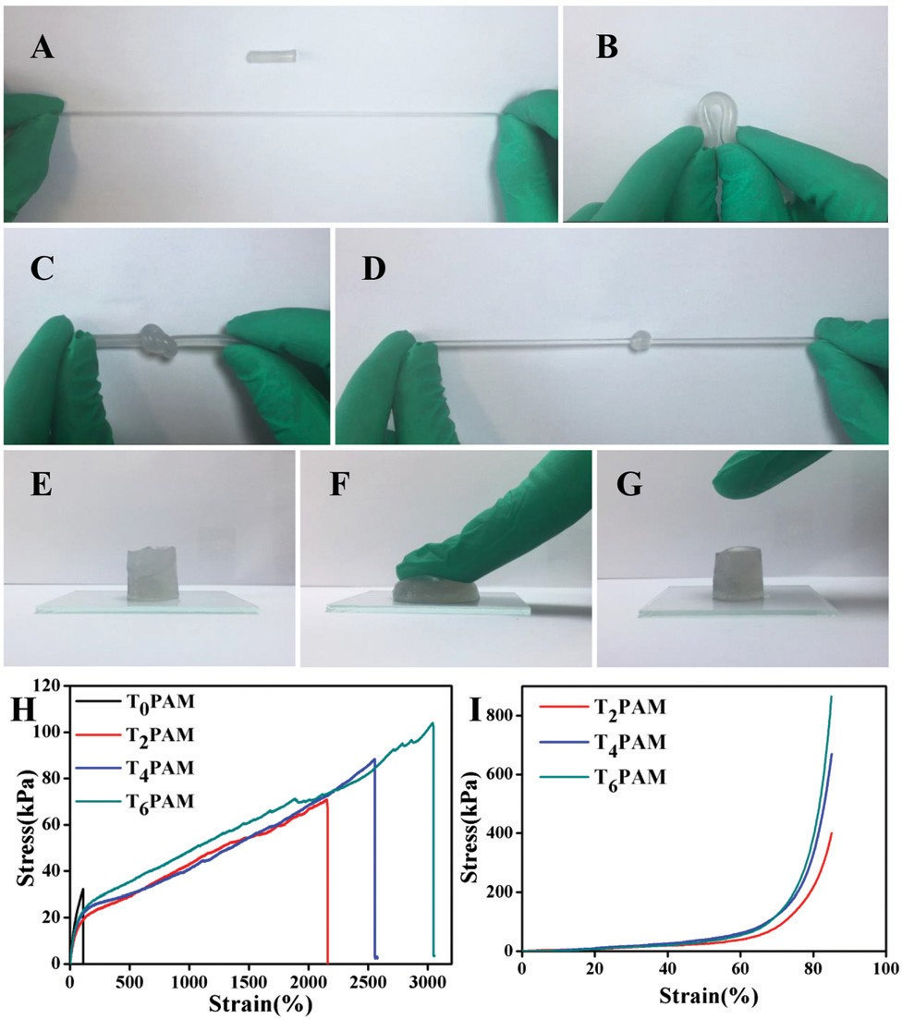
Fig. 4 Deformations of as-prepared Ti₃C₂/PAM (T₆PAM) hydrogels.
(A) elongation, (B) bending, (C) knotting, (D) knotting and elongation, and (E–G) compression. Stress–strain curves of (H) tensile and (I) compressive tests for BIS/PAM (T₀PAM) and Ti₃C₂/PAM (T₂PAM, T₄PAM, T₆PAM) hydrogels.

stress (400.6–819.4 kPa) in compressive tests. The compression properties of BIS/PAM hydrogels cannot be measured due to their brittle nature.⁴⁹ The enhanced mechanical performances can be attributed to the uniformly dispersed micropores and more flexible linear polymer chains (confirmed by the later
Table 1 Mechanical properties of BIS/PAM (T₀PAM) and Ti₃C₂/PAM (T₂PAM, T₄PAM, and T₆PAM) hydrogels

Sample | Ti₃C₂ content (%) | l_{ts} (%) | s_{f} (kPa) | s_{c} (kPa)
T₀PAM | 0 | 109.6 | 32.0
T₂PAM | 0.0145 | 2158.6 | 66.5 | 400.6
T₄PAM | 0.0291 | 2555.0 | 88.4 | 670.0
T₆PAM | 0.0436 | 3047.5 | 102.7 | 819.4
l_{ts}: elongation at break; s_{f}: fracture strength; s_{c}: compressive strength at a strain up to 85%.

estimation of hydrogel microstructures), which facilitate the energy dissipation during the deformations.^{23,24} The tensile stresses of the as-prepared Ti₃C₂/PAM NC hydrogels are higher than those of clay, LDH and C-dot crosslinked NC hydrogels, slightly inferior to those of GO/PAM NC hydrogels (Table S2, ESI†). Furthermore, the mechanical performance of Ti₃C₂/PAM NC hydrogels improved with the content of Ti₃C₂. These results reveal that the mechanical properties of Ti₃C₂/PAM NC hydro- gels can be tuned by adjusting the content of Ti₃C₂, which shows great potential in improving the mechanical properties of hydrogels. The improved mechanical properties are of vital importance for fabricating stable networks and practically utilizing NC hydrogels in various applications, such as catalysis, chemical sensors and drug carrier systems.

  - Swelling behavior and in vitro drug release
The swelling properties of BIS/PAM and Ti₃C₂/PAM NC xerogels were investigated by immersing B0.1 g xerogels in 100 g water at room temperature. A good swelling performance is beneficial
for the uptake of drug solutions.⁵⁰ All the samples display similar swelling behaviors (Fig. 5A). The water uptake can be attributed to hydrogen bonding interactions between the hydrophilic groups (–CONH₂) of polymer chains, the functional

groups (–OH, –F) on the Ti₃C₂ surface and the H₂O molecules in aqueous solution. The equilibrium swelling ratios of the Ti₃C₂/ PAM NC hydrogels (B16–33 g g^{—1}) are higher than that of
BIS/PAM hydrogels (9.6 g g^{—1}), indicating enhanced swelling
performances of Ti₃C₂/PAM NC hydrogels. The water contents after reaching the equilibrium swelling ratios were calculated to be 89.6%, 97.0%, 95.0% and 93.8% for T₀PAM, T₂PAM,
T₄PAM, and T₆PAM, respectively, which were higher than those of the original samples (81.8%, Table S1, ESI†). The Ti₃C₂ nanosheet crosslinked NC hydrogels significantly improved the swelling performance of the PAM hydrogels, which might be ascribed to the fact that flexible polymer chains have few limitations between nanosheets (confirmed by the later estimation of hydrogel microstructures).^{9,22,25} Besides, the uniform distri- bution of the pores and hydrophilic groups on the Ti₃C₂ nanosheets might also facilitate the uptake of water. Further- more, the swelling ratio of the Ti₃C₂/PAM NC hydrogels decreased with the increase of the Ti₃C₂ content, indicating that an adjustable swelling ratio was achieved by controlling the Ti₃C₂ content. Ti₃C₂/PAM NC hydrogels need a longer time
(B70 h) to reach the swelling equilibrium state than BIS/PAM hydrogels (B35 h) due to their high swelling equilibrium ratios. Moreover, no dissolving phenomenon was observed, demon-
strating the formation of a stable and tough network between the Ti₃C₂ nanosheets and the PAM chains in the Ti₃C₂/PAM NC hydrogels.
Chloramphenicol was selected as a model hydrophobic drug to investigate the drug sustained release eﬀect of the as-prepared hydrogels.⁵¹ The cumulative release eﬀect of chloramphenicol from freeze-dried hydrogels was determined in HCl solution (pH = 1.2) at 37 1C (Fig. 5B). The drug loads were calculated to
be 46.4, 127.7, 126.2 and 97.5 mg g^{—1} for T₀PAM, T₂PAM, T₄PAM
and T₆PAM, respectively (Fig. S2, ESI†). Ti₃C₂/PAM NC hydrogels exhibited higher drug loads than BIS/PAM hydrogels. This drug load diﬀerence can be attributed to the uniform porous structure
and excellent swelling behavior of Ti C /PAM NC hydrogels. The
Furthermore, the percentage release values (Fig. S3, ESI†) of chloramphenicol from Ti₃C₂/PAM NC hydrogels are 81.4%, 79.6%, and 62.1% (T₂PAM, T₄PAM and T₆PAM, respectively), which are much higher than that of BIS/PAM hydrogels (45.0%). That is to say, higher drug loads and higher percentage release values were simultaneously achieved in Ti₃C₂/PAM NC hydro- gels. The uniform pore distribution facilitates the migration of drug molecules and leads to higher drug release percentages. Unlike LDH-based nanocomposites,¹⁹ no dissolving phenomenon was observed throughout the in vitro drug release tests, indicating that Ti₃C₂/PAM NC hydrogels are acid resistant. Thus, a stable and mechanical strong network was constructed for improving the drug release performance of NC hydrogels.

  - Estimation of hydrogel microstructures
The excellent mechanical properties and swelling behaviors can be attributed to the fine microstructures of the Ti₃C₂/PAM NC hydrogels. It has been revealed that NC hydrogels have a much lower crosslinking density (the number of network chains per unit volume, N*)⁵² and a higher molecular weight of polymer chains between crosslinking points (the molecular weight of chains between crosslinks, M_{c}) than those of traditional organic crosslinked hydrogels.^{9,24,53,54} The higher M_{c} values endow the polymer chains in hydrogels with flexibility and extensibility to endure deformations. The classic theory of rubber elasticity was applied to estimate the N* and M_{c} values.⁵²
The classical equation of networks for tensile stress is^{24,52–54}
F = FN*kT(a — a^{—2}) (4)
where F is the force per unit original cross sectional area of the hydrogel (F = force/A₀). F, k and T are the front factor, Boltzmann’s constant and absolute temperature, respectively. a is the extension ratio (a = L/L₀). Here, let F = 1 and F at a = 2 (l_{ts} = 100%), N* can be calculated using eqn (4).^{24,53,54} The M_{c}
value is determined using the following equation^{53,54}

3 2

drug release reached an equilibrium at B360 min for T₀PAM, slightly faster than those of Ti₃C₂/PAM NC hydrogels (B420 min).
The slightly slower equilibrium for NC hydrogels might result from the fact that NC hydrogels exhibited higher drug loads.
N* = r*N_{A}/M_{c} (5)
where r* is the density of the polymer in hydrogels and N_{A} is Avogadro’s constant.

Published on 13 November 2019. Downloaded on 1/9/2020 4:47:48 PM.

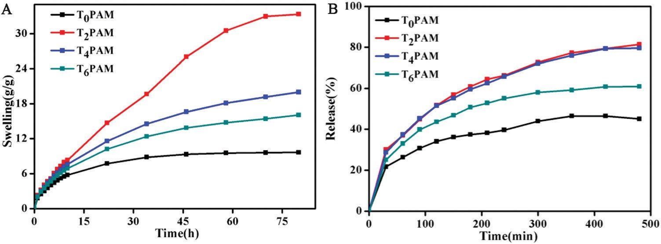
Fig. 5 (A) Swelling kinetics and (B) chloramphenicol release in HCl (pH = 1.2) of freeze-dried BIS/PAM (T₀PAM) and Ti₃C₂/PAM (T₂PAM, T₄PAM, T₆PAM) hydrogels.

Table 2 Parameters of crosslinking networks for the BIS/PAM (T₀PAM) hydrogel and Ti₃C₂/PAM (T₂PAM, T₄PAM, and T₆PAM) NC hydrogels

Sample | F_{a=2} (kPa) | N* (10¹⁸ chains per cm³) | M_{c} (10⁴ g mol^{—1}) | n (10¹⁴ sheets per cm³) | N*/n (chains per sheet)
T₀PAM | 30.6 | 4.39 | 2.6 | — | —
T₂PAM | 18.3 | 2.63 | 4.3 | 1.04 | 25 247
T₄PAM | 21.1 | 3.03 | 3.8 | 2.09 | 14 471
T₆PAM | 22.0 | 3.15 | 3.7 | 3.18 | 9898

The calculated N* and M_{c} of BIS/PAM and Ti₃C₂/PAM NC hydrogels are listed in Table 2. Compared with the BIS/PAM hydrogel (4.39 × 10¹⁸ chains per cm³ and 2.6 × 10⁴ g mol^{—1}), all Ti₃C₂/PAM NC hydrogels exhibit lower N* values (2.63 × 10¹⁸ B 3.15 × 10¹⁸ chains per cm³) and higher M_{c} values (3.7 ×
Published on 13 November 2019. Downloaded on 1/9/2020 4:47:48 PM.
10⁴ g mol^{—1} B 4.3 × 10⁴ g mol^{—1}). The longer polymer chains in the hydrogels enable hydrogels bear higher level of defor- mations without severing the constituent polymer chains and
give rise to enhanced mechanical properties. When it comes to BIS/PAM hydrogels, the higher density of chains (N*) and shorter length of chains between crosslinking points (M_{c}) indicate severe restriction of polymer chains and lead to their brittle and weak mechanical performance.
By assuming Ti₃C₂ nanosheets as disk-like sheets with a diameter of 350 nm and a thickness of 11 nm (according to the AFM and DLS results, Fig. 1C and D), the number of sheets per cm³ (n), and the number of chains per sheet (N*/n) can be
obtained.^{9,25,53} The results are also listed in Table 2. The so-obtained values of N*/n indicated that thousands of (0.99 × 10⁴–2.5 × 10⁴) polymer chains were grafted on the surface of the Ti₃C₂ nanosheets.
The crosslinking points of BIS/PAM hydrogels are estimated to be 5.6 × 10¹⁸ sites per cm³ depending on the BIS content.^{25,53} The inter-crosslinking distance of the polymer chains in NC hydrogels is deemed to be equivalent to the distance between adjacent inorganic nanosheets^{9,24,53,54} owing to the fact that the number of sheets per unit volume in Ti₃C₂/PAM NC hydro- gels (1.04 × 10¹⁴–3.18 × 10¹⁴) is much smaller than that of BIS/
PAM hydrogels (5.6 × 10¹⁸ sites per cm³). Thus, the inter- crosslinking distance of polymer chains in NC hydrogels is much longer than that in BIS/PAM hydrogels. Hence, the
crosslinked polymer chains in Ti₃C₂/PAM NC hydrogels are more flexible and behave more like free, linear polymers.^{24,54,55} That is to say, the polymers in NC hydrogels have less restric- tion with regard to swelling and mechanical characterization in comparison with those in BIS/PAM hydrogels.

Conclusions
In summary, we have successfully fabricated Ti₃C₂/PAM NC hydrogels by in situ free radical polymerization. The Ti₃C₂ nanosheets are proved to be evenly distributed in the matrix of Ti₃C₂/PAM NC hydrogels and act as inorganic crosslinkers. Compared with BIS/PAM hydrogels, Ti₃C₂/PAM NC hydrogels exhibit excellent mechanical properties, high degrees of defor- mations, extraordinary stretching ability and enhanced swelling properties owing to their uniform fine structures. When the content of Ti₃C₂ is only 0.0436%, the fracture strength and
break elongation of Ti₃C₂/PAM NC hydrogels are 102.7 kPa and 3047.5%, respectively. Furthermore, the tensile and compressive mechanical performances of the Ti₃C₂/PAM NC hydrogels increase with joining Ti₃C₂ while the swelling ratio decreases, making it possible to tune the performances by controlling the contents of Ti₃C₂. In the case of drug release performance, Ti₃C₂/PAM NC
hydrogels exhibit higher drug loads and drug release percentages simultaneously (97.5–127.7 mg g^{—1} and 62.1–81.4%), showing their practical applications in biomedicine. The uniform pore structures
and flexible linear polymer chains are suggested to account for the high mechanical strength and enhanced drug release performance. It is supposed that the incorporation of Ti₃C₂ might endow hydro- gels with electrical conductivity, catalytic performance and mechan- ical performances. The new Ti₃C₂ crosslinked NC hydrogel may pave the way for its applications in gel electrolytes, chemical sensors and hydrogel-based supercapacitors.

Conflicts of interest
There are no conflicts to declare.

Acknowledgements
We acknowledge the funding from the National Natural Science Foundation of China (No. 21502227), the Fundamental Research Funds for the Central Universities (No. 19CX02040A, 15CX02015A, and 16CX05009A), the State Key Laboratory of Heavy Oil Processing (No. SLKZZ-2017009), the Shandong Province Major Science and Technology Innovation Project (No. 2018CXGC1002), and the Key Laboratory of Photochemical Conversion and Opto- electronic Materials, TIPC, CAS.

Notes and references
- K. Y. Lee and D. J. Mooney, Chem. Rev., 2001, 101, 1869.
- O. P. Varghese, W. Sun, J. Hilborn and D. Ossipov, J. Am. Chem. Soc., 2009, 131, 8781.
- J. H. Holtz and S. A. Asher, Nature, 1997, 389, 829. 4 P. Calvert, Adv. Mater., 2009, 21, 743.
- J.-Y. Sun, X. Zhao, W. R. K. Illeperuma, O. Chaudhuri, K. H. Oh, D. J. Mooney, J. J. Vlassak and Z. Suo, Nature, 2012, 489, 133.
- Y. Sun, G. Gao, G. Du, Y. Cheng and J. Fu, ACS Macro Lett., 2014, 3, 496.
- A. Wu, X. Gao, P. Sun, F. Lu and L. Zheng, Angew. Chem., Int. Ed., 2018, 57, 4025.
- Y. Okumura and K. Ito, Adv. Mater., 2001, 13, 485.
- K. Haraguchi and T. Takehisa, Adv. Mater., 2002, 14, 1120.

- H.-J. Li, H. Jiang and K. Haraguchi, Macromolecules, 2018,
Published on 13 November 2019. Downloaded on 1/9/2020 4:47:48 PM.
51, 529.
- J. Xu, Y. Zhang, W. Zhu and Y. Cui, Macromolecules, 2018,
51, 2672.
- J. Du, S. Xu, S. Feng, L. Yu, J. Wang and Y. Liu, Soft Matter, 2016, 12, 1649.
- S. Gu, L. Duan, X. Ren and G. H. Gao, J. Colloid Interface Sci., 2017, 492, 119.
- J. Gong, Y. Katsuyama, T. Kurokawa and Y. Osada, Adv. Mater., 2003, 15, 1155.
- J. Gong, Soft Matter, 2010, 6, 2583.
- M. Kurisawa, L. Fan, L. Wang and J. Chung, J. Mater. Chem., 2010, 20, 5371.
- X. Cai, Y. Luo, B. Liu and H.-M. Cheng, Chem. Soc. Rev., 2018, 47, 6224.
- Y. Chen, Z. Fan, Z. Zhang, W. Xin, C. Li, N. Yang, B. Chen and H. Zhang, Chem. Rev., 2018, 118, 6409.
- Y. Zhang, H. Li, N. Du, S. Song and W. Hou, Appl. Clay Sci., 2017, 143, 336.
- T. Su, L. Wu, X. Pan, C. Zhang, M. Shi, R. Gao, X. Qi and
  - Dong, J. Colloid Interface Sci., 2019, 542, 253.
- L. Z. Zhao, C. H. Zhou, J. Wang, D. S. Tong, W. H. Yu and
H. Wang, Soft Matter, 2015, 11, 9229.
- R. Liu, S. Liang, X.-Z. Tang, D. Yan, X. Li and Z. Z. Yu,
J. Mater. Chem., 2012, 22, 14160.
- S. Liu, A. K. Bastola and L. Li, ACS Appl. Mater. Interfaces, 2017, 9, 41473.
- Z. Hu and G. Chen, Adv. Mater., 2014, 26, 5950.
- Y. Zhang, J. Ji, H. Li, N. Du, S. Song and W. Hou, Soft Matter, 2018, 14, 1789.
- X.-J. Yang, P. Zhang, P. Li, Z. Li, W. Xia, H. Zhang, Z. Di,
M. Wang, H. Zhang and Q. J. Niu, J. Mol. Liq., 2019, 280, 128.
- M. Naguib, O. Mashtalir, J. Carle, V. Presser, J. Lu,
L. Hultman, Y. Gogotsi and M. W. Barsoum, ACS Nano, 2012, 6, 1322.
- M. Naguib, M. Kurtoglu, V. Presser, J. Lu, J. Niu, M. Heon,
L. Hultman, Y. Gogotsi and M. W. Barsoum, Adv. Mater., 2011, 23, 4248.
- H. Lin, Y. Wang, S. Gao, Y. Chen and J. Shi, Adv. Mater., 2018, 30, 1703284.
- O. Mashtalir, M. Naguib, V. N. Mochalin, Y. Dall’Agnese,
M. Heon, M. W. Barsoum and Y. Gogotsi, Nat. Commun., 2013, 4, 1716.
- C. Dai, Y. Chen, X. Jing, L. Xiang, D. Yang, H. Lin, Z. Liu,
  - Han and R. Wu, ACS Nano, 2017, 11, 12696.
- J. Chen, K. Chen, D. Tong, Y. Huang, J. Zhang, J. Xue,
Q. Huang and T. Chen, Chem. Commun., 2015, 51, 314.
- M. Boota, B. Anasori, C. Voigt, M. Q. Zhao, M. W. Barsoum and Y. Gogotsi, Adv. Mater., 2016, 28, 1517.
- X. Wang, S. Kajiyama, H. Iinuma, E. Hosono, S. Oro,
I. Moriguchi, M. Okubo and M. Yamada, Nat. Commun., 2015, 6, 6544.
- M.-Q. Zhao, C. E. Ren, Z. Ling, M. R. Lukatskaya, C. Zhang,
K. L. V. Aken, M. W. Barsoum and Y. Gogotsi, Adv. Mater., 2015, 27, 339.
- J. Guo, Y. Zhao, A. Liu and T. Ma, Electrochim. Acta, 2019,
305, 164.
- J. Ran, G. Gao, F.-T. Li, T.-Y. Ma, A. Du and S.-Z. Qiao, Nat. Commun., 2016, 8, 13907.
- W. Zhou, J. Zhu, F. Wang, M. Cao and T. Zhao, Mater. Lett., 2017, 206, 237.
- O. Mashtalir, K. M. Cook, V. N. Mochalin, M. Crowe,
M. W. Barsoum and Y. Gogotsi, J. Mater. Chem. A, 2014,
2, 14334.
- Q. Zhang, J. Teng, G. Zou, Q. Peng, Q. Du, T. Jiao and
J. Xiang, Nanoscale, 2016, 8, 7085.
- C. Xing, S. Chen, X. Liang, Q. Liu, M. Qu, Q. Zhou, J. Li,
H. Tan, L. Liu, D. Fan and H. Zhang, ACS Appl. Mater. Interfaces, 2018, 10, 27631.
- S. G. Ingebrigtsen, A. Didriksen, M. Johannessen, N. ˇSkalko-
Basnet and A. M. Holsæter, Int. J. Pharm., 2017, 526, 538.
- M. R. Lukatskaya, J. Halim, B. Dyatkin, M. I. Naguib,
Y. S. Buranova, M. W. Barsoum and Y. Gogotsi, Angew. Chem., Int. Ed., 2014, 53, 4877.
- Y. Sun, D. Jin, Y. Sun, X. Meng, Y. Gao, Y. Dall’Agnese,
G. Chen and X.-F. Wang, J. Mater. Chem. A, 2018, 6, 9124.
- M. Naguib, V. N. Mochalin, M. W. Barsoum and Y. Gogotsi,
Adv. Mater., 2014, 26, 992.
- K. Shi, Z. Liu, C. Yang, X.-Y. Li, Y.-M. Sun, Y. Deng,
W. Wang, X.-J. Ju, R. Xie and L.-Y. Chu, ACS Appl. Mater. Interfaces, 2017, 9, 21979.
- M. Shibayama, S.-I. Takata and T. Norisuye, Physica A, 1998,
249, 245.
- C. Teng, J. Qiao, J. Wang, L. Jiang and Y. Zhu, ACS Nano, 2016, 10, 413.
- J. Shen, B. Yan, T. Li, Y. Long, N. Li and M. Ye, Soft Matter, 2012, 8, 1831.
- N. Cheng, Q. Hu, Y. Guo, Y. Wang and L. Yu, ACS Appl. Mater. Interfaces, 2015, 7, 10258.
- G. Giammanco, C. Sosnofsky and A. Ostrowski, ACS Appl. Mater. Interfaces, 2014, 7, 3068.
- A. Tobolsky, D. Carlson and N. Indictor, J. Polym. Sci., Polym. Chem., 1961, 54, 175.
- K. Haraguchi, T. Toru and S. Fan, Macromolecules, 2002,
35, 10162.
- L. Wu, Z. Hu, G. Chen and Z. Li, Soft Matter, 2015, 11, 9038.
- M. Hu, Y. Yang, X. Gu, Y. Hu, Z. Du and C. Wang, Macromol. Mater. Eng., 2015, 300, 1043.

