

ChemicalEngineeringJournal380(2020)122475
Contents lists available at ScienceDirect

Chemical Engineering Journal
journal homepage: www.elsevier.com/locate/cej


Flame-retardant poly(vinyl alcohol)/MXene multilayered films with outstanding electromagnetic interference shielding and thermal conductive performances
Xiuxiu Jin^{a,b}, Jianfeng Wang^{b,⁎}, Lunzhi Daiª, Xiaoya Liu^{b}, Lei Li^{b}, Yanyu Yang^{b}, Yanxia Cao^{b},
Wanjie Wang^{b,⁎}, Hong Wu^{c}, Shaoyun Guo^{c}
ª State Key Laboratory of Biotherapy, West China Hospital, Sichuan University, and Collaborative Innovation Center for Biotherapy, Chengdu 610041, China
^{b} College of Materials Science and Engineering, Henan Key Laboratory of Advanced Nylon Materials and Application, Zhengzhou University, Zhengzhou 450001, China
^{c} The State Key Laboratory of Polymer Materials Engineering, Polymer Research Institute of Sichuan University, Chengdu 610065, China

H I G H L I G H T S
•

PVA/MXene alternating multilayered films were fabricated via multilayered casting.
The multilayered films exhibited high EMI SE of 44.4 dB and SSE_{t} of 9343 dB cm² g⁻¹.
•
•
The multilayered films exhibited a high thermal conductivity of 4.57 W/ mK.
•
The multilayered films showed re- markable anti-dripping performance.

A R T I C L E I N F O

Keywords:
Polymeric film MXene
Multilayered structure Electromagnetic interference shielding Thermal conductivity
Flame retardancy
G R A P H I C A L A B S T R A C T
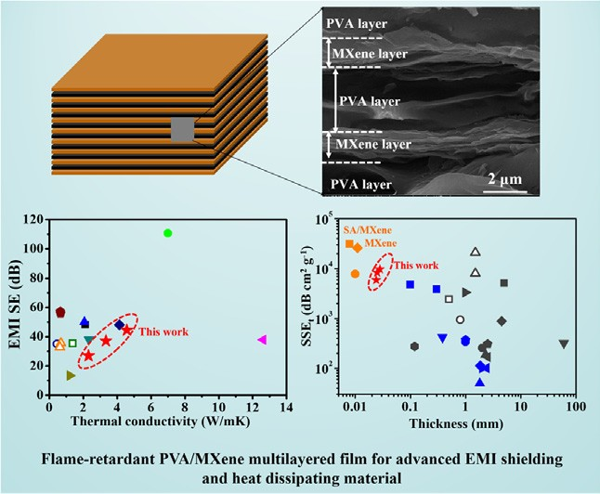

A B S T R A C T
With the miniaturized and high-frequency development in electronic products, polymeric films synchronously
with high electromagnetic interference (EMI) shielding effectiveness (SE) and thermal conductivity (TC) are
urgently needed. In this work, poly (vinyl alcohol)/transition metal carbide (PVA/MXene) films featured with
alternating multilayered structure were fabricated through multilayered casting. The continuous MXene layer
provided a compact network for conducting heat and electron, endowing the multilayered film with excellent
EMI SE and TC synchronously. In particular, the 27-μm-thick PVA/MXene multilayered film (containing 19.5 wt
% MXene in total) exhibited an electrical conductivity of 716 S/m, a maximum EMI SE of 44.4 dB and a specific
EMI SE (SSE_{t}) of 9343 dB cm² g⁻¹. Meanwhile, the multilayered film showed a high in-plane TC of 4.57 W/mK,
enhanced by almost 23-fold compared with that of neat PVA. Moreover, the multilayered architecture endowed
the film with remarkable anti-dripping performance. This work provides a novel and feasible strategy for fab-
ricating flame-retardant polymeric thermal conductive and EMI shielding films, which will have enormous
prospect in advanced electrical devices.

⁎ Corresponding authors.
E-mail addresses: jfw@zzu.edu.cn (J. Wang), wwj@zzu.edu.cn (W. Wang).

https://doi.org/10.1016/j.cej.2019.122475
Received 28 April 2019; Received in revised form 23 July 2019; Accepted 9 August 2019
Availableonline09August2019
1385-8947/©2019ElsevierB.V.Allrightsreserved.

- Introduction

With the miniaturized and high-frequency development in elec- tronic products, electromagnetic radiation and heat accumulation during the operation of electron component are growing more and more serious, which not only deteriorate the performance of precision devices nearby but also threaten the health of human beings. To eﬃ- ciently dissipate heat and minimize the problem associated with elec- tromagnetic interference (EMI), materials synchronously with excellent EMI shielding and thermal conductive performance are urgently needed [1]. Compared with conventional metal-based EMI shielding and heat dissipating materials, polymeric materials are attracting increasing at- tention due to their lightweight, flexible, easy processing and excellent corrosion resistance [2]. However, most polymers are intrinsically poor conductor for heat and electron, resulting in low EMI shielding effec- tiveness (SE) and thermal conductivity (TC) in polymer matrix. More- over, the high combustibility of polymeric materials limits their appli- cation in EMI shielding and heat dissipating devices greatly. How to significantly enhance the EMI SE, TC and flame retardancy of polymer matrix at the same time is a key issue for promoting the miniaturized and high-frequency development in electronic products.
Incorporating fillers with high electrical conductivity and high TC
into polymer matrix is considered as one of the most feasible and ef- fective ways to enhance the EMI SE and TC of polymer matrix syn- chronously [3–13]. In particular, due to the intrinsic surpassing elec- trical conductivity and thermal conductivity, carbon nanomaterials like graphene and carbon nanotubes (CNTs) have been extensively in- vestigated in polymeric EMI shielding and heat dissipating composite materials [1,14]. Wang et al. fabricated thiol-modified rGO-waterborne polyurethane/cotton fabric with an EMI SE of 48.1 dB and a TC of
2.13 W/mK via adding 2 wt% thiol-rGO [3]. Guo et al. obtained an EMI SE of 50 dB and a TC of 2.06 W/mK in nylon matrix via melt-blending with 18 wt% hybrid carbon fillers of expanded graphite and multi- walled CNTs [5]. In general, carbon fillers are incompatible with polymer matrix, resulting in serious aggregation of carbon fillers and great filler-matrix interfacial thermal resistance in the polymer com- posites, which greatly restrict the EMI SE and TC performance of the as- obtained composites. Even though surface modification on the carbon fillers can improve the filler-matrix interfacial compatibility and reduce the filler-matrix interfacial thermal resistance, structure destruction on the modified carbon fillers inevitably weakens the intrinsic electrical conductivity and thermal conductivity of the carbon fillers. This is conversely adverse for fabricating high-performance polymeric EMI shielding and heat dissipating composite materials. It is still a great problem to make a perfect balance between the high intrinsic elec- trical/thermal conductivity of incorporating fillers and better filler- matrix interfacial compatibility. Moreover, the typically complex pro- cess of most surface modifications makes them impracticable for large- scale fabrication of polymeric EMI shielding and heat dissipating composites.
Hybrid fillers of carbon nanomaterial and insulating thermal con-
ductive filler (like boron nitride) [7] or magnetic conductive filler (like iron oxide) [8–13] have also been adopted to enhance the EMI SE and TC of polymer matrix synchronously. For example, Liu et al. obtained an anisotropic TC of 1.213 W/mK and an EMI SE of 13.45 dB in epoxy composites via adding 8.97 wt% aligned rGO@Fe₃O₄ [8]. Zhao et al. obtained a TC of 0.66 W/mK and an EMI SE of 55.8 dB in poly(vinyli- dene fluoride) (PVDF) composites via adding 5 wt% graphene nano- platelets (GnPs) and 8 wt% Ni chains [10]. Even though the above strategies can enhance the EMI SE and TC of polymer matrix at the same time, there are still some problems in fabricating high-perfor- mance polymeric thermal conductive and EMI shielding materials. Large thickness (usually > 1 mm) is usually required for achieving high EMI SE in polymer composites, which cannot satisfy the growing narrow space for electronic packaging. It is still a great challenge to realize excellent but balanced EMI SE and TC in polymeric films.
Moreover, the flammability of the reported polymeric thermal con- ductive and EMI shielding materials has been rarely referred to before, which is crucial for safe utilization of polymeric EMI shielding and heat dissipating devices.
Recently, two dimensional transition metal carbides (MXenes) have attracted enormous attention due to their exceptional metallic electrical conductivity, large aspect ratio and tunable surface functional groups [15–17], and are considered as promising alternatives to carbon na- nomaterials for providing excellent EMI shielding performance [16].
The 45-μm-thick MXene film exhibited a maximum EMI SE of 92 dB and the 11-μm-thick MXene film containing 10 wt% sodium alginate (SA) showed a specific EMI SE (SSE_{t}) of 30830 dB cm² g⁻¹ [17]. Further-
more, the tunable functional groups (eOH, ]O and eF) on MXene surface endow MXene better interfacial compatibility with polymer matrix while the exceptional intrinsic electrical conductivity of MXene was maintained well [18–22]. Yu et al. obtained a high electrical conductivity (1081 S/m) and an EMI SE (> 54 dB) in 2-mm-thick polystyrene(PS)/Ti₃C₂ composites containing 1.9 vol% MXene with a 3D network structure [18]. It should be pointed that large thickness was also usually required for achieving excellent EMI SE performance in polymer/MXene composites. Meanwhile, apart from the exceptional electrical conductivity, MXenes have also been reported to be of high intrinsic TC (the theoretical TC of Sc₂C MXene was up to 472 W/mK [23]), which are promising candidates for fabricating polymeric EMI shielding films exhibiting remarkable combination of excellent EMI SE and TC. So far, few study has been focused on enhancing the TC of polymer matrix using MXene as filler [24,25]. It still lacks in-depth exploration on fabricating highly thermal conductive polymer/MXene composites despite its great potential on fabricating polymeric thermal conductive and EMI shielding composites.
In this work, we demonstrate the fabrication of MXene-filled poly-
meric films exhibiting excellent
 |  | EMI shielding and thermal conductive
performance synchronously. Poly (vinyl alcohol) (PVA) was used as the
polymer matrix, which can form strong hydrogen bond interaction with
MXene [21] | Multilayered structure alternating PVA layer and MXene
layer was constructed through multilayered casting. The continuous
electrical/thermal conductive MXene layer endowed the 27-μm-thick
PVA/MXene multilayered film with excellent electrical conductivity,
EMI SE, specific EMI SE (SSE_{t}) and in plane TC. Meanwhile, the mul-
tilayered film exhibited remarkable anti-dripping performance.

.

Corre- sponding mechanisms for EMI shielding, thermal conductive and flame retardancy in the PVA/MXene multilayered films were explored.
This
work demonstrates the great potential of MXene on enhancing the TC
and flame retardancy of polymer matrix, providing a feasible and ef-
fective strategy for fabricating flame-retardant, highly thermal con-
ductive polymeric EMI shielding films.

- Experimental

  - Materials

PVA, with a polymerization degree of 2000 and an alcoholysis de- gree of 99 was commercially purchased from Shanxi Sanwei Group. Layered titanium aluminum carbide (Ti₃AlC₂) powder was commer- cially procured (Beijing Forsman Scientific Co., Ltd., 200 mesh). Lithium fluoride (LiF) was purchased from Shanghai Macklin bio- chemical technology Co., Ltd. All other chemicals were used as received without further purification.

  - Preparation of Ti₃C₂T_{x} (MXene)

Ti₃C₂T_{x} MXene was synthesized following the minimally intensive layer delamination (MILD) method through selective etching of Ti₃AlC₂ using in situ HF-forming etchant [26]. Briefly, 10 g of LiF was dissolved in 200 ml 9 M HCl in a PTFE container followed by stirring for 30 min. Then, 10 g of Ti₃AlC₂ powder was slowly added to the MILD etchant to

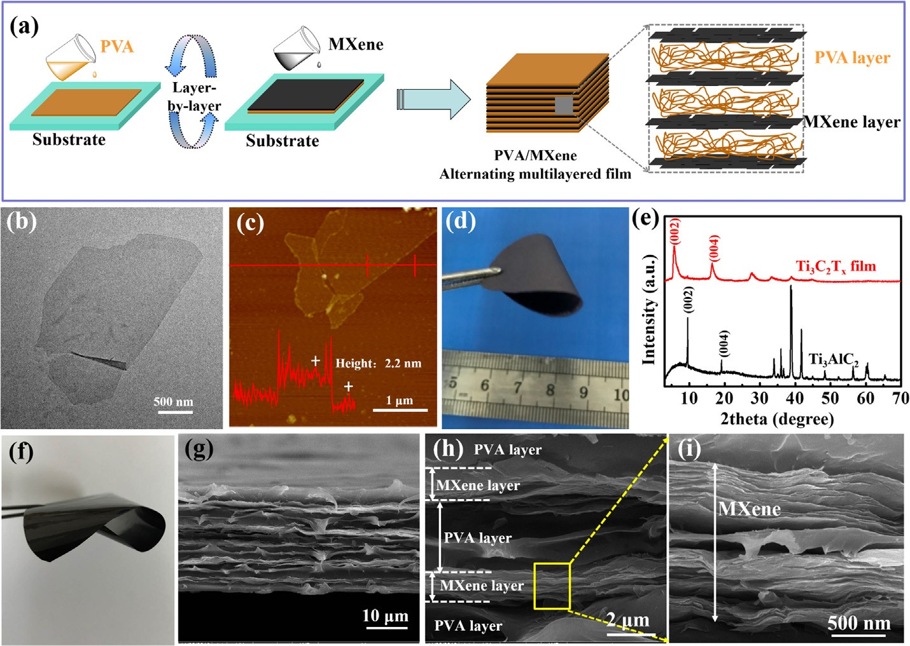
Fig. 1. a) Schematic of the fabrication of PVA/ MXene alternating multilayered film through mul- tilayered casting; b) TEM image and c) AMF image and height morphology of delaminated Ti₃C₂T_{x}; d) digital image of free-standing vacuum-filtrated Ti₃C₂T_{x} MXene film with a diameter of 50 mm; e) XRD patterns of Ti₃AlC₂ and Ti₃C₂T_{x} MXene film, respectively; f) digital image of the flexible PVA/ MXene-AM-19.5 film; g), h) and i) are SEM images of PVA/MXene-AM-19.5 film at low and high mag- nification, respectively.

react for 24 h at 35 °C under stirring and the resultant slurry was re- peatedly washed and centrifuged at 3500 rpm until pH > 6. Around pH ≥ 6, the Ti₃C₂T_{x} sediment was re-dispersed in DI water and shook by hand for 10 min and then collected after 5 min of centrifugation at 3500 rpm. The concentration of the Ti₃C₂T_{x} solution was measured by filtering specific amounts of colloidal solution through a PVDF filter, followed by drying under a vacuum at 70 °C for 6 h. The supernatant of the final centrifugation was used for all the work in this study to ensure the Ti₃C₂T_{x} being used was completely delaminated.

  - Fabrication of PVA/MXene alternating multilayered film

PVA/MXene alternating multilayered films were fabricated through
multilayered casting method, as shown in Fig. 1a. For example, aqueous
PVA solution (31 mg/ml, 4 ml) was casted onto a square iron substrate
and dried at 45 °C to form a PVA layer. Then, MXene aqueous (5 mg/ml,
2 ml) was casted onto the PVA layer and dried at 45 °C to form a con-
tinuous MXene layer. Repeat casting of PVA and MXene in succession of
11 cycles and a PVA/MXene multilayered film with 6 layers of PVA and
5 layers of MXene was obtained, and the total mass fraction of MXene in
this multilayered film was 7.5 wt%, calculated according to the con-
centration and volume of PVA aqueous solution and MXene solution.
The above PVA/MXene multilayered film was named as PVA/MXene- AM-7.5. Then, PVA/MXene multilayered films with 13.9 wt% and
19.5 wt% MXene were fabricated using the same procedure except for the concentration and volume of MXene aqueous (10 mg/ml, 2 ml; 10 mg/ml, 3 ml, respectively), and were named as PVA/MXene-AM-
13.9 and PVA/MXene-AM-19.5, respectively. The thickness of PVA/ MXene-AM-7.5, PVA/MXene-AM-13.9 and PVA/MXene-AM-19.5 film were 24 μm, 25 μm and 27 μm, respectively, measured from the SEM images of the film.

  - Characterization

Scanning electron microscopy (SEM) images were taken using JSM- 5900LV-SEM at a voltage of 5.0 kV. Prior to being analyzed, the sam-
mica wafers were examined using atomic force microscopy (AFM, Anasys, AFM + nano IR). X-ray diffraction (XRD) measurements were conducted on a D8 Advance (Bruker), using Cu Ka radiation (k = 1.5405 Å) with a scanning speed of 20°/min from 2 to 70°. Fourier transform infrared spectra were measured on a FTIR (Nicolet iS50, Thermo Fisher). Thermogravimetric analysis (TGA) was conducted on a TG-DTA8122 Smart loader thermal-analyzer at a heating rate of 20 °C min⁻¹ under air. X-ray photoelectron spectroscopy (XPS) was used an ESCALAB 250Xi (Thermo Scientic) with the X-ray source of
monochromatic Al Kα. Raman were obtained on a RM 2000
Microscopic confocal Raman spectrometer (Renishaw PLC, England) using a 514.5 nm argon ion laser in the wavenumber range of 100–3500 cm⁻¹. Thermal conductivity of the multilayered film was calculated from the equation λ = α × C_{p} × ρ, where the λ, α, C_{p} and ρ represented thermal conductivity, thermal diffusivity, heat capacity
and material density, respectively. The heat capacity and thermal dif- fusivity of the multilayered film can be measured through a light flash system (LFA 447 NanoFlash). In-plane thermal conductivity of the multilayered film was measured, and at least three samples were measured to achieve an average value in each group. The combustion test of the multilayered film was conducted on an alcohol burner, in which the specimen was ignited on the flame of alcohol burner for 1 s and then was moved away from the flame. The whole combustion process was recorded using a digital camera. The electrical conductivity of the film was measured using a standard four-probe technique (RTS-8, Guangzhou four-point probe technology co. Itd, China). Electromagnetic interference (EMI) shielding effectiveness (SE) of the multilayered film with the diameter of 12 mm was measured using a coaxial test cell (APC-7 connector) in conjunction with an Aglilent N5230 vector network analyzer, based on ASTM ES7-83. The measuring frequency range was 8.2–12.4 GHz (X band). The EMI performance, including SE_{total} (SE_{T}), SE_{reflection} (SE_{R}) and SE_{absorption} (SE_{A}), was cal- culated from the scattering parameters (S₁₁ and S₂₁) [11,17].
R = |S₁₁|2 (1)
T = |S₂₁|2 (2)

ples were mounted on stubs and their surfaces were platinum coated. Transmission electron microscopy (TEM) images were taken using Tecnai G2F20 S-TWIN-TEM at an accelerating voltage of 200 kV. The surface topography and thickness of MXene nanosheets deposited onto
SE_{R} = −log₁₀ (1 − R)
SE_{A} = −log10 ⎛ TR ⎞
⎝ 1 - ⎠
(3)

(4)

SE_{T} = SE_{R} + SE_{A} (5)
In addition, the specific EMI SE accounting for the thickness con- tribution (SSE_{t}) is defined as the SE value divided by surface density and the thickness of the specimen, as described in the following equa- tion (6), to evaluate the absolute effectiveness of the film [17]:
SSE_{t} = SSE/ t= dBcm3g−1cm−1 = dBcm2g−1 (6)
Meanwhile, EMI shielding eﬃciency (%), which presents the ability of a material to block waves in terms of percentage, was converted from the EMI shielding effectiveness (dB) using the following Eq. (7) [17]:
Shielding efficiency(%) = 100 − ⎛ 1 ⎞ × 100
SE

As shown in Fig. 2b, the EMI SE of neat PVA film was almost zero in the X-band. For the 24-μm-thick PVA/MXene- AM-7.5 film, the EMI SE increased up to a maximum value of 26.9 dB. The EMI SE of the 25-μm-thick PVA/MXene-AM-13.9 film reached up to a maximum value of 37.1 dB. Furthermore, the 27-μm-thick PVA/ MXene-AM-19.5 film exhibited high EMI SE in the whole X-band,
reaching up to a maximum value of 44.4 dB. One can observe that the alternating multilayered MXene endowed the PVA matrix with an outstanding EMI shielding performance, the shielding eﬃciency of the PVA/MXene-AM-19.5 film was up to 99.996%, meaning a blockage of 99.996% of the incident radiation with only 0.004% transmission.
MXene multilayered films.
To understand the EMI shielding mechanism in the PVA/MXene

- Results and discussion
⎜ ⎟
⎝ 10 10 ⎠
(7)
multilayered films, the total EMI SE (SE_{T}), absorption SE (SE_{A}) and reflection SE (SE_{R}) values at 10 GHz were calculated, as shown in Fig. 2c. Intuitively, the SE_{A} values in the PVA/MXene multilayered films significantly overpassed the SE_{R} values.

  - Morphology of MXene and PVA/MXene multilayered film

TEM image in Fig. 1b depicts the typical morphology of delami- nated Ti₃C₂T_{x} MXene with lateral size reaching over 2 μm. AFM image and AFM height morphology in Fig. 1c show that the thickness of the MXene nanosheet was about 2.2 nm, indicating the successful pre- paration of single/few layer MXene nanosheets through a sequence of
etching and delamination process. These large flakes with nanoscale thickness are ideal for assembling into free-standing and flexible Ti₃C₂T_{x} MXene film, as shown in Fig. 1d, which presents a strong (0 0 2)
XRD peak at 2θ = 5.7° (Fig. 1e), corresponding to a d-spacing of
1.5 nm. Fig. 1f is the digital image of the as-obtained 27-μm-thick PVA/
MXene-AM-19.5 film, which was flexible with a smooth surface. The SEM images of PVA/MXene-AM-19.5 film in Fig. 1g–i show the perfect layer structure alternating continuous MXene layer and PVA layer. The MXene nanosheet stacked orderly in the MXene layer (Fig. 1i).

  - EMI shielding performance of PVA/MXene multilayered film

Fig. 2a shows the electrical conductivity of different PVA/MXene multilayered films. The electrical conductivity of PVA/MXene-AM-7.5, PVA/MXene-AM-13.9, and PVA/MXene-AM-19.5 films reached up to 17 S/m, 379 S/m and 716 S/m, respectively.
The continuous MXene
layer provided a connected conductive network, contributing to the
dramatically enhanced electrical conductivity in the PVA/MXene mul-
tilayered films.

Moreover, the thickness of MXene layer increased with the increase of the total mass fraction of MXene. This was favorable to construct a much more perfect conductive network in the whole film, resulting in further enhancement in the electrical conductivity of PVA/ MXene-AM-13.9 and PVA/MXene-AM-19.5 films.
The high electrical
conductivity indicates excellent EMI shielding performance in the PVA/
MXene-AM-19.5 film, the SE_{T}, SE_{A} and SE_{R} were 44.4 dB, 36.1 dB and
The percentage of SE_{A} in SE_{T} was 81.3%, in- dicating the dominant role of microwave absorption in the EMI shielding process, which could reduce the secondary EMI pollution resulting from microwave reflection and was the expected mechanism for EMI shielding [10]. As dedicated in Fig. 2e, when the incident electromagnetic microwave (EMW) encountered the outside PVA layer, most of the EMW transmitted through the PVA layer except for a little reflected EMW. Owing to the high electrical conductivity of the con- tinuous MXene layer, the incident EMW entered the inside of the MXene layer with great reflectivity at the MXene-PVA layer interface. The entered EMW was trapped in the MXene layer and was absorbed or dissipated in the form of heat within the material. After that, the sur- viving incident EMW was further attenuated progressively by the multiple reflection between conductive MXene layers due to the unique alternating multilayered structure. Furthermore, the improved multiple interfacial reflection enhanced the number of EMW transmission through MXene layer, making the re-reflected waves get absorbed or dissipated in the form of heat within the material and resulting in great enhancement in the absorption or dissipation of EMW in the MXene layer. Therefore, we can draw a conclusion that the excellent EMI shielding performance of the PVA/MXene multilayered films was pri- marily triggered by the improved multiple interfacial reflection and the improved absorption in the MXene layer.
8.3 dB, respectively.
For instance, in the PVA/
On the other hand, as shown in Fig. 2d, we calculated the specific SE
accounting for the thickness (SSE_{t}) of the PVA/MXene multilayered
films. The PVA/MXene multilayered films exhibited high SSE_{t}. In par- ticular, the SSE_{t} of the 27-μm-thick PVA/MXene-AM-19.5 film was 9343 dB cm² g⁻¹. A lot of literature reported EMI shielding materials with ultrahigh SSE_{t}, for instance, Ti₃C₂T_{x} MXene foam (SSE_{t} of 136752
and 69444 dB cm² g⁻¹) [16], silver nanowire @ carbon (Ag @ C) core–shell hybrid sponges (a SSE_{t} of 61169 dB cm² g⁻¹) [27], MXene-

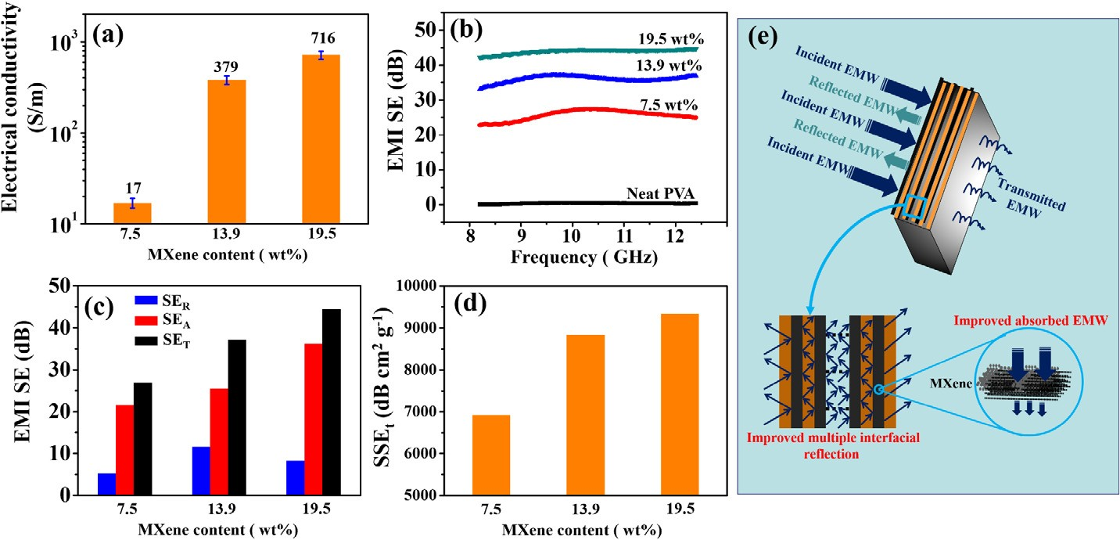
Fig. 2. a) Electrical conductivity of different PVA/ MXene multilayered films; b) EMI SE of neat PVA and different PVA/MXene multilayered films in the X-band; c) comparison of SE_{T}, SE_{A}, and SE_{R} of dif- ferent PVA/MXene multilayered films at 10 GHz; d) Specific SE accounting for the thickness (SSE_{t}) of different PVA/MXene multilayered films; e) sche- matic of electromagnetic microwave dissipation in the PVA/MXene multilayered films.

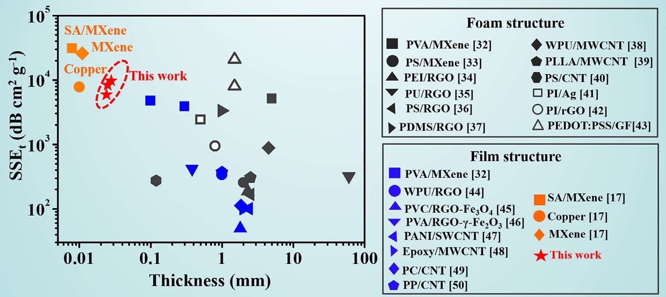
Fig. 3. Comparison of EMI SSE_{t} versus thickness of different polymeric composite materials.

Table 1
Comparison of EMI SSE_{t} versus thickness of different polymeric composite materials in this work and previous literature.
 | Matrix | Filler | Content | t (mm) | SE (dB) | SSE/t (dB cm² g-¹) | Ref.
Foam Structure | PVA | MXene | 0.15 vol% | 5 | 28 | 5136 | [32]
 | PS | MXene | 1.9 vol% | 2 | 62 | 255.2 | [33]
 | PEI | RGO | 1.38 vol% | 2.3 | 13 | 188 | [34]
 | PU | RGO | 4.7 vol% | 60 | 57.7 | 320 | [35]
 | PS | RGO | 3.47 vol% | 2.5 | 45.1 | 167.5 | [36]
 | PDMS | RGO | 0.36 vol% | 1 | 20 | 3333 | [37]
 | WPU | MWCNT | 7.2 vol% | 4.5 | 50 | 881.8 | [38]
 | PLLA | MWCNT | 1.47 vol% | 2.5 | 23 | 306.7 | [39]
 | PS | CNT | 3.6 vol% | 0.12 | 18.5 | 275 | [40]
 | PI | Ag nanowires | / | 0.5 | 35 | 2416 | [41]
 | PI | rGO | 16 wt% | 0.08 | 21 | 937.5 | [42]
 | PEDOT:PSS | Graphene | 50 | 1.5 | 69.1 | 20,800 | [43]
 | PEDOT:PSS | Graphene | 17.9 | 1.5 | 91.9 | 8040 | [43]
Film Structure | PVA | MXene | 2.5 vol% | 0.3 | 21 | 3867 | [32]
 | PVA | MXene | 7.6 vol% | 0.1 | 26 | 4770 | [32]
 | WPU | RGO | 5 vol% | 1 | 34 | 338 | [44]
 | PVC | RGO-Fe₃O₄ | 3.4 vol% | 1.8 | 13 | 49.5 | [45]
 | PVA | RGO-r-Fe₂O₃ | 2.3 vol% | 0.38 | 20.3 | 416.7 | [46]
 | PANI | RGO | 18.8 vol% | / | 34.2 | 118.75 | [47]
 | PANI | SWCNTs | 15.5 vol% | 2.4 | 31.5 | 100.8 | [47]
 | Epoxy | MWCNTs | 1.34 vol% | 2 | 40 | 100.5 | [48]
 | PC | CNTs | 5 vol% | 1.85 | 25 | 112.6 | [49]
 | PP | CNTs | 7.5 vol% | 1 | 35 | 372 | [50]
 | SA | MXene | 90 wt% | 0.008 | 57 | 30,830 | [17]
 | MXene | Bulk | 100 vol% | 0.011 | 68 | 25,863 | [17]
 | PVA | MXene | 7.5 wt% (4.4 vol%) | 0.024 | 26.9 | 6919 | This work
 | PVA | MXene | 13.9 wt% (8.3 vol%) | 0.025 | 37.1 | 8833 | This work
 | PVA | MXene | 19.5 wt% (12 vol%) | 0.027 | 44.4 | 9343 | This work
Densities of pure MXene film, PVA/MXene-AM-7.5, PVA/MXene-AM-13.9 and PVA/MXene-AM-19.5 film were 2.27, 1.62, 1.68 and 1.76 g cm⁻³, respectively; The volume fraction of MXene in PVA/MXene-AM-7.5, PVA/MXene-AM-13.9 and PVA/MXene-AM-19.5 film were 4.4, 8.3 and 12 vol%, respectively; / indicates that the values were either not available or impossible to calculate.

CNT composite film (a SSE_{t} of 58187 dB cm² g⁻¹) [28], CNT sponge (a SSE_{t} of 30444 dB cm² g⁻¹) [29], potassium-doped graphene film (a SSE_{t} > 26321 dB cm² g⁻¹) [30], Ti₃C₂T_{x} MXene film (a SSE_{t} of 25863 dB cm² g⁻¹) [17], graphene film (a SSE_{t} of 25680 d dB cm² g⁻¹) [31]. However, most of the reported EMI shielding materials with ul- trahigh SSE_{t} were based on pure metal, graphene, CNTs, MXene or their composites. Up to now, as shown in Fig. 3 and Table 1 [32–50], few study reported polymeric EMI shielding composites with a SSE_{t} ex- ceeding 10000 dB cm² g⁻¹, except for the sodium alginate (SA)/MXene composite film with 90 wt% MXene (a SSE_{t} of 30830 dB cm² g⁻¹) [17] and graphene foam (GF)/poly(3,4-ethylenedioxythiophene):poly(styr- enesulfonate) (PEDOT:PSS) composite foam with 50 wt% graphene (a SSE_{t} of 20800 dB cm² g⁻¹) [43]. However, in these cases, high loading fillers (> 50 vol% or > 50 wt%) were required to obtain a high SSE_{t}. It is still a challenge to realize a SSE_{t} over or approach to 10000 dB cm² g⁻¹ in polymer composites via adding relatively low filler loading

(< 20 wt% or < 20 vol%). In this work, the as-obtained PVA/MXene- AM film exhibited a high SSE_{t} of 9343 dB cm² g⁻¹ via incorporating
19.5 wt% (12 vol%) MXene in total, which was superior to most re- ported polymeric EMI shielding materials (seen in Fig. 3 and Table 1).

  - Thermal conductivity of PVA/MXene multilayered film
The miniaturized and high-frequency development in electronic
products generates increasingly serious heat accumulation. Moreover,
the EMI shielding materials tend to overheat if exposed to electro-
magnetic radiation for a long time [11]. Therefore, high thermal con-
ductivity (TC) is highly desired in EMI shielding materials for dis-
sipating heat eﬃciently. Herein, the in-plane TC of PVA/MXene
multilayered film was investigated, as shown in Fig. 4a. The in-plane TC
of PVA/MXene-AM-7.5 and PVA/MXene-AM-13.9 films were 2.31 W/
mK and 3.34 W/mK, respectively, enhanced by 1055% and 1570%,

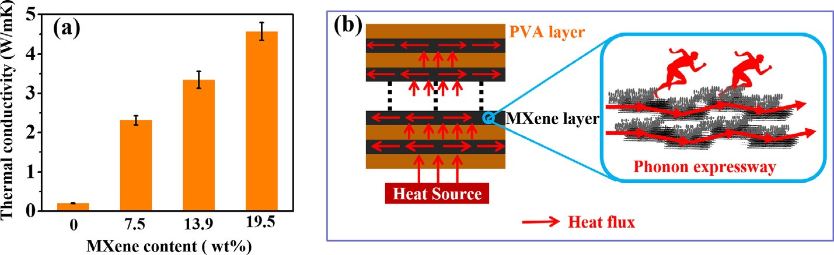
Fig. 4. a) Thermal conductivity of neat PVA and different PVA/MXene multilayered films; b) Schematic of thermal conductive pathway contributing to the high thermal conductivity in the PVA/MXene multilayered films.

As demonstrated in Fig. 4b, the MXene layer provided a continuous thermal conductive network in the whole film.
mK, enhanced by almost 23-fold compared with that of neat PVA.
more, the in-plane TC of PVA/MXene-AM-19.5 film was up to 4.57 W/
respectively, compared with that of neat PVA (0.20 W/mK). Further-
The overlapped MXene
nanosheets in the MXene layer could reduce the interfacial thermal
resistance between fillers to the full extent, providing an expressway for
phono conduction. Therefore, the heat flux could be dissipated eﬃ-
ciently along the continuous MXene layer, contributing to the largely
enhanced in-plane TC in PVA/MXene multilayered films. Moreover,
with the increase in the thickness of MXene layer, the thermal con-
ductive pathway and phono expressway in the MXene layer was im-
proved greatly, resulting in a further enhancement in the TC of PVA/
MXene-AM-19.5 films.

From the above result of EMI SE and TC, it is exciting that excellent EMI SE and TC were realized in the PVA/MXene multilayered films synchronously.
The continuous MXene layer could provide conductive
network not only for thermal conduction but also for electron con-
duction, resulting in synchronous and remarkable enhancement in the
EMI SE and TC of PVA matrix.

Fig. 5 (Table 2) shows the comparison of EMI SE and TC performance in this work with those of other polymeric composite materials reported in previous literature.
One can observe
that it is very diﬃcult to obtain high EMI SE and TC synchronously in
the case of polymeric films. In this work, the PVA/MXene multilayered
film exhibited excellent EMI SE and TC at the same time, which was
superior to most previous literature especially when referring to the
film state.

  - Flammability of PVA/MXene multilayered film

The high combustibility of polymers is an important factor limiting
their application in EMI shielding and heat dissipating device, which must be solved for practical application. The pure MXene film exhibited excellent fire resistance for a long time (seen in Fig. S1), and the TGA curves shown in Fig. S2 indicated that the introduction of layered MXene in PVA/MXene-AM-19.5 film could enhance the thermal stabi- lity of PVA matrix significantly. The above results indicate the great potential of MXene for polymer flame retardancy. Herein, combustion experiments were performed to investigate the flammability of the neat PVA and PVA/MXene multilayered films. As shown in Fig. 6, the combustion test was conducted on an alcohol burner, in which the specimen was ignited on the flame of alcohol burner for 1 s and then was moved away from the flame.
the specimen burned heavily after the ignition of 1 s, and kept burning
Interestingly, as shown in Fig. 6b–d, the specimens of PVA/MXene multilayered films burned for a shorter time after being moved away from the flame compared with that of neat PVA film.
for 9 s until all the film burned into melt drip at the end.
For neat PVA film shown in Fig. 6a,
 |  | Most importantly, there was no
melt drip appeared during the whole combustion process of the PVA/
MXene multilayered films, and the film structure was maintained after
burning. This indicates the great potential of MXene on improving the
anti-dripping performance of polymers. Moreover, as shown in
Fig. 7a–d, the thicker the MXene layer or the higher the MXene content,
the better the film structure was kept, indicating that the MXene con-
tent played a great role on flame retardancy of the PVA/MXene mul-
tilayered films. | (All the videos of the combustion test can be seen in the

supporting materials).
In order to understand the mechanism of MXene on improving the anti-dripping performance of PVA/MXene multilayered films, SEM images were performed based on the burned residues of PVA/MXene- AM-19.5 film. As shown in Fig. 7e–g, it is clear that the layer structure of the PVA/MXene multilayered film was kept well after burning, and

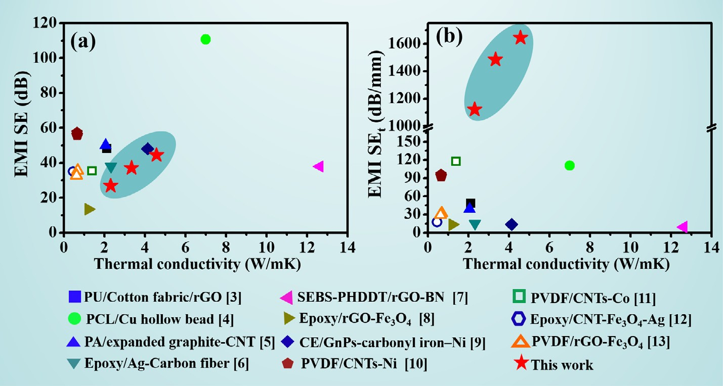
Fig. 5. Comparison of EMI SE and thermal conductivity of different polymeric composite materials. a) EMI SE versus thermal conductivity; b) EMI SE_{t} versus thermal conductivity.

Table 2
Comparison of EMI SE and thermal conductivity of different polymeric composite materials.
Composites | TC (W/mK) | EMI SE (dB) | Thickness (mm) | EMI SE_{t} (dB/mm) | Content (wt%) | Combustion performance | Ref.
PU/Cotton fabric/rGO | 2.13 | 48.1 | 1 | 48.1 | 2 | / | [3]
PCL/Cu hollow bead | 7 | 110.7 | 1 | 110.7 | 9.8 | / | [4]
PA/expanded graphite-CNT | 2.06 | 50 | 1.3 | 38.5 | 18 | / | [5]
Epoxy/Ag-Carbon fiber | 2.33 | 35–38 | 2.5 | 14–15.2 | 4.5 | / | [6]
SEBS-PHDDT/rGO-BN | 12.62 | 37.92 | 4 | 9.5 | > 35 | / | [7]
Epoxy/rGO-Fe₃O₄ | 1.213 | 13.45 | 1 | 13.45 | 8.97 | / | [8]
Cyanate ester/GnPs- carbonyl iron–Ni | 4.13 | 48 | 3.5 | 13.7 | 20 | / | [9]
PVDF/CNTs-Ni | 0.65 | 57.3 | 0.6 | 95.5 | 7 | / | [10]
PVDF/GnPs-Ni | 0.66 | 55.8 | 0.6 | 93.0 | 13 | / | [10]
PVDF/CNTs-Co | 1.39 | 35.3 | 0.3 | 117.7 | 12 | / | [11]
Epoxy/CNT-Fe₃O₄-Ag | 0.46 | 35 | 2 | 17.5 | 15 | / | [12]
PVDF/rGO-Fe₃O₄ | 0.68 | 35.6 | 1.1 | 32.4 | 13 | / | [13]
PVDF/CNT-Fe₃O₄ | 0.62 | 32.7 | 1.1 | 29.7 | 13 | / | [13]
PVA/MXene-AM | 2.31 | 26.9 | 0.024 | 1120.8 | 7.5 | Anti-dripping | This work
PVA/MXene-AM | 3.34 | 37.1 | 0.025 | 1484 | 13.9 | Anti-dripping | This work
PVA/MXene-AM | 4.57 | 44.4 | 0.027 | 1644 | 19.5 | Anti-dripping | This work
/ indicates that the values were either not available or impossible to calculate.

the burned MXene nanosheets could be seen clearly on the surface of residues (Fig. S3). Furthermore, SEM energy dispersive spectroscopy (EDS) of PVA/MXene-AM-19.5 film before and after burning were performed, as shown in Figs. S4 and S5, respectively. As for the burned PVA/MXene-AM-19.5 film (Fig. S5), F element could also be found on the surface of residues (the at% of F element reduced compared with that in PVA/MXene-AM-19.5 before burning), indicating the -F termi- nating group was not removed completely during burning. Meanwhile, the at% of O element in the burned PVA/MXene-AM-19.5 residues in- creased significantly compared with that in the unburned PVA/MXene- AM-19.5. This may indicate the evolution of
Ti₃C₂T_{x} MXene toward
TiO₂ during burning.
Raman spectra were further performed (Fig. 8) to confirm the speculation of SEM EDS results. As shown in Fig. 8a, the peak at 2908 cm⁻¹ belonging to PVA [51] disappeared in the Raman spectrum
of burned PVA/MXene-AM-19.5 film, while the amorphous and gra- phitic carbon peaks around 1591 cm⁻¹ (G band) and 1367 cm⁻¹ (D band) became stronger, indicating the
during burning. However, the information of the inferred TiO₂ could not be found in the spectra of PVA/MXene-AM-19.5 film before and after burning. This was because the existence of alternating multi- layered structure, and the outermost PVA layer covered the MXene layer during the Raman test. In order to investigate the role of MXene on improving the anti-dripping performance of PVA matrix directly, the Raman spectra of pure MXene before and after burning were performed (Fig. 8b). The amorphous and graphitic carbon peaks around 1570 cm⁻¹ (G band) and 1340 cm⁻¹ (D band) in the Raman spectrum of MXene disappeared after burning, while peaks belonging to the various phases of TiO₂ were found obviously around 608 cm⁻¹, 446 cm⁻¹ and 239 cm⁻¹ in the Raman spectrum of burned MXene [52].
carbonization process of PVA

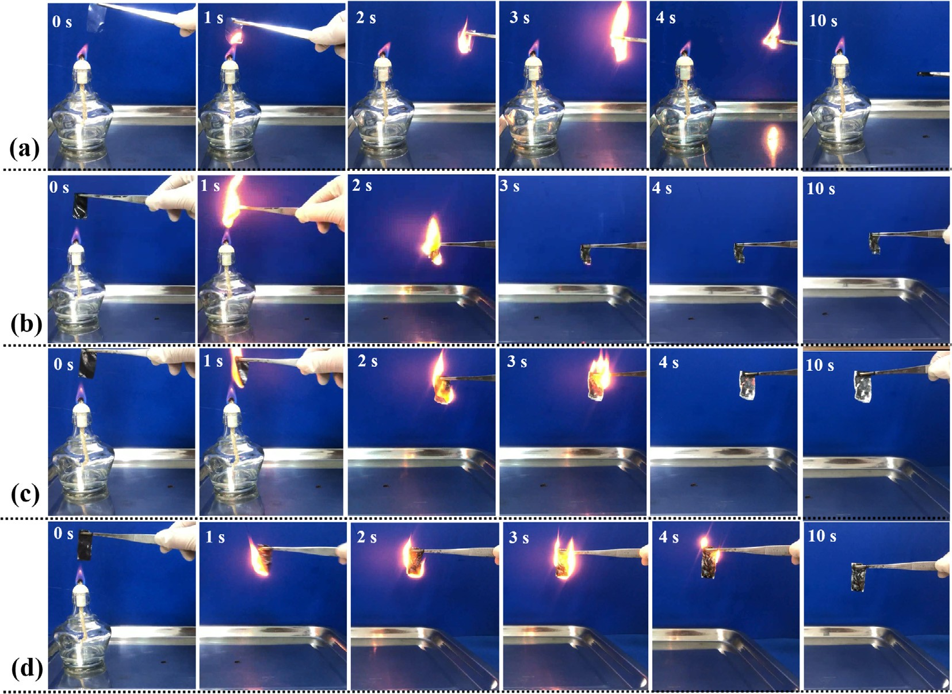
Fig. 6. Digital images of the combustion process at different time of a) neat PVA, b) PVA/MXene-AM-7.5, c) PVA/MXene-AM-13.9 and d) PVA/MXene-AM-19.5 film.

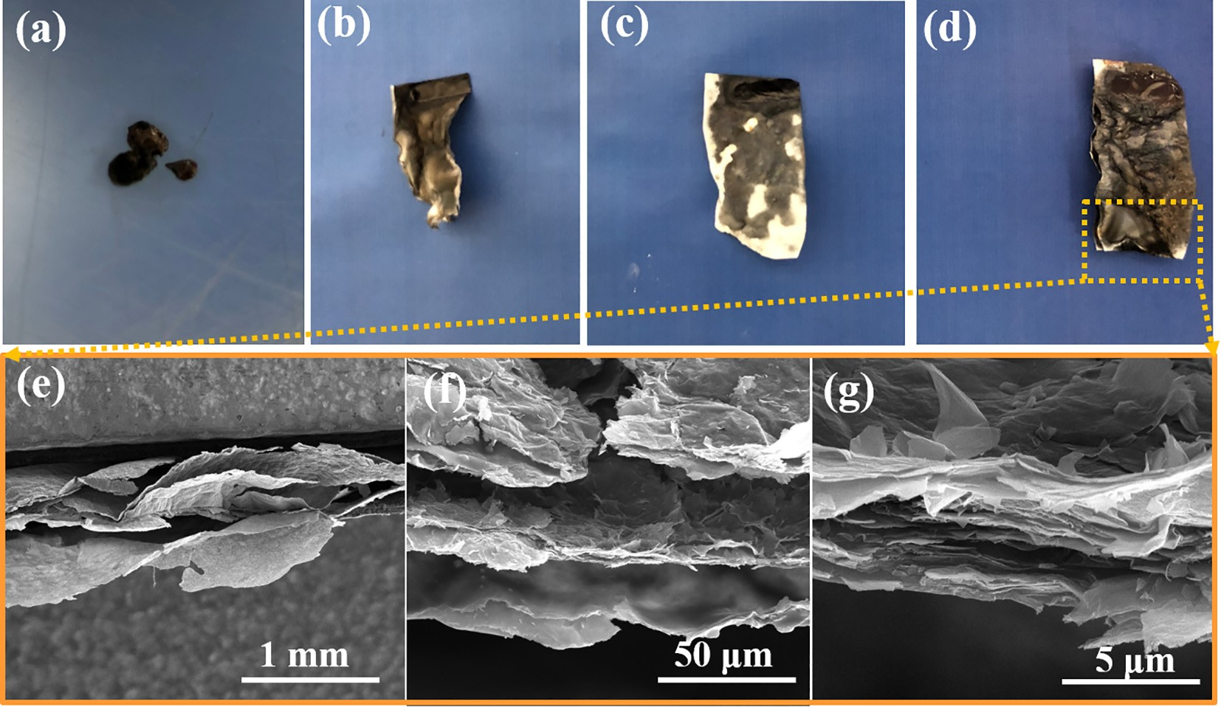
Fig. 7. a), b), c) and d) are digital images of the burned residues of neat PVA, PVA/MXene-AM-7.5, PVA/MXene-AM-13.9 and PVA/MXene-AM-19.5 film, respec- tively; e), f) and g) are SEM images of the residues of burned PVA/MXene-AM-19.5 film under different magnifications.
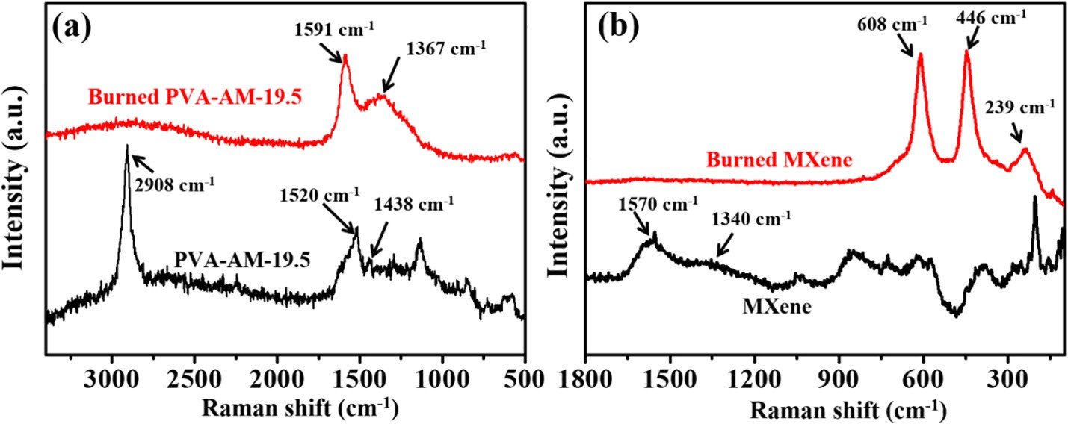
Fig. 8. a) Raman spectra of burned and unburned PVA/MXene-AM-19.5; b) Raman spectra of burned and unburned MXene.

This confirmed the formation of TiO₂ during burning. In addition, the result of FTIR (Fig. S6a) and XPS (Fig. S6b) also demonstrate the evo- lution of Ti₃C₂T_{x} MXene toward TiO₂ during burning. In a word, the above results confirmed the evolution of oxygen-containing functional group (eOH, ]O) and fluorinated functional groups (-F) as well as the formation of TiO₂. This can form a physical protective layer of TiO₂ on the PVA-MXene layer interface, preventing the propagation of flame and the appearance of melt drip.

- Conclusions

Herein, PVA/MXene alternating multilayered films were fabricated through multilayered casting method. The MXene layer provided a continuous network for thermal and electron conduction, endowing the PVA matrix with excellent EMI shielding and thermal conductive per- formance at the same time. The microwave absorption (SE_{A}) was the dominant mechanism for shielding electromagnetic radiation, and the enhanced EMI SE in the PVA/MXene multilayered films was attributed to the improved multiple interfacial reflection and improved absorption in the MXene layer.
Moreover, the PVA/MXene multilayered film ex-
hibited remarkable anti-dripping performance due to the formation of
This work demonstrates the great potential of MXene on enhancing the TC and flame retardancy of polymer matrix, providing a novel and effective strategy for fabricating flame-retardant
TiO₂ during burning.
polymeric films with excellent EMI shielding and thermal conductive performances synchronously.

Acknowledgements

Financial support of the China Postdoctoral Science Foundation (No. 2018M642780), Opening Project of State Key Laboratory of Polymer Materials Engineering (Sichuan University) (No. sklpme2019-4-31) and Startup Research Fund of Zhengzhou University (No. 32211146) are gratefully acknowledged.

Appendix A. Supplementary data

Supplementary data to this article can be found online at https:// doi.org/10.1016/j.cej.2019.122475.

References

- B. Shen, W.T. Zhai, W.G. Zheng, Ultrathin flexible graphene film: an excellent thermal conducting material with eﬃcient EMI shielding, Adv. Funct. Mater. 24 (2014) 4542–4548.
- X.M. Zhang, J.J. Zhang, X.L. Zhang, C.H. Li, J.F. Wang, H. Li, L.C. Xia, H. Wu,
S.Y. Guo, Toward high eﬃciency thermally conductive and electrically insulating pathways through uniformly dispersed and highly oriented graphites close-packed with SiC, Compos. Sci. Technol. 150 (2017) 217–226.
- Y. Wang, W. Wang, R. Xu, M.F. Zhu, D. Yu, Flexible, durable and thermal

conducting thiol-modified rGO-WPU/cotton fabric for robust electromagnetic in- terference shielding, Chem. Eng. J. 360 (2019) 817–828.
- S.H. Lee, S.G. Yu, F. Shahzad, W.N. Kim, C. Park, S.M. Hong, C.M. Koo, Density- tunable lightweight polymer composites with dual-functional ability of eﬃcient EMI shielding and heat dissipation, Nanoscale 9 (2017) 13432–13440.
- Y.L. Guo, R.Z. Zhang, K. Wu, F. Chen, Q. Fu, Preparation of nylon MXD6/EG/CNTs ternary composites with excellent thermal conductivity and electromagnetic in- terference shielding effectiveness, Chinese. J. Polym. Sci. 35 (2017) 1497–1507.
- J.P. Li, S.H. Qi, M.Y. Zhang, Z.F. Wang, Thermal conductivity and electromagnetic shielding effectiveness of composites based on Ag-plating carbon fiber and epoxy, J. Appl. Polym. Sci. 132 (2015) 42306–42311.
- X.L. Zhang, X.M. Zhang, M.T. Yang, S. Yang, H. Wu, S.Y. Guo, Y.Z. Wang, Ordered multilayer film of (graphene oxide/polymer and boron nitride/polymer) nano- composites: An ideal EMI shielding material with excellent electrical insulation and high thermal conductivity, Compos. Sci. Technol. 136 (2016) 104–110.
- Y.C. Liu, M.P. Lu, K. Wu, S. Yao, X.X. Du, G.K. Chen, Q. Zhang, L.Y. Liang, M.G. Lu,
Anisotropic thermal conductivity and electromagnetic interference shielding of epoxy nanocomposites based on magnetic driving reduced graphene oxide@Fe₃O₄, Compos. Sci. Technol. 174 (2019) 1–10.
- F. Ren, D.P. Song, Z. Li, L.C. Jia, Y.C. Zhao, D.X. Yan, P.G. Ren, Synergistic effect of graphene nanosheets and carbonyl iron–nickel alloy hybrid filler on electro- magnetic interference shielding and thermal conductivity of cyanate ester compo- sites, J. Mater. Chem. C 6 (2018) 1476–1486.
- B. Zhao, S. Wang, C.X. Zhao, R.S. Li, S.M. Hamidinejad, Y. Kazemi, C.B. Park, Synergism between carbon materials and Ni chains in flexible poly(vinylidene fluoride) composite films with high heat dissipation to improve electromagnetic shielding properties, Carbon 127 (2018) 469–478.
- X.P. Li, S.P. Zeng, S.J. E., L.Y. Liang, Z.Y. Bai, Y.Y. Zhou, B. Zhao, R. Zhang, Quick heat dissipation in absorption-dominated microwave shielding properties of flexible poly(vinylidene fluoride)/carbon nanotube/Co composite films with anisotropy- shaped Co (flowers or chains), ACS Appl. Mater. Interfaces 10 (2018) 40789–40799.
- L. Wang, H. Qiu, C.B. Liang, P. Song, Y.X. Han, Y.X. Han, J.W. Gu, J. Kong, D. Pan,
Z.H. Guo, Electromagnetic interference shielding MWCNT-Fe₃O₄@Ag/epoxy na- nocomposites with satisfactory thermal conductivity and high thermal stability, Carbon 141 (2019) 506–514.
- H.R. Cheng, S.N. Wei, Y.X. Ji, J.S. Zhai, X.L. Zhang, J.B. Chen, C.Y. Shen, Synergetic effect of Fe₃O₄ nanoparticles and carbon on flexible poly (vinylidence fluoride) based films with higher heat dissipation to improve electromagnetic shielding, Compos. Part A 121 (2019) 139–148.
- W.L. Song, L.Z. Fan, M.S. Cao, M.M. Lu, C.Y. Wang, J. Wang, T.T. Chen, Y. Li,
Z.L. Hou, J. Liu, Facile fabrication of ultrathin graphene papers for effective elec- tromagnetic shielding, J. Mater. Chem. C 2 (2014) 5057–5064.
- M. Naguib, M. Kurtoglu, V. Presser, J. Lu, J. Niu, M. Heon, Y. Gogotsi,
M.W. Barsoum, Two-dimensional nanocrystals produced by exfoliation of Ti₃AlC₂, Adv. Mater. 23 (2011) 4248–4253.
- J. Liu, H.B. Zhang, R.H. Sun, Y.F. Liu, Z.S. Liu, A.G. Zhou, Z.Z. Yu, Hydrophobic, flexible, and lightweight MXene foams for high-performance electromagnetic-in- terference shielding, Adv. Mater. 29 (2017) 1702367.
- F. Shahzad, M. Alhabeb, C.B. Hatter, B. Anasori, S.M. Hong, C.M. Koo, Y. Gogotsi, Electromagnetic interference shielding with 2D transition metal carbides (MXenes), Science 353 (2016) 1137–1140.
- R. Sun, H.B. Zhang, J. Liu, X. Xie, R. Yang, Y. Li, Z.Z. Yu, Highly conductive tran- sition metal carbide/carbonitride(MXene)@polystyrene nanocomposites fabricated by electrostatic assembly for highly eﬃcient electromagnetic interference shielding, Adv. Funct. Mater. 27 (2017) 1702807.
- M.S. Cao, Y.Z. Cai, P. He, J.C. Shu, W.Q. Cao, J. Yuan, 2D MXenes: electromagnetic property for microwave absorption and electromagnetic interference shielding, Chem. Eng. J. 359 (2019) 1265–1302.
- J. Liu, H.B. Zhang, X. Xie, R. Yang, Z.S. Liu, Y.F. Liu, Z.Z. Yu, Multifunctional, superelastic, and lightweight mxene/polyimide aerogels, Small 14 (2018) 1802479.
- Z. Ling, C.E. Ren, M.Q. Zhao, J. Yang, J.M. Giammarco, J.S. Qiu, M.W. Barsoum,
Y. Gogotsi, Flexible and conductive MXene films and nanocomposites with high capacitance, Proc. Natl. Acad. Sci. U.S.A. 111 (2014) 16676–16681.
- R.T. Liu, M. Miao, Y.H. Li, J.F. Zhang, S.M. Cao, X. Feng, Ultrathin biomimetic polymeric Ti₃C₂T_{x} MXene composite films for electromagnetic interference shielding, ACS Appl. Mater. Interfaces 10 (2018) 44787–44795.
- X.H. Zha, J. Zhou, Y.H. Zhou, Q. Huang, J. He, J.S. Francisco, K. Luo, S.Y. Du, Promising electron mobility and high thermal conductivity in Sc₂CT₂ (T= F, OH) MXenes, Nanoscale 8 (2016) 6110–6117.
- Y. Cao, Q.H. Deng, Z.D. Liu, D.Y. Shen, T. Wang, Q. Huang, S.Y. Du, N. Jiang,
C.T. Lin, J.H. Yu, Enhanced thermal properties of poly (vinylidene fluoride) com- posites with ultrathin nanosheets of MXene, RSC Adv. 7 (2017) 20494–20501.
- R. Liu, W.F. Li, High-thermal-stability and high-thermal-conductivity Ti₃C₂T_{x} MXene/Poly(vinyl alcohol) (PVA) composites, ACS Omega. 3 (2018) 2609–2617.
- C.J. Zhang, S. Pinilla, N. McEvoy, C.P. Cullen, B. Anasori, E. Long, S.H. Park,
A. Seral-Ascaso, A. Shmeliov, D. Krishnan, C. Morant, X. Liu, G.S. Duesberg,
Y. Gogotsi, V. Nicolosi, Oxidation Stability of Colloidal Two-Dimensional Titanium Carbides (MXenes), Chem. Mater. 29 (2017) 4848–4856.
- Y.J. Wan, P.L. Zhu, S.H. Yu, R. Sun, C.P. Wong, W.H. Liao, Anticorrosive, ultralight, and flexible carbon-wrapped metallic nanowire hybrid sponges for highly eﬃcient electromagnetic interference shielding, Small 14 (2018) 1800534.
- G.M. Weng, J. Li, M. Alhabeb, C. Karpovich, H. Wang, J. Lipton, Y. Gogotsi, Layer- by-layer assembly of cross-functional semi-transparent MXene-carbon nanotubes composite films for next-generation electromagnetic interference shielding, Adv. Funct. Mater. 28 (2018) 1803360.
- D.W. Lu, Z.C. Mo, B.H. Liang, L.L. Yang, Z.F. He, H.K. Zhu, X.C. Gui, Flexible, lightweight carbon nanotube sponges and composites for high-performance elec- tromagnetic interference shielding, Carbon 133 (2018) 457–463.
- E.Z. Zhou, J.B. Xi, Y.J. Liu, Z. Xu, Y. Guo, L. Peng, C. Gao, Large-area potassium- doped highly conductive graphene films for electromagnetic interference shielding, Nanoscale 9 (2017) 18613–18618.
- S.F. Lin, S. Ju, J.W. Zhang, G. Shi, Y.L. He, D.Z. Jiang, Ultrathin flexible graphene films with high thermal conductivity and excellent EMI shielding performance using large-sized graphene oxide flakes, RSC Adv. 9 (2019) 1419–1427.
- H.L. Xu, X.W. Yin, X.L. Li, M. Li, S. Liang, L.T. Zhang, L.F. Cheng, Lightweight Ti₂CT_{x} MXene/Poly (vinyl alcohol) composite foams for electromagnetic wave shielding with absorption dominated feature, ACS Appl. Mater. Interfaces 11 (2019) 10198–10207.
- R. Sun, H.B. Zhang, J. Liu, X. Xie, R. Yang, Y. Li, Z.Z. Yu, Highly conductive tran- sition metal carbide/carbonitride (MXene)@ polystyrene nanocomposites fabri- cated by electrostatic assembly for highly eﬃcient electromagnetic interference shielding, Adv. Funct. Mater. 27 (2017) 1702807.
- J. Ling, W. Zhai, W. Feng, B. Shen, J. Zhang, W. Zheng, Facile preparation of lightweight microcellular polyetherimide/graphene composite foams for electro- magnetic interference shielding, ACS Appl. Mater. Interfaces 5 (2013) 2677–2684.
- B. Shen, Y. Li, W. Zhai, W. Zheng, Compressible graphene-coated polymer foams with ultralow density for adjustable electromagnetic interference (EMI) shielding, ACS Appl. Mater. Interfaces 8 (2016) 8050–8057.
- D.X. Yan, H. Pang, B. Li, R. Vajtai, L. Xu, P.G. Ren, J.H. Wang, Z.M. Li, Structured reduced graphene oxide/polymer composites for ultra-eﬃcient electromagnetic interference shielding, Adv. Funct. Mater. 25 (2015) 559–566.
- Z. Chen, C. Xu, C. Ma, W. Ren, H.M. Cheng, Lightweight and flexible graphene foam composites for high-performance electromagnetic interference shielding, Adv. Mater. 25 (2013) 1296–1300.
- Z. Zeng, H. Jin, M. Chen, W. Li, L. Zhou, Z. Zhang, Lightweight and anisotropic porous MWCNT/WPU composites for ultrahigh performance electromagnetic in- terference shielding, Adv. Funct. Mater. 26 (2016) 303–310.
- T. Kuang, L. Chang, F. Chen, Y. Sheng, D. Fu, X. Peng, Facile preparation of lightweight highstrength biodegradable polymer/multi-walled carbon nanotubes nanocomposite foams for electromagnetic interference shielding, Carbon 105 (2016) 305–313.
- Y. Yang, M.C. Gupta, K.L. Dudley, R.W. Lawrence, Novel carbon nanotube−po- lystyrene foam composites for electromagnetic interference shielding, Nano Lett. 5 (2005) 2131–2134.
- J. Ma, K. Wang, M. Zhan, A comparative study of structure and electromagnetic interference shielding performance for silver nanostructure hybrid polyimide foams, RSC Adv. 5 (2015) 65283–65296.
- Y. Li, X. Pei, B. Shen, W. Zhai, L. Zhang, W. Zheng, Polyimide/graphene composite foam sheets with ultrahigh thermostability for electromagnetic interference shielding, RSC Adv. 5 (2015) 24342–24351.
- Y. Wu, Z.Y. Wang, X. Liu, X. Shen, Q.B. Zheng, Q. Xue, J.K. Kim, Ultralight graphene foam/conductive polymer composites for exceptional electromagnetic interference shielding, ACS Appl. Mater. Interfaces 9 (2017) 9059–9069.
- S.T. Hsiao, C.C.M. Ma, W.H. Liao, Y.S. Wang, S.M. Li, Y.C. Huang, R.B. Yang,
W.F. Liang, Lightweight and flexible reduced graphene oxide/water-borne poly- urethane composites with high electrical conductivity and excellent electro- magnetic interference shielding performance, ACS Appl. Mater. Interfaces 6 (2014) 10667–10678.
- K. Yao, J. Gong, N. Tian, Y. Lin, X. Wen, Z. Jiang, H. Na, T. Tang, Flammability properties and electromagnetic interference shielding of PVC/graphene composites containing Fe₃O₄ nanoparticles, RSC Adv. 5 (2015) 31910–31919.
- B. Yuan, C. Bao, X. Qian, L. Song, Q. Tai, K.M. Liew, Y. Hu, Design of artificial nacre-like hybrid films as shielding to mitigate electromagnetic pollution, Carbon 75 (2014) 178–189.
- B. Yuan, L. Yu, L. Sheng, K. An, X. Zhao, Comparison of electromagnetic inter- ference shielding properties between single-wall carbon nanotube and graphene sheet/polyaniline composites, J. Phys. D 45 (2012) 235108.
- Y. Chen, H.B. Zhang, Y. Yang, M. Wang, A. Cao, Z.Z. Yu, High-performance epoxy nanocomposites reinforced with three-dimensional carbon nanotube sponge for electromagnetic interference shielding, Adv. Funct. Mater. 26 (2016) 447–455.
- M. Arjmand, M. Mahmoodi, G.A. Gelves, S. Park, U. Sundararaj, Electrical and electromagnetic interference shielding properties of flow-induced oriented carbon nanotubes in polycarbonate, Carbon 49 (2011) 3430–3440.
- M.H. Al-Saleh, U. Sundararaj, Electromagnetic interference shielding mechanisms of CNT/polymer composites, Carbon 47 (2009) 1738–1746.
- L. Zhang, Z.P. Wang, C. Xu, Y. Li, J.P. Gao, W. Wang, Y. Liu, High strength graphene oxide/polyvinyl alcohol composite hydrogels, J. Mater. Chem. 21 (2011)
10399–10406.
- P. Wang, J. Wang, X.F. Wang, H.G. Yu, J.G. Yu, M. Lei, Y.G. Wang, One-step synthesis of easy-recycling TiO₂-rGO nanocomposite photocatalysts with enhanced photocatalytic activity, Appl. Catal. B Environ. 132 (2013) 452–459.

